Introduction
Welcome to Treasurer Training!

The role of the treasurer is involved in every Maplewood Cemetery (MWC) transaction. The treasurer is the fiduciary of the Maplewood Cemetery Association, incorporated.
- What Is a Fiduciary? A fiduciary is a person or organization that acts on behalf of another person or persons, putting their clients' interests ahead of their own, with a duty to preserve good faith and trust. Being a fiduciary thus requires being bound both legally and ethically to act in the other's best interests.
- This document will try to list and explain the areas of the transactions and provide references and links to supporting materials.
- The methods and procedures may continue to change over time, but the concepts and responsibilities will not.
- The role of the treasurer is a critical and integrated portion of the proper functioning of the entire MWC Association. The tasks require the treasurer to understand how all aspects of the MWC Association function and the timely and accurate response needed from the treasurer.
- The MWC financial core is based on Intuit QuickBooks (QB) software. A change was made at the beginning of 2023 to transition from QB Desktop version to QB Online (QBO).
  - Prior knowledge of QBO would be beneficial. I will list the MWC specific items, but it would not be possible to teach QBO here. Here is a link to some of the Intuit QB training tutorials.
  - This change to QBO was part of the process to allow for more access and more services. QBO allows for multiple users (authorized) to have access to the finances for sales tracking, reporting and internal audit capabilities.
  - Currently, QBO manages the MWC Payroll, after the treasurer enters the payroll data. Intuit sends out the direct deposit to each employee and pays the Federal and State taxes as part of the payroll services. MWC will require each new employee to subscribe to direct deposit.
  - We have also added the Intuit WORKFORCE function of QBO to allow all employees to access their own paystubs, see the paycheck details, and retrieve their W-2 statement at the end of the year.
  - QBO allows for an electronic invoice (E-Invoice) to be sent to customers that prefer to pay with credit cards and are willing to pay online.
  - QBO has been ‘linked’ to our central banking account at KeyBank. This linking integrates our Accounts Receivable (AR), Accounts Payable (AP) and Payroll processes.
- More information will be provided throughout this document and in the ‘Notes Sections’ near the end.
What are the areas that must be managed?
- Here are the major areas:
  - INCOME:
    - Dividends and Interest
    - Donations
    - Foundation Income
    - Grave Sales
    - Interment income
  - EXPENSES:
    - Contractor expenses
    - Equipment and Supplies
    - Insurance expenses
    - NYS Cemetery Division charges
    - Payroll and Taxes
    - Permanent Maintenance expenses
    - Projects
    - Security expenses
    - Software expenses
    - Utility expenses
    - Vendor expenses
  - REPORTS:
    - 1099 filing for non-employee vendors/contractors.
    - 990 Return of Organization Exempt from Income Tax
    - IRS EFTPS - Electronic Federal Tax Payment System
    - NYS45 - Quarterly Combined NYS Tax Payment System
    - NYS Cemetery Division – Annual Report
    - Insurance (The Hartford) – Premium Audits
    - MWC – Quarterly Business Reports
    - MWC – keeping MWC pricing, inventory, account status, billing, and sales progress current and coordinated with the MWC Secretary, sales contacts, and the webmaster.
What is the Maplewood Cemetery Association?
Business description: Maplewood Cemetery is owned and operated by the Maplewood Cemetery Association which was incorporated in 1896. Maplewood Cemetery is a not-for-profit, volunteer run, charitable organization made up of member-owners elected to the Association Board of Directors. The Board of Directors manages the cemetery corporation, appoints a superintendent, elects Officers for various functions and positions to make sure the cemetery grounds and business is properly operated, maintained, and meets all the required NY state and Federal regulations for cemeteries and non-profit corporations.

The operation of the cemetery is divided into 2 primary areas:
Cemetery Operations: Overall property and equipment management.
Superintendent
  - Supervises the Grounds employees (2)
  - Burial scheduling and management
  - Vendor/Contractor management for mowing and projects
  - Landscape and grounds management:
    - Mowing
    - Trimming
    - Grave topping & seeding
    - Roads – accessibility and maintenance
  - Equipment Management:
    - Purchases
    - Repairs
    - Supplies
    - Shed – storage.
    - Tools
    - Hydrants
- Grounds employees (2)
    - Provide the landscape and grounds services.
    - Provide the cremation grave openings and closings.
    - Provide onsite equipment maintenance.
Business Management: Primarily financial, records and customer management.
- Business manager – oversight of:
  - Sales transactions.
  - Financial transactions and records.
  - Inventory records and maps
  - Customer data
  - Employee data and payroll records.
  - Vendor/Contractor transactions.
  - Tax filings; state and federal
  - Insurance contracts
  - Compliance with NYS & Division of Cemetery laws.
  - Communications, marketing, social media, and websites
  - Infrastructure technology
  - Security requirements.
- Treasurer, responsible for:
  - Financial transactions and records.
  - Customer data
  - Employee data and payroll records.
  - Vendor/Contractor transactions.
  - Tax filings; state and federal

- Secretary responsible for:
  - Purchase – Deed management
  - MWC Inventory and Customer database
  - Meeting minutes

The NYS Department of State – Cemetery Division regulates and audits many of our MWC operations.
- The Treasurer should read and become familiar with the rules, guidelines, and expectations of the NYS Cemetery Division.
- I have included 2 training documents from them in our training directory:
  - cemeteries-101-basics
  - cemeteries-101-accounting-basics

NYS Internal Controls & Best Practices:
- All income (from interments, lot sales, etc.) should pass through the operating account (General Fund) first; transfers can then be made to the PM or other accounts from the operating account.
- Include at least 2 officers in every transaction, i.e. one closes sale & collects payment; then gives it to Treasurer to deposit and file.
- The cemetery should issue receipts for all income received.
- Cash is discouraged.
- Bank statements should be reviewed by someone other than the Treasurer on a regular basis.
- There is a two-signature requirement on all checks; confirm wire transfers also require two authorizations if possible.
- Adopt and adhere to Conflict-of-Interest policy.
- Separation of duties
- Do NOT delay deposits.
- Do NOT pre‐sign checks.
- Pay attention to investments (ROR, fees)
- Convert CDs to investments when appropriate.
- The cemetery should make all disbursements by check. (see MWC note)
  - MWC Note: I treat this statement as a guideline. The ability to track and audit all disbursements is the intent. MWC uses the General Fund for ALL our income and disbursements. The method of disbursement may be an electronic bill payment (ACH), account transfer, or a credit card payment and not a ‘paper’ check. All of which are run through our General Fund.

Types of Funds
General Fund (GF)
Permanent Maintenance (PM)
Perpetual Care (PC)
Specials Trusts (ST)

MWC Fund Specifics:

General Fund (GF): KeyBank is our primary account for all financial transactions.
- KeyBank provides our:
  - Checking Account ** 0768
  - Credit and Debit cards (MasterCard)
  - ACH functions.
    - An ACH is an electronic fund transfer made between banks and credit unions across what is called the Automated Clearing House network. ACH is used for all kinds of fund transfer transactions, including direct deposit of paychecks and monthly debits for routine payments.

Permanent Maintenance (PM): MWC has multiple accounts at Vanguard.
Maplewood Cemetery Association — Brokerage Account — ***7077* GF | $48,001.36
Maplewood Cemetery Association Account - 1 **7016 PM (Equity) | $78,611.48
Maplewood Cemetery Association Account - 2 **9513 PM (US Gov’t Trust) | $46,462.01
Maplewood Cemetery Association Account - 3 **9542 PM (Savings) | $233,608.34
Maplewood Cemetery Association Account - 4 **9585 GF | $99,585.12
Maplewood Cemetery Association Account - 5 **0997 Perpetual Care (PC) | $1,548.01
Maplewood Cemetery Association Account - 6 **9555 ‘Flower’ Fund (ST)

The GF accounts at Vanguard are interest earning investments that supplement the KeyBank GF. Funds may be transferred between KeyBank and Vanguard GF funds as needed to maintain a good account balance at KeyBank for all transactions and the rest of the funds can be at Vanguard GF to potentially earn interest.
All deposits to any of the Vanguard accounts originate at the KeyBank GF account. The KeyBank GF account is linked to Vanguard to make buying/selling/transfers easier.
The PM accounts are set up to transfer the dividends and interest to the KeyBank GF account.
The PC and ST accounts must remain separate from the other Vanguard accounts and are not active. These accounts were created for specific requests and no deposits or like accounts will be accepted.

Income details:
  - INCOME:
    - Dividends and Interest
      - The PM accrued dividends and interest are automatically transferred from the Vanguard PM accounts to the KeyBank GF account.
    - Donations - Fundraising
      - Any donations will be entered into QBO, deposited in GF and a donation receipt send to the donor.
    - Foundation Income
      - Foundation orders come from our monument vendors. These orders will be entered into QBO. The customer order is entered into QBO as a new customer under the Monument vendor as a sub customer.
    - Grave Sales
      - Grave sales are entered into QBO as a grave sale and deposited into the GF.
      - The QBO entry will record the sale by the customer, either new or returning. A new customer must have all the contact information from the grave sale form entered. The new or returning customer must have the grave Section-Lot-Grave (SLG), and the method and amount of payment entered.
      - The grave sale funds received may be the full price of the grave sale or a partial price deposit.
      - The MWC Secretary will also need this information to update the grave inventory records.
      - The treasurer will let the Secretary know if this is a partial or full payment for the grave.
      - Receipts for any payment will be created and sent to the customer.
    - Interment income
      - Interment payments are typically made by check at the cemetery funeral. NYS and MWC require that the grave and the interment fees are fully paid before the interment can occur.
      - Refer to the MWC price list and the example that follows for the amount to be paid.
      - All income received will be recorded in QBO and deposited in the GF.
      - Receipts are only required if the payment is not from a funeral home.

    - TREASURER TIPS:
      - Make paper copies of all checks and attach them to the QBO customer statement for the MWC files.
      - Make a copy of the Burial-Transit permit for full interments or attach the cremation certificate to the customer statement and payment.
      - The signed Burial-Transit permit must be mailed to:
Monroe County
NY Vital Records
740 E Henrietta Rd
Rochester, NY 14623
- Some of the information on the Burial-Transit permit will be needed by the MWC Secretary for the records. It is important to know what information is needed to complete the MWC database records.
- All paper checks that have been ‘Mobile Deposited’ must have the KeyBank GF deposit receipt attached to it and stored in a check folder. The deposit receipt verifies a completed deposit in the GF for the MWC or NYS auditors.
- Any paper checks that are directly deposited at the GF bank must have a paper copy made before the deposit and a bank verified deposit slip attached and filed in the check folder.
- All QBO ‘Pledges’ (orders) will have a ‘Pledge’ number and must have an accurate Item Description and the proper Class assigned to each entry.
- QBO is linked to the GF account at KeyBank. The QBO Bank Transactions tab will allow you to update the linked data and confirm or edit any of the records that QBO cannot resolve.
- QBO is also linked to the KeyBank credit and debit card accounts. This set of accounts will also be updated and list the card transactions.
  - Many of the card transactions will be for fuel for the MWC equipment.
  - Occasionally the cards will be mistakenly used for non-MWC items. The account listing will list where the card was used. A reimbursement should be made by the person who mistakenly used that card.
- Keep all entries in QBO clean and concise. List items separately, not grouped into 1 line. Each grave SLG must be entered on a different item line when there are multiple graves being sold to 1 customer in 1 QBO Pledge.
- Note: All graves have an integer number, except the Section J Cremation Grave Only Area. These graves are ½ the length of the full-size grave and have a .1 or .2 suffix. SLG example J 19 2.1
- There are a few graves in the older sections that also have a decimal suffix. These were originally located in a ‘walkway’ and were sold and needed a new designation.
- Make sure the SLG data is properly entered in QBO and shared with the Secretary for the MWC inventory records.

Expense details:
  - EXPENSES:
    - Contractor expenses: MWC has ongoing business with:
      - Genesee Valley Cemetery Services (GVCS) (by event invoice)
        - Full interment grave opening and closing.
        - Monument foundation installations (for all Monument companies)
      - Shafer Landscape (monthly invoice) (an ACH bill pay has been set up)
        - Shafer has a contract for mowing and trimming Sections B, C and D.
        - Shafer also submits a bid for the spring cleanup. (separate invoice)
      - Cardinal Landscape (2 invoices per year)
        - Cardinal Landscape has a contract for garden maintenance.
      - TruGreen (1 invoice per year)
        - TruGreen has a contract to perform 2 lawn maintenance treatments a year.
    - Equipment and Supplies:
      - Many of these expenses are on KeyBank credit/debit cards.
      - Includes fuel and maintenance items.
    - Insurance expenses
      - The Hartford is our insurance company.
      - Our Hartford insurance agency is the Regan Agency
        - Denise Tunstall Account Executive • Brennan Regan Agency
        - There are multiple accounts. Most are set up on ‘auto-pay’.
        - Some of the accounts require an audit questionnaire to be completed to determine the fees.
    - NYS Cemetery Division charges (refer to the NYS Cemetery Division training)
      - NYS annual ‘Vandalism and Assessment’ fee.
      - The NYS Annual report is required.
    - Payroll and Taxes
      - QBO is used to manage the monthly payroll. Employee payroll is a direct-deposit expense through KeyBank GF.
      - Federal and NYS withholding taxes are paid through KeyBank GF via QBO.
    - Permanent Maintenance expenses: See below.
Permanent Maintenance (PM) expenses:
- MWC has set the contribution rate for grave sales to the PM account at 10%.
- Quarterly the **9513 PM account should have 10% of ALL grave sale deposits for that quarter transferred to Vanguard. That PM account is composed of 2 funds. The fund performance and the overall economy can determine which fund to make the deposit to.
  - All grave sales income includes any monthly grave sale plan partial payments made during that quarter. A QBO report has been created to provide that amount.
  - A PM spreadsheet is used to track the entire fiscal year for grave sales, PM due-paid, and the interment PM contributions due-paid. (A PM spreadsheet is on the MWC Admin website under REPORTS.
  - The PM requirement is currently fixed by NYS at $35/interment. That amount will be shown on the updated PM spreadsheet and must be deposited to the same **9513 PM account as the grave sales PM. You must be able to clearly show the auditors how much was deposited and when for each the Grave sale PM and the interment PM.
    - Projects
      - Periodic projects are planned by the board of directors for the year.
        - Road sealing
        - Road repair
        - Tree trimming
        - New equipment
        - Major equipment repairs
        - Fundraising expenses
    - Security expenses
      - MWC has a security system that may need maintenance or other changes.
    - Software expenses
      - QBO is an annual expense. Payroll is an add-on portion of QBO.
      - WordPress – CRM software, public website.
      - Cozi – ‘Gold’ level upgrade is an annual expense.
    - Utility expenses
      - RG&E – autopay monthly
      - Waste Management – autopay monthly
      - Justhost – website host, annual autopay, MWC internal website
      - WordPress – website host and CRM software, linked to Justhost.
      - Spectrum - internet
    - Vendor expenses
      - Miscellaneous credit card expenses
      - Project payments

REPORT details:
  - REPORTS:
    - 1099 filing for non-employee vendors/contractors.
      - QBO generates this report and sends it to the 1099 vendors.
    - 990 Return of Organization Exempt from Income Tax
      - The website FORM990.org is used to provide a ‘smart’ fillable form that can be electronically submitted to the IRS.
    - IRS EFTPS - Electronic Federal Tax Payment System
      - QBO submits the withholding taxes. The treasurer is responsible for monitoring the payments to ensure proper payments and timing.
    - NYS45 - Quarterly Combined NYS Tax Payment System
      - QBO submits the withholding taxes. The treasurer is responsible for monitoring the payments to ensure proper payments and timing.
    - NYS Cemetery Division – Annual Report
      - A sample report is shown in the Cemetery 101 training.
      - This report is due by March 30th each year.
    - Insurance (The Hartford) – Premium Audits
      - The notice of these annual audits will be sent to MWC via email.
    - MWC – Quarterly Business Reports
      - This is the quarterly update presented to the MWC board.
      - A sample of the current content is shown below.
      - An Excel spreadsheet is used to compile the required data and present the Business report shown below. A sample spreadsheet is on the MWC Admin website, under REPORTS.
      - This report reports the KeyBank GF, the Vanguard GF and a summary of the Vanguard PM accounts. The year-to-date (YTD) business summary is also provided.
      - The Financial officer provides the details of the Vanguard PM accounts.
    - MWC – keeping MWC pricing, inventory, account status, billing, and sales progress current and coordinated with the MWC Secretary, sales contacts, and the webmaster.
      - Any proposed rate increases must be submitted to the NYS Cemetery Division for approval.
Below is a sample of the quarterly business report:
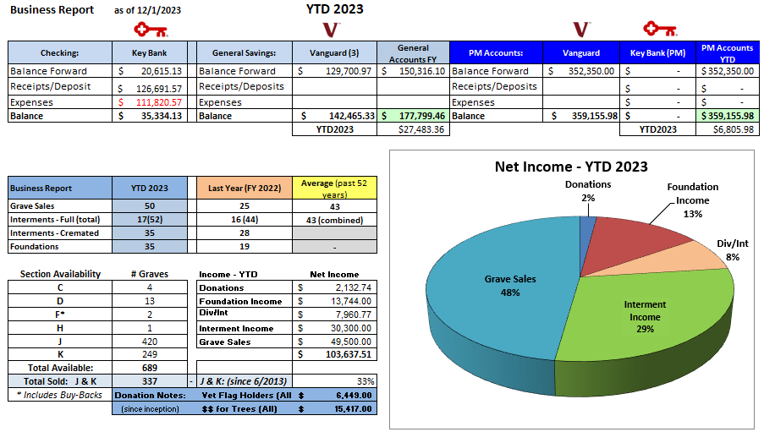
Below is a sample of the Vanguard account financial report:
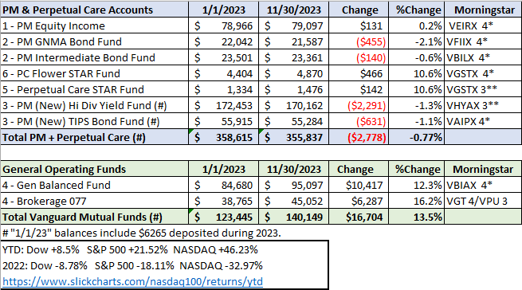

The Grave Sales Form… Treasurer details
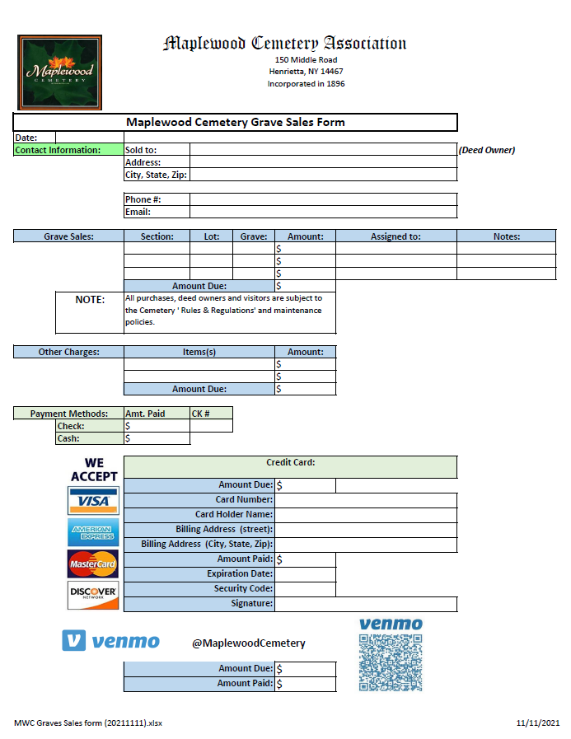
This sales form is an important part of the process. We use this to document what the customer wants or needs, and any related details.
- Date: Record the meeting date
- ‘Sold to:’ This should be the new DEED OWNER, and all the contact information available.
  - The deed owner should be the one responsible for any pending or future use. More information on the deed owner is available in the Cemetery 101 Basics training.
  - Most people have an email address that can facilitate quicker information exchange and potentially allowing an electronic payment link to be established by the treasurer.
- A Maplewood Cemetery Embossed Deed (indenture) will be mailed to the deed owner by the Secretary upon full payment and should be retained with their other legal documents. A copy of this deed will be retained electronically by the Secretary. The treasurer will inform the Secretary when the full grave payment is complete.
- GRAVE SALE: The Section, Lot and Grave(s) (SLG) must be clearly entered. Enter 1 grave per line.
- AMOUNT: Enter the price of the grave.
- ASSIGNED TO: Enter the name of the person(s) intended to use this grave.
- NOTES: Enter any important information such as to be Cremated or not. Relationship to the deed owner is also helpful.
- OTHER CHARGES: These may include the interment fees if the situation is urgent. We need to make sure that any fees being paid directly by the customer are not also being charged by a funeral home. The funeral home may also ask the customer to meet with us, make the grave selection and let us know that the funeral will provide a check for all services rendered. Communication directly with the funeral home is important to let them know what grave was purchased and if any fees were paid to us directly by the customer. The treasurer will enter all these items and charges in QBO.
- PRICING: Refer to the Rates & Charges Notes Section that follows.
  - The prices listed are the only prices we can charge. NYS does not allow discounts of any kind.
  - Prepayment: Payments for a grave must be made in full before an interment. However, we do not accept prepayments for any ‘future’ interment fees.
  - Grave Sales Deposits: A deposit of $100/grave being sold is requested to reserve a grave and place it on a monthly payment plan.
  - Monthly Payment Plan: This is a customer agreement to pay overtime. Usually a $100/month/grave payment is expected. The terms can be worked out with the Treasurer. There is no finance charge or any extra fee for the monthly payment plan. The grave balance can be paid off at any time during the plan schedule and must be fully paid off before any use of the grave. This use includes any interments, monuments, gardens, or other use of the grave area. The Treasurer will send the customer monthly invoices for the grave sale balance.
    - Please note that for any payment plan started before a rate increase, we will honor the original pricing for that grave sale. New grave sales will be charged at the current rate.
  - Grave HOLD: This is used for customers that may think they want the grave but either can’t afford it right now or must check with others first. The grave can be marked as ‘ON HOLD’ for up to 60 days. A sales form with the contact information should be filled out with ‘HOLD’ marked so we can follow up with the customer.
  - Pets: Read the ‘Rules & Regulations’ document for the details regarding pets. We do allow domestic pets, as detailed in the document, and we need the NYS approved Cremation Certificate. The pet is required to be entered in our records with the same cremation data as their owner. A fee may or may not be required for the pet but must be included on the sales form if an interment is being planned for with the grave sale. The Treasurer should enter any pet burial information.

- PAYMENT METHODS: We can accept various payment methods.
  - CHECKS are preferred. Made out to Maplewood Cemetery
  - CASH is accepted, although not preferred. Some customers prefer cash. A deposit slip will be required to deposit cash at the bank.
  - CREDIT CARDS: We do accept those cards listed on the form.
    - Record the required credit card information and get a signature on the sales form. The billing address may not be the same as the Deed Owner’s address.
    - For Pre-Need sales, if possible, ask if they want an E-Invoice. An E-Invoice eliminates the handling of any credit card information directly. The treasurer will set up the QBO E-Invoice.

The Process
Now the work really begins. The customer is hopefully content that their planning has been accomplished successfully.
The Sales form should have all the critical information to continue the process.
- Submit the sales form to the Business Office as soon as possible.
  - A legible scanned copy of the form can be securely emailed to:
    - Business@MaplewoodCemetery.org
    - Refer to the Send Secured Email in the Notes Section.
    - Protect the customer data, especially any credit card data from getting into the wrong hands.
- Make arrangements to submit or deliver any checks or cash to the Treasurer. The proper depositing and clearing of any payments must be recorded before a deed can be created or a burial can occur.
- Communication: Update Cozi with the grave sale or pending interment schedule. Urgent interment requests should also be updated by a phone call to the Superintendent. (more on Cozi in the Notes Section)
- The Secretary will record the grave sale data and prepare the Deed once the Treasurer clears the funds.
  - The sales form data must be complete and correct. A minor error can be corrected if an error is found. Other errors could create big problems.
  - The location of the grave sold or to be used for an interment will be verified before data entry. Authorization may be required from an existing deed owner if the person listed to be interred is not the deed owner or previously authorized to use the grave.
- The Treasurer will record the sales entries and any payment received in QuickBooks Online.
  - Receipts will be sent to the customer via mail or email, depending on the contact information and the customer preference.
  - The Treasurer, or webmaster, will also update the map(s) with the new sales data. The updated database and the updated map(s) will then be uploaded to the MWC Admin and Public websites.
  - Use the MWC Admin website for the latest and most accurate data and maps available.

Notes Section:
Send attachments with confidential mode with Gmail.
Tip: If you're using Gmail with a work or school account, contact your admin to make sure you can use confidential mode.
On your computer, go to Gmail. (other mailers may vary)

Click Compose.
Click Attach

Choose the files you want to upload.
In the bottom right of the window, click Turn on confidential mode.
Tip: If you've already turned-on confidential mode for an email, go to the bottom of the email, then click Edit.
Set an expiration date and passcode. These settings impact both the message text and any attachments. Usually, 1 day will work for the expiration duration.
Choose "SMS passcode," recipients will get a passcode by text message. Make sure you enter the recipient's phone number (usually the Treasurer’s #), not your own.
If you choose "No SMS passcode," recipients using the Gmail app will be able to open it directly. Recipients who don't use Gmail will get emailed a passcode.
Click Save, then Send.
COZI:
What is it? Cozi is a website and mobile app intended to help families (and MWC) stay organized. Its features include allowing multiple family members to manage schedules with one account.
How do I get the app? The app is free from your Smartphone app store (iPhone or Android). You can also access COZI.com in your web browser. MWC has purchased the Upgraded Gold version to allow everyone to have the added functionality without ads. The added functionality includes:
- Mobile Calendar - Month View, Calendar Search, Multiple Reminders, and Change Notifications.
How do I use it? We use the Calendar function of Cozi for coordinating our schedules. Once you have been given access to Cozi you can use your MWC Email address and the ‘Family’ one account password. Please keep in mind that you enter may be seen by everyone. This is not for ‘personal’ reminders.
More COZI details are included in the Sales Training Manual on the MWC Admin website, under REPORTS.
Notes Section: (continued)
What hardware, software or applications will I need?
- The hardware you can use depends mostly on your comfort level.
  - Your Smart Phone, tablet or PC running a ‘standard’ up to date OS (operating system) and web browser should work.
- Software or applications required are minimal.
  - A standard web browser with your device connected to the internet, wi-fi or 4/5G.
  - COZI is a free application for Smart Phones and accessible from your browser on the internet at COZI.com from almost any device.
    - COZI is a ‘shared’, family application. You login to COZI with your Email address and all registered users have the same password.
    - CAUTION: Please do not change the password. That would change it for all registered users, and no one would be able to log in. There is no ‘admin’ that can fix it. (The person that changed the password is the only one that can change it back.)
  - MWC Admin: most of the data, forms and maps are accessible from: https://maplewoodcemetery.org/mwcadmin/ from your web browser.
    - The MWC Admin link is not password protected. The MWC Admin Mobile Menu will appear with several options. Note: If you enter https://maplewoodcemetery.org/ instead of Mwcadmin, you will end up on the ‘Public’ Maplewood Cemetery website.
    - The REPORTS menu button takes you to many directories of reports, meeting minutes, NYS Cemetery documents and the MWC Training manuals.
    - MWC Admin is a custom web-based application that I wrote and will hopefully keep it up to date for some time.
  - MaplewoodCemetery.org (https://maplewoodcemetery.org/) is the ‘Public’ Maplewood Cemetery website created using WordPress. WordPress is a web content management system. Customers and Funeral Homes access this site on a regular basis. Listings, maps, photos, ‘Rules & Regulations’, monument photos and some of the cemetery history. They can also use the ‘Contact Us’ page to request information or even start a sale.
  - Microsoft Word or Excel are needed to edit some of the MWC documents. Adobe PDF is the format used for finalized documents for the customers.
- QuickBooks Online (QBO): This is fundamentally the finance core of the cemetery. This is also a web-based application with restricted access. The Treasurer may grant limited access to those that require access for sales tracking or audits. There is also a smartphone application that will connect to the MWC QBO data.
  - All MWC financial transactions are managed in QBO. The customer contact and sales information are entered and managed in QBO. The payments made and any balance due are recorded here and categorized as required.
  - E-Invoices are generated by the Treasurer in QBO. These E-Invoices allow an electronic invoice with a link for customers to pay via PayPal or with credit cards directly. A receipt is automatically sent to the customer and their payment is credited to their QBO account bill. We also pay a lower % charge for the E-Invoice usage than us manually entering the credit card information.

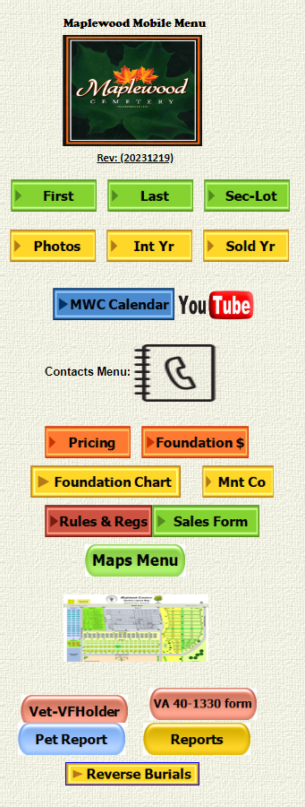
Notes Section: (continued)
This is the main page at:
https://maplewoodcemetery.org/mwcadmin/
- Clicking on the logo will take you to the PUBLIC MaplewoodCemetery.org website.

- Clicking on any of these buttons will allow you to enter search parameters.
- Except, the Photos button will now take you to the PUBLIC MaplewoodCemetery.org website, MONUMENT tab.
- The MWC Calendar button will take you to COZI.com.
- The YouTube button will take to the MWC Expansion video.
- The Contacts Menu will bring up a menu to select from contact groups, such as Funeral Homes.

- The Foundation $ button will let you calculate the customer and MWC costs of a foundation.
- A Foundation Chart and a search for Monument Companies.
- Rules & Regs will send you back to the PUBLIC site where you can select to DOWNLOAD a pdf or open the READER and glance through the document.
- A SALES FORM can be downloaded when the Sales Form button is selected.
- The Maps Menu and the REPORTS menu will be explained separately.
- Clicking on the map picture will bring up a larger MWC map.
- The Vet-VFHolder button will allow us to search for listed Veterans that either have an MWC flag holder, or not.
- This VA 40-1330 form button allows you to display or download the VA form needed for VA plaques and monuments.
- The Pet Report and the Reverse Burials buttons will list the requested records in our database.

Notes Section: (continued)
Access this menu by clicking on the Maps Menu button on the MAIN MWC Admin page.
- Query Maps are generated in MS Excel using more data from the database query.
- These maps are helpful for quickly identifying if there is a monument at the grave or if anyone is buried there.
- These maps are intended for MWC personnel and not necessarily our customers. These maps might confuse the sales issues.

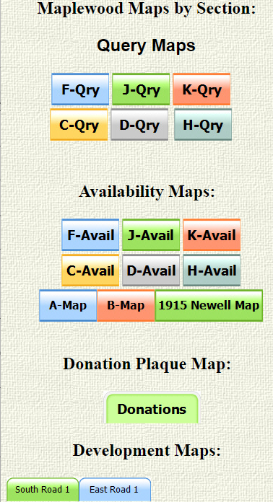
- Availability Maps are also generated in MS Excel with the primary intent of showing which graves are still available for sale and which are already sold.
- A-Map and B-Map are for general reference.
- The 1915 Newell Map was our 1st known map. Things have changed since then…..

- Donations: This is a map of where the donation plaques are placed each spring. They are stored for winter.

- Development Maps are my planning thoughts for review. Nothing ‘Official’, yet.
Note: The maps can be printed from this menu. You may have to use the ‘Print as PDF’ and scale the map to fit on the paper.

Notes Section: (continued)
MWC Admin Main page:
https://maplewoodcemetery.org/mwcadmin/

Reports button
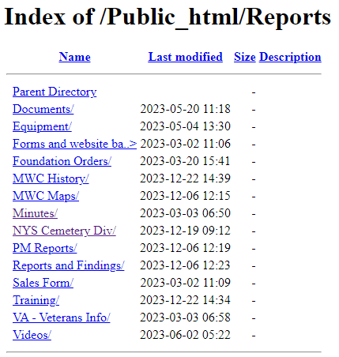

This is what you should see when you click on the REPORTS button on the MWC Admin Main page.
- Each line you click on will take you into the corresponding directory.
- Clicking on ‘Training’ will open the directory that contains this training manual.
- Clicking on ‘Parent Directory' will take you back up 1 level to this Reports directory.
Please note that these directories and their contents will change over time and the contents will be updated or removed as needed.

Notes Section: (continued)
Rates & Charges: Maplewood Cemetery Association
Rates and Charges (Customer version)
2023 Update

Notes:
- (1) The Rates and Charges include the 2001 NY State mandatory charge of $35.00 to our Permanent Maintenance account for interments and a $5 vandalism fee.
- (2) Cremated pets that require a separate grave opening.
- (3) The Special Grave Maintenance Fee will be charged for exceptions to the concrete vault or concrete liner requirements.
- (4) Winter Access: An additional charge may be made for snow removal or penetration of frost based on the additional costs to the cemetery pursuant to Section 1509 (d) of the not-for-profit corporation law.
- (5) Disinterment: The removal of a buried vault or urn from the ground.
- (6) Foundation price updated 7/1/2022
- (7) Visa, MasterCard, and Discover Card are now accepted for payment in addition to checks and cash. Venmo has now been added!

Please make checks out to:
Maplewood Cemetery Association

Lot Sales:
Full size (per grave) | $1,200
Cremation-only (Section J) | $600
Interments: (1)
Adult and Child (casket/vault) | $800
Infants (up to 4 ft.  length - casket/vault) | $600
Cremated Remains -  Human (urn) | $600
Cremated Remains –  Pet (urn) (2) | $600
Additional Fees:
Special Grave  Maintenance fee (3) | $200
Weekend & Holiday  Interments Fee | $500
Winter Fee (4)  (Dec.1-April 1) | $50
Disinterment Fee (5) | $1,500
Monument Foundations:
Per square inch (6) | $1.50
Minimum Charge | $432
Duplicate Deed: | $10

There is another version (MWC ONLY) of the Rates and Charges that shows both the ‘Customer’ rates and the internal cost paid to a contractor (usually GVCS)

Notes Section: (continued)
Rates & Charges:
- Grave Sales: The current rates are:
  - FULL-SIZE Grave: $1,200. This rate applies to every available grave in the cemetery except for the Cremation-Only portion of Section J, Rows 18 – 23.
  - Cremation-Only portion of Section J, Rows 18 – 23, $600
    - Note: These are ½ the size (length = 5’) of the FULL-SIZE Graves.
    - The grave numbering adds a .1 or .2 to the grave number.
      - Any row in this area will have a designation of Section J, Row XX (18 – 23), Grave YY.1 or YY.2
      - Refer to the Section J map for details.
      - Only 1 cremation urn can be interred in a grave in this area.
      - Only a 24”x12” FLAT, ground-flush, monument can be installed here.
      - These monuments will still require a full-depth foundation.
  - MWC has a not-for-profit status and is tax exempt. No taxes are due on any grave sale.
  - There are no annual or maintenance charges on a grave sale.
  - An MWC Deed will be issued for every completed grave sale.
  - Occasionally a grave is available in one of the older sections. The rules and rates are the same FULL-SIZE Grave rates as in the new sections.
  - MWC has decided not to actively sell any graves more in Section A. This is the oldest section.

Many of our customers ask about the ‘other costs’ when they are purchasing a grave. Here are a few notes that may help answer their questions.
- Funerals: A few notes to help clarify the Interments section of the Rates & Charges.
  - We prefer at least 3 days’ notice to schedule a burial.
  - All adult - full (casket/vault) interments are $800.
    - Winter Access Fee, December 1 – April 1, add $50.
      - This is a fee we are charged by GVCS during this winter period.
    - Special Grave Maintenance fee: This is an exception to the concrete vault requirement, for personal or religious reasons. Add $200.
  - Weekend & Holiday Fee: Add $500 for any weekend or holiday schedule.
- Example: If we scheduled a full interment on January 1 and the request was for no vault, the charge would be: $800 + $50 + $200 + $500 = $1,550.
  - Cremations: MWC will usually stop cremation interments from December 1 – April 1. We cannot plan on being able to open a cremation grave in the winter. Cremation funerals should wait until the warmer weather.
  - Note: When a grave is sold for the planned interment of a full casket and a cremation urn, the casket must be interred first. If the person planning to be cremated passes 1st, the urn must wait until the casket burial has been buried.
  - Note: Sometimes when a casket and a cremation urn are scheduled to be interred at the same time, the urn may be placed inside the casket by the funeral home.
    - In those cases, we still must charge for a full casket and a cremation burial.
    - NYS requires full payment and proper certificates for each person, and-or pet, being interred.

- Monument Foundations: Concrete foundations are required for every monument to provide the proper stability of the monument.
  - Foundations are ordered by the monument company and the cost of the foundation is included in the customer’s monument invoice charges.
  - Monuments can be ordered after the grave is fully paid for.
  - Foundations are installed between May 1st and October 15th.
    - Customers can still work with a monument company during this period. The ‘winter’ foundation orders will be queued up until foundations can start being installed.
  - The MWC Rates & Charges current lists the foundation charge as $1.50/sq in. The Foundation $ calculator is available on the MWC Admin website. A mowing collar space is added to the requested monument foundation size.
    - Example: A 12” x 24” monument would add a 2” x 2” mowing collar (1” collar on each side) with the size now calculated as 14” x 26” = $546 (customer’s price)

Traditions and things:
- Reverse Burials. You may be wondering why there is a button to search for this on the MWC Admin menu. A tradition, not a requirement, has been when a married couple buys 2 graves, side by side, the husband is assigned to the Left-hand grave and the wife is assigned to the right-hand grave. The viewpoint is from the foot-end of the grave facing the monument-end.
  - When a couple does not want this ‘traditional’ positioning of grave assignments we call it a REVERSE BURIAL. We track this to make sure that the customers’ wishes are followed so that the correct grave is opened when the first of the couple passes. Families do this for a reason and don’t appreciate it if we make assumptions and mess it up.
  - The same care is required when their monument is ordered. A shared monument spanning the 2 graves needs to have the names and grave positions correct.
- It’s a J & K Thing. The entire layout and survey marking of the J & K Sections is different than any other Section.
  - The ODD numbered rows will have the monument facing the west, Middle Road.
  - The EVEN numbered rows will have the monument facing the east, Red Creek.
  - Many families have discussions and preferences about ‘facing’ the rising sun in the east or the setting sun in the west. Please mention this when talking with the customers.
  - Occasionally a funeral director may need assistance with which end the head of the casket is supposed to go at. It is always the ‘monument’ end of the grave.
  - The J & K things don’t end there. The ODD or EVEN row numbers not only impact where the monument goes, but where a garden can be planted. ODD numbered rows can have a garden area in front of the WEST facing monument. The EVEN numbered rows can have a garden area in front of the EAST facing monument. Everywhere else in the cemetery we try to ensure that the garden areas are only on the EAST side. Not always true in Sections J & K.
  - Section J is unique in MWC in that it is the only section to have a CREMATION-ONLY area. Rows 18 to 23 of Section J have ½ length graves, require flat ground-flush monuments, and can NOT have any gardens.
- The History of the Cemetery is interesting. Many may not know how rich the history is. The ‘RICH IN HISTORY’ tab of the PUBLIC website lists many names of familiar places, schools, and roads that were named after people in Maplewood Cemetery.
  - This history brings in church groups, school classes, veteran groups, and other connected and curious people.
  - Many of our listings have been posted on the ‘FIND A GRAVE’ website for genealogists. We will get email and phone requests for some of this information.
  - If you look around the MWC Admin REPORT directories, you will find documents containing the MWC meetings starting in 1896.
  - A copy of the MWC Certificate of Incorporation from 1896 is also included there.
  - Some of the original Henrietta families are still in the area and visit the graves of the Town’s founders.
  - This is a history that we can be proud to share and will hopefully build upon in the future.

Other Reference materials: All are on the MWC Admin website.

Reports/NYS Cemetery Div
- cemeteries-101-basics
- cemeteries-101-accounting-basics
- Not-For-Profit-Corporation-Law-Article-15-Public-Cemetery-Corporations
- NYS public cemetery regulations
- NYS treasurers-manual-final-100611

Reports/Training
- MWC Treasurer QBO Training
- MWC Treasurer Training (this document)
- MWC Sales Training
- MWC Business Reports
- MWC PM Reports
- MWC Graves SOLD Reports
- MWC Section Maps Training

