Introduction
Welcome to Sales Training!
Our sales process is intended to be easy and helpful for the customer to understand and complete.
- Our internal process must be followed and completed to make sure that everything gets recorded properly.
- Most customers have never been through this situation. You are guiding them, and they count on that. Many of our customers will have many questions about the whole situation they are now in. I have included other topics that may help answer some of those questions.
- Many of our sales appointments are done at a time of need and are requested to be completed in a timely manner.
- It is very important to get the process and the information correct the 1st time.
- Communicating the outcome to the right people promptly will be important.
- Remember, Grave Sales represent a large portion of our income every year.
- The MWC public website https://maplewoodcemetery.org/ has a lot of information about Maplewood Cemetery. Do not be worried about referring a customer to the website. The maps, listings, Frequently Asked Questions (FAQs), our Rules & Regulations, and more are there.
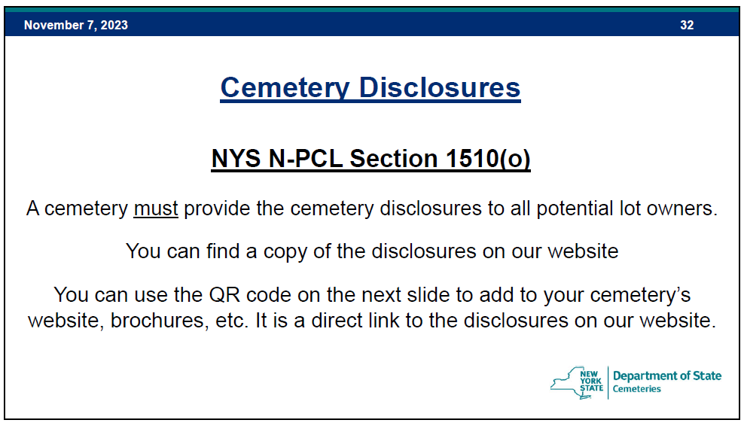

- There are also some interesting traditions and things about the cemetery that are listed in the Notes Section.
  - This document is created and maintained by NYS. The link is in this QR code.

  - Copies of this document are in the shed brochure holder.

In the beginning…
- Most grave sales are phone calls from a funeral home or from a family member. The website will also be used to contact us with requests for a sales follow-up or other requests via an email message.
- The phone call may come in on our Accessline, MWC voicemail line (585.672-1020). This phone number is used mainly for new potential customers. Funeral homes and ‘repeat’ customers should know the salesperson’s direct phone number or the MWC Business Office phone number (585.473.2609)
- The Accessline call notification can be sent out to a few select MWC salespeople and coordination of managing each call is important. A website email request will be sent out to a salesperson for follow up.
- Preparation is key! Make sure that you have all the information about the customer, the situation, time expectations and any other important details.
  - Customer Name and phone number, for the appointment.
  - What is the situation? Urgent need, pre-need? Intended for who? Will this need be for 1 full interment and/or 1 or more cremains?
  - If urgent, when? Is a funeral home managing the details?
  - Will this situation require a new grave or are they planning on using an existing grave?
  - Set up the appointment at the cemetery if an onsite meeting is required. Occasionally, the customer already knows what they want to purchase or arrange for.
  - Part of the preparation is making sure that you have the sales form and the appropriate section map(s) to show availability and location.
  - The COZI application has been used as a good way to communicate with our other cemetery personnel. This application can notify others of:
    - Scheduled Grave Sale
    - Updates on a Grave Sold
    - Notification of pending requests for a funeral and any details about the situation.
    - Other notifications can be sent out as reminders, as needed.
- Use your MWC Email address when communicating with others. This identifies you as a member of MWC and may also be more identifiable (non-spam) by others. Your MWC Email will be set up to automatically forward your MWC email to your personal email address.
Sales Form Basics
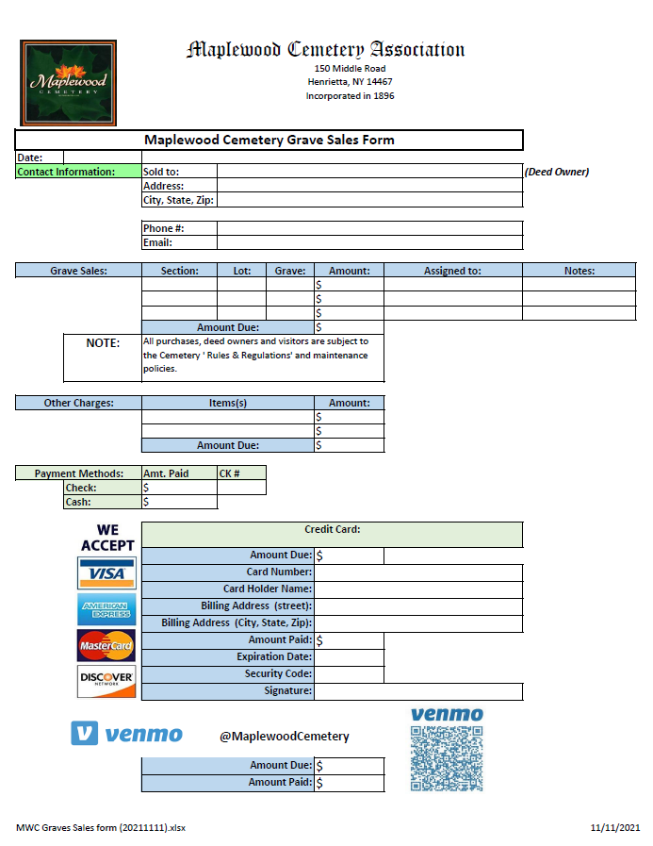
This sales form is an important part of the process. We use this to document what the customer wants or needs, and any related details.
- Date: Record the meeting date
- ‘Sold to:’ This should be the new DEED OWNER, and all the contact information available.
  - The deed owner should be the one responsible for any pending or future use. More information on the deed owner is available in the Cemetery 101 Basics training.
  - Most people have an email address that can facilitate quicker information exchange and potentially allowing an electronic-payment link to be established.
- A Maplewood Cemetery Embossed Deed (indenture) will be mailed to the deed owner upon full payment and should be retained with their other legal documents. A copy of this deed will be retained electronically by the secretary,
- GRAVE SALE: The Section, Lot and Grave(s) must be clearly entered. Enter 1 grave per line.
- AMOUNT: Enter the price of the grave.
- ASSIGNED TO: Enter the name of the person(s) intended to use this grave.
- NOTES: Enter any important information such as to be Cremated or not. Relationship to the deed owner is also helpful.
- OTHER CHARGES: These may include the interment fees if the situation is urgent. We need to make sure that any fees being paid directly by the customer are not also being charged by a funeral home. The funeral home may also ask the customer to meet with us, make the grave selection and let us know that the funeral will provide a check for all services rendered. Communication directly with the funeral home is important to let them know what grave was purchased and if any fees were paid to us directly by the customer.
- PRICING: Refer to the Rates & Charges Notes Section that follows.
  - The prices listed are the only prices we can charge. NYS does not allow discounts of any kind.
  - Prepayment: Payments for a grave must be made in full before an interment. However, we do not accept prepayments for any ‘future’ interment fees.
  - Grave Sales Deposits: A deposit of $100/grave being sold is requested to reserve a grave and place it on a monthly payment plan.
  - Monthly Payment Plan: This is a customer agreement to pay overtime. Usually a $100/month/grave payment is expected. The terms can be worked out with the Treasurer. There is no finance charge or any extra fee for the monthly payment plan. The grave balance can be paid off at any time during the plan schedule and must be fully paid off before any use of the grave. This use includes any interments, monuments, gardens, or other use of the grave area.
    - Please note that for any payment plan started before a rate increase, we will honor the original pricing for that grave sale. New grave sales will be charged at the current rate.
  - Grave HOLD: This is used for customers that may think they want the grave but either can’t afford it right now or must check with others first. The grave can be marked as ‘ON HOLD’ for up to 60 days. A sales form with the contact information should be filled out with ‘HOLD’ marked so we can follow up with the customer.
  - Pets: Read the ‘Rules & Regulations’ document for the details regarding pets. We do allow domestic pets, as detailed in the document, and we need the NYS approved Cremation Certificate. The pet is required to be entered in our records with the same cremation data as their owner. A fee may or may not be required for the pet but must be included on the sales form if an interment is being planned for with the grave sale.

- PAYMENT METHODS: We can accept various payment methods.
  - CHECKS are preferred. Made out to Maplewood Cemetery
  - CASH is accepted, although not preferred. Some customers prefer cash.
  - CREDIT CARDS: We do accept those cards listed on the form.
    - Record the required credit card information and get a signature on the sales form. The billing address may not be the same as the Deed Owner’s address.
    - For Pre-Need sales, if possible, ask if they want an E-Invoice. An E-Invoice eliminates the handling of any credit card information directly.

The Process
Now the work really begins. The customer is hopefully content that their planning has been accomplished successfully.
The Sales form should have all the critical information to continue the process.
- Submit the sales form to the Business Office as soon as possible.
  - A legible scanned copy of the form can be securely emailed to:
    - Business@MaplewoodCemetery.org
    - Refer to the Send Secured Email in the Notes Section.
    - Protect the customer data, especially any credit card data from getting into the wrong hands.
- Make arrangements to submit or deliver any checks or cash to the treasurer. The proper depositing and clearing of any payments must be recorded before a deed can be created or a burial can occur.
- Communication: Update Cozi with the grave sale or pending interment schedule. Urgent interment requests should also be updated by a phone call to the Superintendent. (more on Cozi in the Notes Section)
- The Secretary will record the grave sale data and prepare the Deed once the Treasurer clears the funds.
  - The sales form data must be complete and correct. A minor error can be corrected if an error is found. Other errors could create big problems.
  - The location of the grave sold or to be used for an interment will be verified before data entry. Authorization may be required from an existing deed owner if the person listed to be interred is not the deed owner or previously authorized to use the grave.
- The Treasurer will record the sales entries and any payment received in QuickBooks Online.
  - Receipts will be sent to the customer via mail or email, depending on the contact information and the customer preference.
  - The Treasurer, or webmaster, will also update the map(s) with the new sales data. The updated database and the updated map(s) will then be uploaded to the MWC Admin and Public websites.
  - Use the MWC Admin website for the latest and most accurate data and maps available.

Notes Section:
Send attachments with confidential mode with Gmail.
Tip: If you're using Gmail with a work or school account, contact your admin to make sure you can use confidential mode.
On your computer, go to Gmail. (other mailers may vary)

Click Compose.
Click Attach

Choose the files you want to upload.
In the bottom right of the window, click Turn on confidential mode.
Tip: If you've already turned-on confidential mode for an email, go to the bottom of the email, then click Edit.
Set an expiration date and passcode. These settings impact both the message text and any attachments. Usually, 1 day will work for the expiration duration.
Choose "SMS passcode," recipients will get a passcode by text message. Make sure you enter the recipient's phone number (usually the Treasurer’s #), not your own.
If you choose "No SMS passcode," recipients using the Gmail app will be able to open it directly. Recipients who don't use Gmail will get emailed a passcode.
Click Save, then Send.

COZI:
What is it? Cozi is a website and mobile app intended to help families (and MWC) stay organized. Its features include allowing multiple family members to manage schedules with one account.
How do I get the app? The app is free from your Smartphone app store (iPhone or Android). You can also access COZI.com in your web browser. MWC has purchased the Upgraded Gold version to allow everyone to have the added functionality without ads. The added functionality includes:
- Mobile Calendar - Month View, Calendar Search, Multiple Reminders, and Change Notifications.
How do I use it? We use the Calendar function of Cozi for coordinating our schedules. Once you have been given access to Cozi you can use your MWC Email address and the ‘Family’ one account password. Please keep in mind that you enter may be seen by everyone. This is not for ‘personal’ reminders.
Login to Cozi. Click on ‘View Calendar’, then you will be taken to the current date. Viewing in the ‘AGENDA’ view mode is usually more helpful when entering or editing an event.
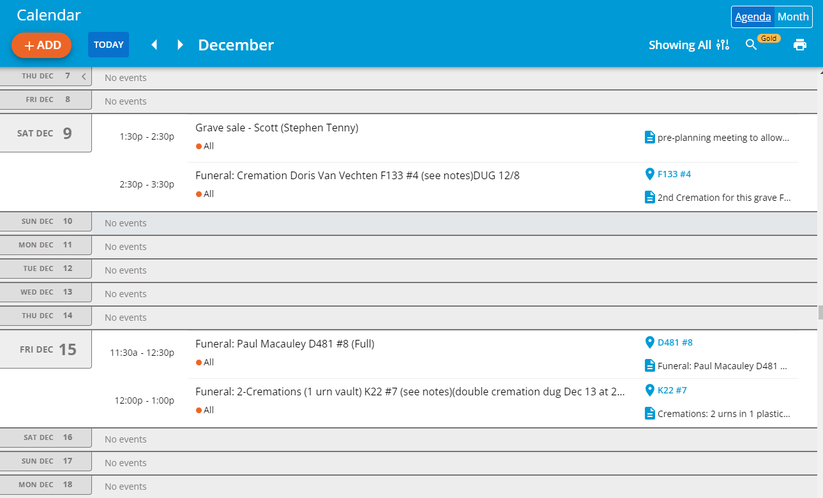
To ADD an event, such as a Grave Sale appointment or a Funeral, click on the DATE.
A new event can be added to a date with existing events by clicking on the DATE.
To EDIT an existing event, click on that event.
Refer to the Event description below:
The form will look the same whether you are ADDING a new event or EDITING an existing event.
Editing, with actual data, is shown below with descriptions.

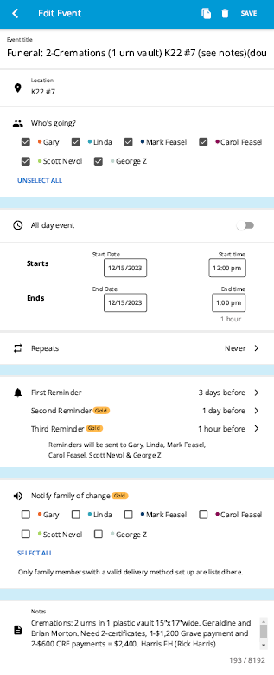
- Click on SAVE when you have completed the edit.
- Event Name, edit as needed.
- Location info is helpful.

- Make sure that everyone is selected, even if they do not plan to attend. Those not selected here may not see all the updates and reminders. (These are ALL selected by default)

- Frequently we get notified of a time change. Be careful to select AM or PM appropriately.

- This is a ‘GOLD’ function that allows for 3 reminders. The reminders shown are the times we have seen as effective. The 1st real notification will be when this event is saved when the edit is complete.

- Same as before, make sure that everyone is selected, even if they do not plan to attend. Those not selected here may not see all the updates and reminders. (These are NOT selected by default)

- Edit any additional notes here. This area can be very helpful information. When the edit is completed, click on SAVE at the top of this tab.
Notes Section: (continued)
What hardware, software or applications will I need?
- The hardware you can use depends mostly on your comfort level.
  - Your Smart Phone, tablet or PC running a ‘standard’ up to date OS (operating system) and web browser should work.
- Software or applications required are minimal.
  - A standard web browser with your device connected to the internet, wi-fi or 4/5G.
  - COZI is a free application for Smart Phones and accessible from your browser on the internet at COZI.com from almost any device.
    - COZI is a ‘shared’, family application. You login to COZI with your Email address and all registered users have the same password.
    - CAUTION: Please do not change the password. That would change it for all registered users, and no one would be able to log in. There is no ‘admin’ that can fix it. (The person that changed the password is the only one that can change it back.)
  - MWC Admin: most of the data, forms and maps are accessible from: https://maplewoodcemetery.org/mwcadmin/ from your web browser.
    - The MWC Admin link is not password protected. The MWC Admin Mobile Menu will appear with several options. Note: If you enter https://maplewoodcemetery.org/ instead of Mwcadmin, you will end up on the ‘Public’ Maplewood Cemetery website.
    - The REPORTS menu button takes you to many directories of reports, meeting minutes, NYS Cemetery documents and the MWC Training manuals.
    - MWC Admin is a custom web-based application that I wrote and will hopefully keep it up to date for some time.
  - MaplewoodCemetery.org (https://maplewoodcemetery.org/) is the ‘Public’ Maplewood Cemetery website created using WordPress. WordPress is a web content management system. Customers and Funeral Homes access this site on a regular basis. Listings, maps, photos, ‘Rules & Regulations’, monument photos and some of the cemetery history. They can also use the ‘Contact Us’ page to request information or even start a sale.
  - Microsoft Word or Excel are needed to edit some of the MWC documents. Adobe PDF is the format used for finalized documents for the customers.
- QuickBooks Online (QBO): This is fundamentally the finance core of the cemetery. This is also a web-based application with restricted access. The Treasurer may grant limited access to those that require access for sales tracking or audits.
  - All MWC financial transactions are managed in QBO. The customer contact and sales information are entered and managed in QBO. The payments made and any balance due are recorded here and categorized as required.
  - E-Invoices are generated by the Treasurer in QBO. These E-Invoices allow an electronic invoice with a link for customers to pay via PayPal or with credit cards directly. A receipt is automatically sent to the customer and their payment is credited to their QBO account bill. We also pay a lower % charge for the E-Invoice usage than us manually entering the credit card information.
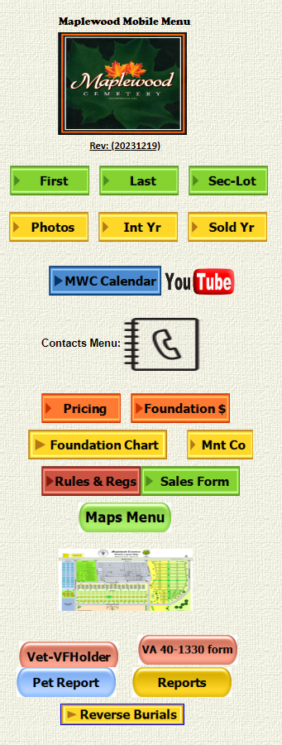
Notes Section: (continued)
This is the main page at:
https://maplewoodcemetery.org/mwcadmin/
- Clicking on the logo will take you to the PUBLIC MaplewoodCemetery.org website.

- Clicking on any of these buttons will allow you to enter search parameters.
- Except, the Photos button will now take you to the PUBLIC MaplewoodCemetery.org website, MONUMENT tab.
- The MWC Calendar button will take you to COZI.com.
- The YouTube button will take to the MWC Expansion video.
- The Contacts Menu will bring up a menu to select from contact groups, such as Funeral Homes.

- The Foundation $ button will let you calculate the customer and MWC costs of a foundation.
- A Foundation Chart and a search for Monument Companies.
- Rules & Regs will send you back to the PUBLIC site where you can select to DOWNLOAD a pdf or open the READER and glance through the document.
- A SALES FORM can be downloaded when the Sales Form button is selected.
- The Maps Menu and the REPORTS menu will be explained separately.
- Clicking on the map picture will bring up a larger MWC map.
- The Vet-VFHolder button will allow us to search for listed Veterans that either have an MWC flag holder, or not.
- This VA 40-1330 form button allows you to display or download the VA form needed for VA plaques and monuments.
- The Pet Report and the Reverse Burials buttons will list the requested records in our database.
- Notes Section: (continued)
Access this menu by clicking on the Maps Menu button on the MAIN MWC Admin page.
- Query Maps are generated in MS Excel using more data from the database query.
- These maps are helpful for quickly identifying if there is a monument at the grave or if anyone is buried there.
- These maps are intended for MWC personnel and not necessarily our customers. These maps might confuse the sales issues.

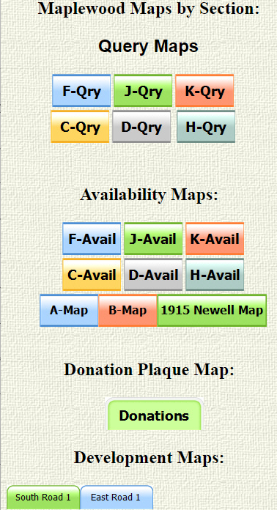
- Availability Maps are also generated in MS Excel with the primary intent of showing which graves are still available for sale and which are already sold.
- A-Map and B-Map are for general reference.
- The 1915 Newell Map was our 1st known map. Things have changed since then…..
- Donations: This is a map of where the donation plaques are placed each spring. They are stored for winter.

- Development Maps are my planning thoughts for review. Nothing ‘Official’, yet.
Note: The maps can be printed from this menu. You may have to use the ‘Print as PDF’ and scale the map to fit on the paper.

- Notes Section: (continued)
- MWC Admin Main page:
- https://maplewoodcemetery.org/mwcadmin/

Reports button
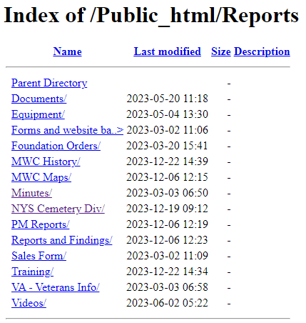

This is what you should see when you click on the REPORTS button on the MWC Admin Main page.
- Each line you click on will take you into the corresponding directory.
- Clicking on ‘Training’ will open the directory that contains this training manual.
- Clicking on ‘Parent Directory' will take you back up 1 level to this Reports directory.
Please note that these directories and their contents will change over time and the contents will be updated or removed as needed.

Notes Section: (continued)
Rates & Charges: Maplewood Cemetery Association
Rates and Charges (Customer version)
2024

Notes:
- (1) The Rates and Charges include the 2001 NY State mandatory charge of $35.00 to our Permanent Maintenance account for interments and a $5 vandalism fee.
- (2) Cremated pets that require a separate grave opening.
- (3) The Special Grave Maintenance Fee will be charged for exceptions to the concrete vault or concrete liner requirements.
- (4) Winter Access: An additional charge may be made for snow removal or penetration of frost based on the additional costs to the cemetery pursuant to Section 1509 (d) of the not-for-profit corporation law.
- (5) Disinterment: The removal of a buried vault or urn from the ground.
- (6) Foundation price updated 7/1/2022
- (7) Visa, MasterCard, and Discover Card are now accepted for payment in addition to checks and cash. Venmo has now been added!

Please make checks out to:
Maplewood Cemetery Association

Lot Sales:
Full size (per grave) | $1,200
Cremation-only (Section J) | $600
Interments: (1)
Adult and Child (casket/vault) | $800
Infants (up to 4 ft.  length - casket/vault) | $600
Cremated Remains -  Human (urn) | $600
Cremated Remains –  Pet (urn) (2) | $600
Additional Fees:
Special Grave  Maintenance fee (3) | $200
Weekend & Holiday  Interments Fee | $500
Winter Fee (4)  (Dec.1-April 1) | $50
Disinterment Fee (5) | $1,500
Monument Foundations:
Per square inch (6) | $1.50
Minimum Charge | $432
Duplicate Deed: | $10

Notes Section: (continued)
Rates & Charges:
- Grave Sales: The current rates are:
  - FULL-SIZE Grave: $1,200. This rate applies to every available grave in the cemetery except for the Cremation-Only portion of Section J, Rows 18 – 23.
  - Cremation-Only portion of Section J, Rows 18 – 23, $600
    - Note: These are ½ the size (length = 5’) of the FULL-SIZE Graves.
    - The grave numbering adds a .1 or .2 to the grave number.
      - Any row in this area will have a designation of Section J, Row XX (18 – 23), Grave YY.1 or YY.2
      - Refer to the Section J map for details.
      - Only 1 cremation urn can be interred in a grave in this area.
      - Only a 24”x12” FLAT, ground-flush, monument can be installed here.
      - These monuments will still require a full-depth foundation.
  - MWC has a not-for-profit status and is tax exempt. No taxes are due on any grave sale.
  - There are no annual or maintenance charges on a grave sale.
  - An MWC Deed will be issued for every completed grave sale.
  - Occasionally a grave is available in one of the older sections. The rules and rates are the same FULL-SIZE Grave rates as in the new sections.
  - MWC has decided not to actively sell any graves more in Section A. This is the oldest section.

Many of our customers ask about the ‘other costs’ when they are purchasing a grave. Here are a few notes that may help answer their questions.
- Funerals: A few notes to help clarify the Interments section of the Rates & Charges.
  - We prefer at least 3 days’ notice to schedule a burial.
  - All adult - full (casket/vault) interments are $800.
    - Winter Access Fee, December 1 – April 1, add $50.
      - This is a fee we are charged by GVCS during this winter period.
    - Special Grave Maintenance fee: This is an exception to the concrete vault requirement, for personal or religious reasons. Add $200.
  - Weekend & Holiday Fee: Add $500 for any weekend or holiday schedule.
- Example: If we scheduled a full interment on January 1 and the request was for no vault, the charge would be: $800 + $50 + $200 + $500 = $1,550.
  - Cremations: MWC will usually stop cremation interments from December 1 – April 1. We cannot plan on being able to open a cremation grave in the winter. Cremation funerals should wait until the warmer weather.
  - Note: When a grave is sold for the planned interment of a full casket and a cremation urn, the casket must be interred first. If the person planning to be cremated passes 1st, the urn must wait until the casket burial has been buried.
  - Note: Sometimes when a casket and a cremation urn are scheduled to be interred at the same time, the urn may be placed inside the casket by the funeral home.
    - In those cases, we still must charge for a full casket and a cremation burial.
    - NYS requires full payment and proper certificates for each person, and-or pet, being interred.

- Monument Foundations: Concrete foundations are required for every monument to provide the proper stability of the monument.
  - Foundations are ordered by the monument company and the cost of the foundation is included in the customer’s monument invoice charges.
  - Monuments can be ordered after the grave is fully paid for.
  - Foundations are installed between May 1st and October 15th.
    - Customers can still work with a monument company during this period. The ‘winter’ foundation orders will be queued up until foundations can start being installed.
  - The MWC Rates & Charges current lists the foundation charge as $1.50/sq in. The Foundation $ calculator is available on the MWC Admin website. A mowing collar space is added to the requested monument foundation size.
    - Example: A 12” x 24” monument would add a 2” x 2” mowing collar (1” collar on each side) with the size now calculated as 14” x 26” = $546 (customer’s price)

Traditions and things:
- Reverse Burials. You may be wondering why there is a button to search for this on the MWC Admin menu. A tradition, not a requirement, has been when a married couple buys 2 graves, side by side, the husband is assigned to the Left-hand grave and the wife is assigned to the right-hand grave. The viewpoint is from the foot-end of the grave facing the monument-end.
  - When a couple does not want this ‘traditional’ positioning of grave assignments we call it a REVERSE BURIAL. We track this to make sure that the customers’ wishes are followed so that the correct grave is opened when the first of the couple passes. Families do this for a reason and don’t appreciate it if we make assumptions and mess it up.
  - The same care is required when their monument is ordered. A shared monument spanning the 2 graves needs to have the names and grave positions correct.
- It’s a J & K Thing. The entire layout and survey marking of the J & K Sections is different than any other Section.
  - The ODD numbered rows will have the monument facing the west, Middle Road.
  - The EVEN numbered rows will have the monument facing the east, Red Creek.
  - Many families have discussions and preferences about ‘facing’ the rising sun in the east or the setting sun in the west. Please mention this when talking with the customers.
  - Occasionally a funeral director may need assistance with which end the head of the casket is supposed to go at. It is always the ‘monument’ end of the grave.
  - The J & K things don’t end there. The ODD or EVEN row numbers not only impact where the monument goes, but where a garden can be planted. ODD numbered rows can have a garden area in front of the WEST facing monument. The EVEN numbered rows can have a garden area in front of the EAST facing monument. Everywhere else in the cemetery we try to ensure that the garden areas are only on the EAST side. Not always true in Sections J & K.
  - Section J is unique in MWC in that it is the only section to have a CREMATION-ONLY area. Rows 18 to 23 of Section J have ½ length graves, require flat ground-flush monuments, and can NOT have any gardens.
- The History of the Cemetery is interesting. Many may not know how rich the history is. The ‘RICH IN HISTORY’ tab of the PUBLIC website lists many names of familiar places, schools, and roads that were named after people in Maplewood Cemetery.
  - This history brings in church groups, school classes, veteran groups, and other connected and curious people.
  - Many of our listings have been posted on the ‘FIND A GRAVE’ website for genealogists. We will get email and phone requests for some of this information.
  - If you look around the MWC Admin REPORT directories, you will find documents containing the MWC meetings starting in 1896.
  - A copy of the MWC Certificate of Incorporation from 1896 is also included there.
  - Some of the original Henrietta families are still in the area and visit the graves of the Town’s founders.
  - This is a history that we can be proud to share and will hopefully build upon in the future.

Other Reference materials: All are on the MWC Admin website.

Reports/NYS Cemetery Div
- cemeteries-101-basics
- cemeteries-101-accounting-basics
- Not-For-Profit-Corporation-Law-Article-15-Public-Cemetery-Corporations
- NYS public cemetery regulations
- NYS treasurers-manual-final-100611

Reports/Training
- MWC Treasurer QBO Training
- MWC Treasurer Training
- MWC Sales Training (this document)
- MWC Business Reports
- MWC PM Reports
- MWC Graves SOLD Reports
- MWC Section Maps Training
- MWC Documents and Forms

