Introduction
Welcome to Foundation Sales Training!
Our sales process is intended to be easy and helpful for the customer to understand and complete.
- Our internal process must be followed and completed to make sure that everything gets recorded properly. Please read the Rules & Regulations to become familiar with what is required and allowed to avoid issues with the foundation orders. All foundations must be installed by our contractor. All monuments must be ordered and installed by our approved vendors. We do not have the facilities to receive and install monuments on our own. Monuments ordered ‘online’ by our customers are not recommended.
- It is very important to get the process and the information correct the 1st time.

We have a few different types of foundations to deal with:
- Single grave: Maximum monument size for a single grave is: 36” wide x 16” deep.
  - Deep meaning front-to-back size.
  - Double grave: Maximum monument size for a double or larger grave is: 60” wide x 16” deep.
  - ‘Cremation Grave’ Area of Section J are restricted to 24”x12” flush only (ground level)
    - These are all ½ the standard grave length, 5’, and have a .1 or .2 suffix to define the grave number.
  - Bench style monuments: The bench measurements are based on the largest dimensions, usually the seat area, not necessarily the ‘base’ or bench leg size. A mowing collar is required in addition to the largest dimension to protect the bench and allow for mowing and trimming.
  - Columbarium style monuments: This style has become popular for cremations that will be interred above the ground. The 2 niche styles will typically fit on a single grave. The 4 niche styles may require a double grave. A mowing collar is required.
  - Footer foundations: They are used when a monument is already installed at the ‘head-end’ of a grave and an additional monument is requested for that grave. The Footer will be marked at the ‘Foot-End’ of the grave. These are restricted to 24”x12” flush only (ground level).

  - Veteran Bronze plaques: These 24x12 bronze plaques can be:
    - Mounted to an existing upright monument, usually on the back.
    - Installed as the primary monument at the head-end of the grave.
    - Or installed as a flush-footer.
    - Note: Our contractor will usually install a border around the bronze plaque to protect it and make it more attractive.
    - Note: A separate installation method and charge is required for either the 24x12 or the smaller ‘niche-size’ when attached to an existing upright monument.
    - The VA 40-1330 form is used to order any of the VA monuments or plaques. The form is available on the MwcAdmin website and provides a good description of what is available and the options available.
      - This form is usually completed at the VA, a funeral home or at a monument vendor with the requesting family. The required discharge papers may also be attached to the form.
      - The completed form is then sent to the Maplewood Cemetery business office for review and approval after completing the cemetery portion of the application. This will include the name of the cemetery official approving the order and the shipping address of the order.
      - The Veteran Bronze plaques can be shipped to your home or the MWC business office.
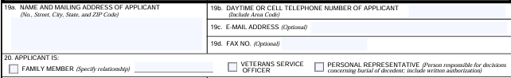
      - Record the contact information of the applicant. This is the information needed to bill for the foundation or the installation service.

    - Veteran Upright Granite monuments:
      - Only accept the granite monuments. The marble monuments will not hold up as well. Both types have the same options.
      - The is also a 24x12x4” thick granite monument available. This one can be used as a header or footer (flush) monument.

      - If the VA order is for an upright granite monument, arrange to have it shipped to our contractor’s address. These upright monuments are large and weigh over 200 Lbs. and are shipped on a pallet. The 24x12x4” thick granite monument weighs over 130 Lbs. and should also be shipped to our contract’s address.
      - The approved VA 40-1330 form, with any attached discharge papers, will then have to be mailed to the VA Service Center. The center is usually the Rochester Center, but maybe from another state or county service center.

Maximum ‘upright’ monument height is: 48.”
  - Any requests for monuments or foundations that do not conform to our Rules & Regulations must be reviewed by the MWC Board of Directors.

Notes & Reminders:
- Remember, that grave sizes vary by section. Sections J&K are 42” wide and the other sections are 45” wide. The Section J Cremation Area is 42” wide but only 5’ long. This will impact on their placement and stake location. However, the maximum monument sizes do not vary by section, as listed above. Sections J&K also offer East facing (even rows) and West facing (odd rows). Also remember that in Sections J&K the grave numbers start in the middle of the 2 sections. Care needs to be taken when helping to plan a couple’s name placement (right or left side) on a monument. The traditional positioning is the husband on the left (blue) and the wife on the right side (pink) unless they opted for a ‘Reverse Burial’.
- Here is a graph to help clarify the positioning in:
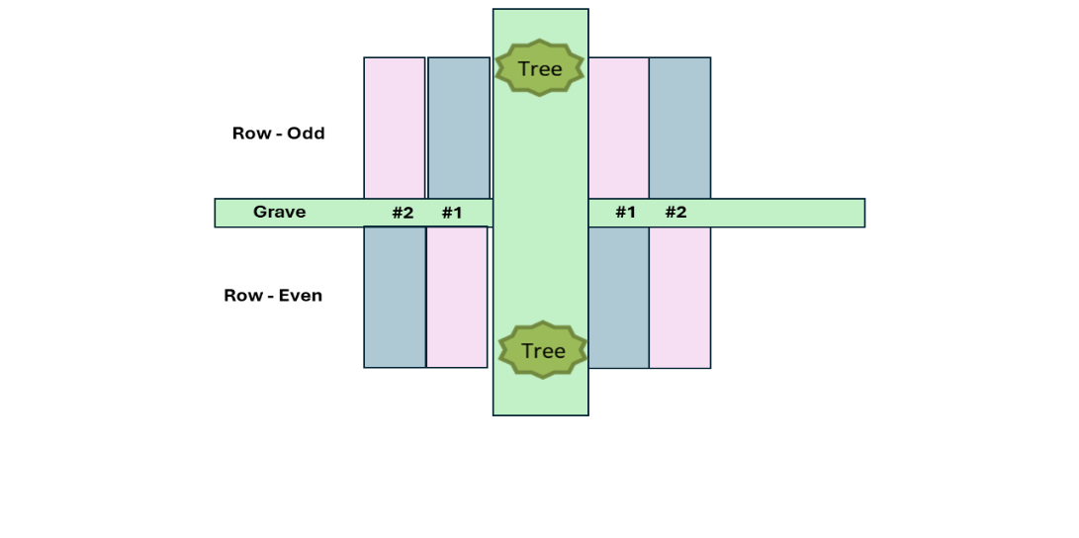
Sections K & J
- The MWC public website https://maplewoodcemetery.org/ has a lot of information about Maplewood Cemetery. Do not be worried about referring a customer or vendor to the website. The maps, listings, Frequently Asked Questions (FAQs), our Rules & Regulations, and more are there.

Order Entry Preparations:
- All information needs to be verified:
  - Section Lot Grave (SLG). Is this the correct location?
  - Name(s) of the sub-customer or those on the inscription.
    - Are these the names in our records?
  - Is the sub-customer ‘authorized’ to make these decisions?
    - Are they the deed owners?
    - Do they have authorization from the owners if they are not the deed owners.
    - Follow the NYS Cemetery Division rules for the hierarchy of family inheritance of authorization.
  - We have been advised to make sure that we know what inscriptions are planned.
    - There have been reports of inappropriate inscriptions in other cemeteries.
    - This is more difficult if the inscription in question is not in our language. The monument vendors would have to help in this case.
  - Does the requested size meet our requirements?
    - Include the mowing collar in the overall dimensions, where required.
    - Some have pushed to get acceptance even when they know the size is too large.
  - Keep in mind that there is a minimum price.
  - What are the timing expectations?
    - Some families plan their services based on the expected delivery date.
    - Our foundations require adequate time to be installed and cure.
    - The primary timing issue has been the availability of the monument.
    - Do not commit to anything that cannot be verified.
  - Foundation orders can be emailed, or USPS delivered. If a ‘phone order’ is received, ask for a ‘paper-copy’ (or email) to verify.

- All foundation orders are to be entered and managed in Quick Books Online (QBO).
- The customer price and the contractor cost are calculated on the MwcAdmin website.
- Our customers for foundation orders are the monument companies. Their customers, becoming our ‘sub-customers’ in QBO, determine the size and location of the monument orders.
- The QBO structure of allowing sub-customers gives us the capacity to bill each monument vendor as 1 customer regardless of how many foundation orders they submit to us.
- During the winter months when we do not install foundations, we queue up for the orders and submit them to the foundation contractor in the spring.
- Many of our regular monument companies use our website to look up their customer’s location, Section, Lot, Grave (SLG) and should know how much to charge for the foundation.

Receiving the Order:
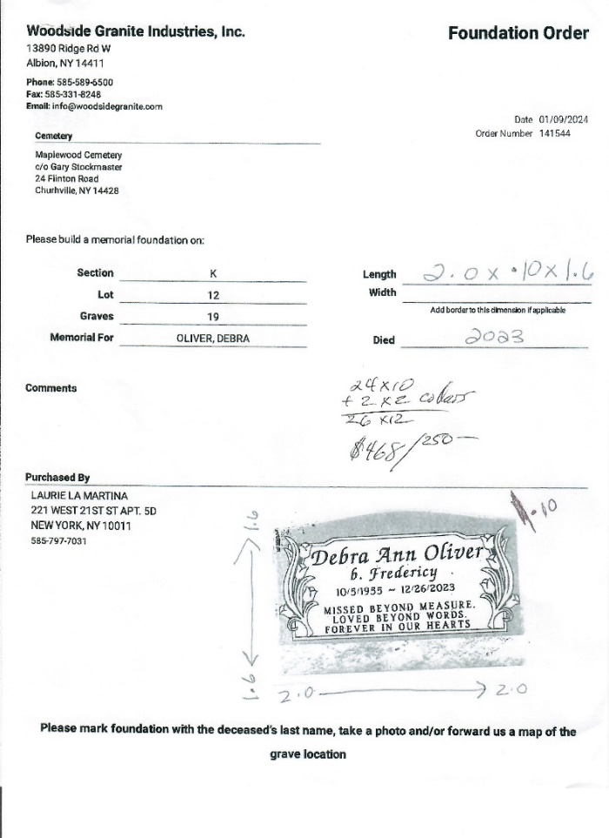
Here is the initial foundation order from Hart Monuments (owned by Woodside Granite).
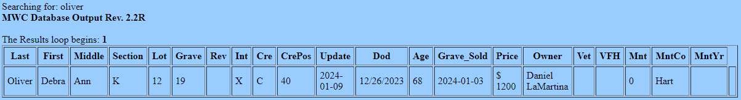
Review and verify the order in MwcAdmin:
- Debra Oliver owns a single grave: K12 #9 and she is interred.
- A 2.0’ x 10” (24” x 10” by 1.6’ tall) will fit.
Now, calculate the customer’s Foundation $ cost using MwcAdmin. This monument will require a mowing collar.
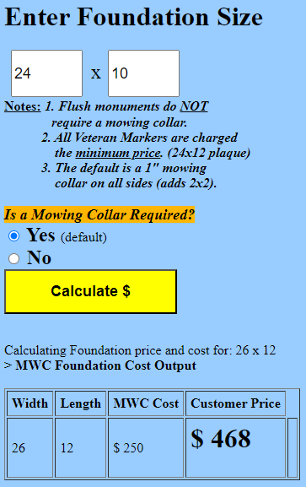

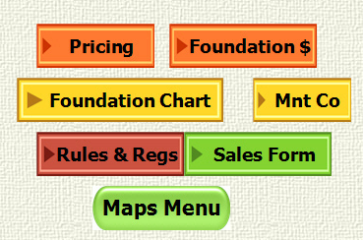

Entering the Order into QBO:
QuickBooks Online (QBO): This is fundamentally the finance core of the cemetery. This is also a web-based application with restricted access. The Treasurer may grant access levels to those that require access for sales creation, tracking or audits.
  - All MWC financial transactions are managed in QBO. The customer contact and sales information are entered and managed in QBO. The payments made and any balance due are recorded here and categorized as required.
  - E-Invoices are generated by the Treasurer in QBO. These E-Invoices allow an electronic invoice with a link for customers to pay via PayPal or with credit cards directly. A receipt is automatically sent to the customer and their payment is credited to their QBO account bill. We also pay a lower % charge for the E-Invoice usage than us manually entering the credit card information.


  - Most Monument vendors are still requesting paper invoices and will pay by paper check. That may change over time. An email address for the monument vendor would allow for E-Invoicing.
Login to QBO and select the CUSTOMERS tab. On the right side click on New Customer.
The new customer forms will show.
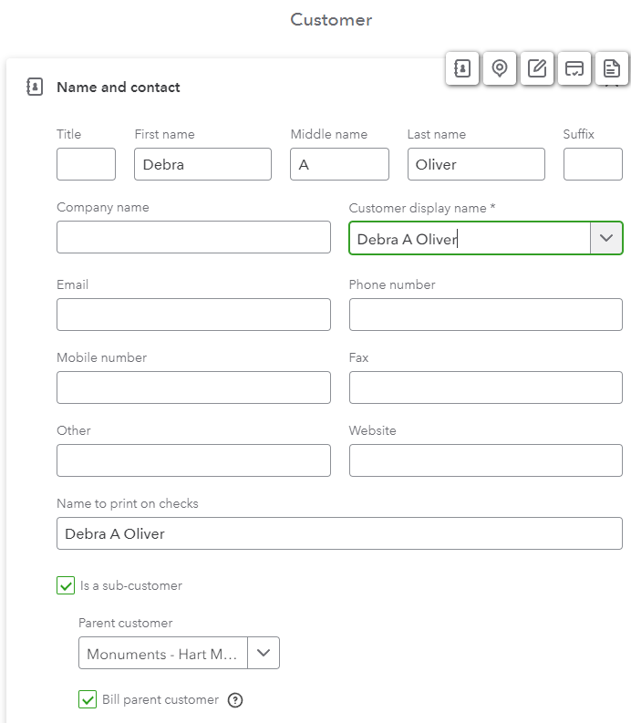
1st, enter the ‘Sub-customer’ information. Since this is the sub-customer, only minimal information is needed.
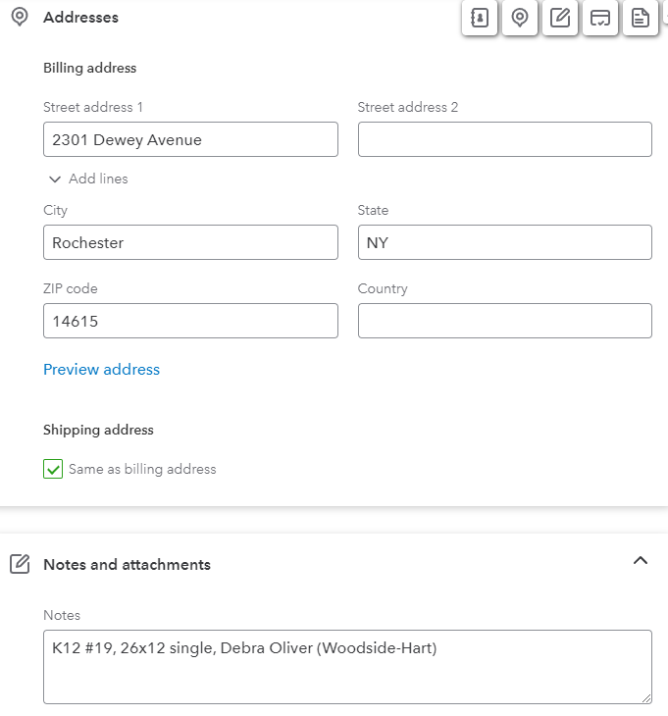
2nd: Check the sub-customer box, select the ‘Parent Customer’ from our contacts pull-down list, and check the ‘Bill Parent Customer’. The Parent Customer information will appear as shown below.
Sub-customer,
Parent customer

You can add the notes at the bottom of the screen:
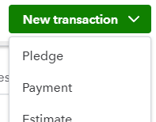
On the right side click on New transaction and then Pledge.
An Invoice form will appear to enter the new pledge.
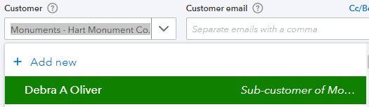
Notice that the customer is listed as:

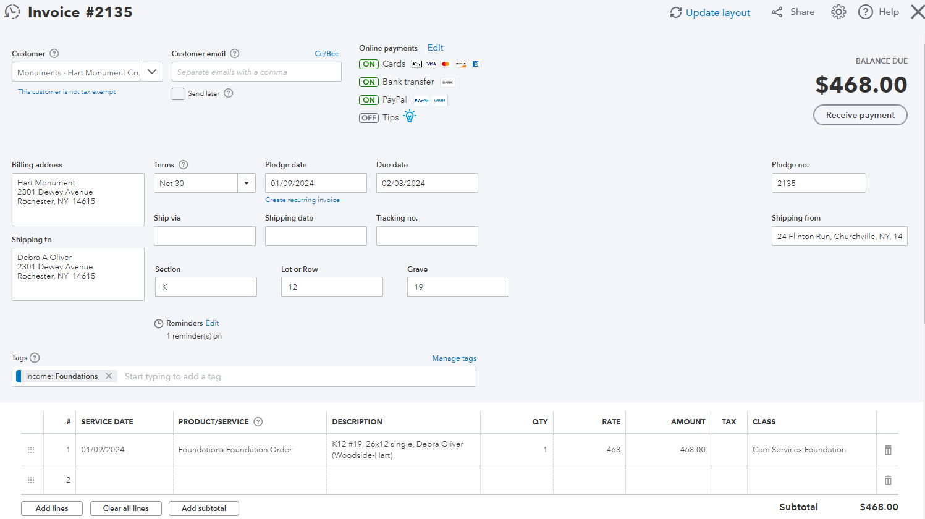

Enter the order information in the invoice form.
The Terms and the Due date fields will vary depending on the time of year. The Term is usually set to ‘Due on Receipt’. This can be changed once we know the foundation is installed and we are ready to bill the customer – monument vendor.
Using the sub-customer option also helps the monument vendor identify which of their customers we have completed the foundations for.
The Tags field is a pull-down that can be used by us when we generate reports. In this case I have tagged it as Income – Foundations.
The main portion of the order is next, creating the details and the amount to be billed.
Service Date is the order entry date.
The Product/Service is a pull-down menu. Select Foundation Order for the ‘Income’ portion of the foundation. The Install Foundation – Cost will be used later as our expense to be paid to the foundation contractor.
Fill in the DESCRIPTION area as shown. The monument vendor is shown in parentheses. This description will be used again in the foundation contractor’s purchase order (PO).
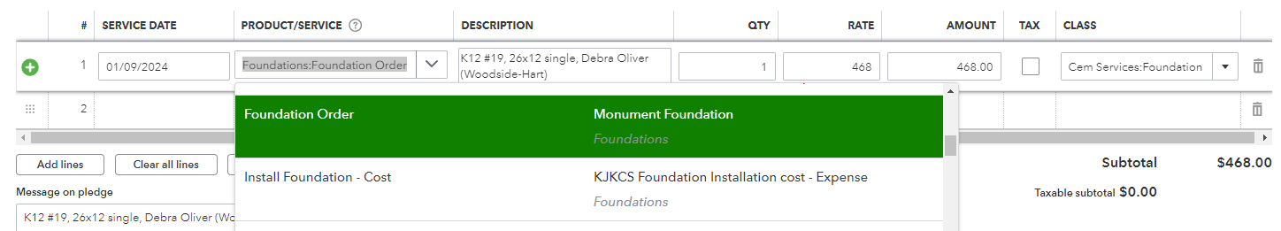
Adding this same description to the ‘Message on pledge’ box helps to identify this order on reports.

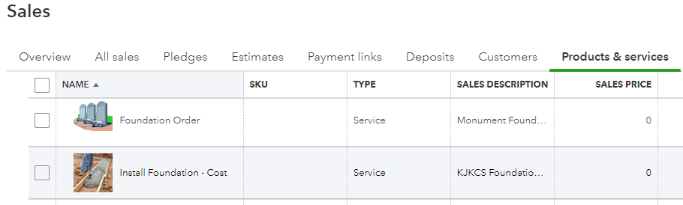
The Products & Services section of QBO is where our items for sale or purchase are listed. In most cases our items/services have a ‘Sales Price’ associated with them. In the case of Foundations, the prices vary and need to be manually entered in the RATE field of the Invoice.
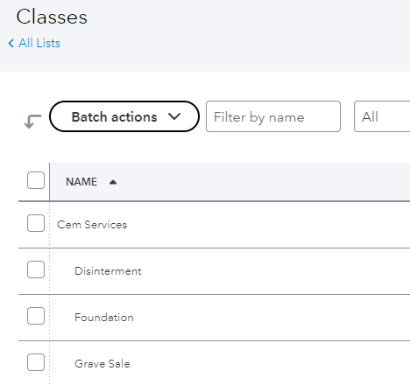
QBO also uses a CLASS LIST to group items together for searches or reports.
The Class pull-down in the order above should be selected as Cem Services: Foundations. Using the CLASS item allows for any Cem Services: Foundations items to reported. This becomes important when running a Profit-Loss (P-L) report for any class. The income items for foundations and the expense (installation) items can be included in the P-L report. The P-L net value should be a positive $ amount when the report is run.

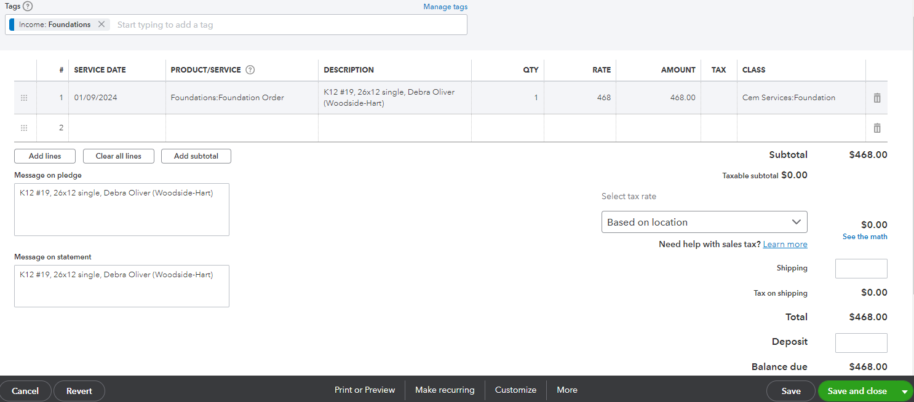
Finishing up the foundation invoice:
The bottom of this QBO form allows for multiple functions to be performed.
1st SAVE the invoice>
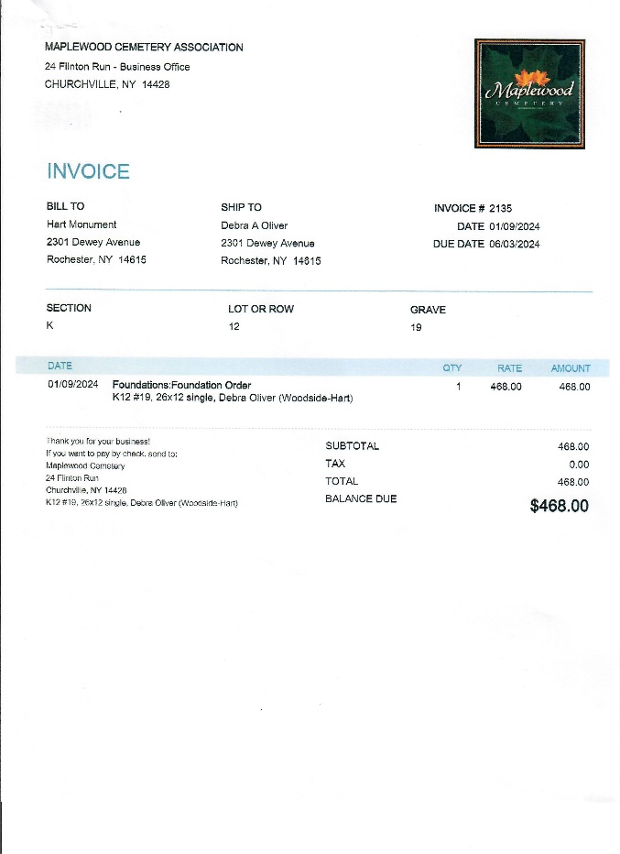
The ‘Customize’ button allows for the template to be used. In this case it is the MWC Invoice.
Select the ‘Print or Preview’ button to see what the MWC Invoice now looks like.
Select the green ‘Save and Close’ button to finish.
The pull down on the ‘Save and Close’ button will allow you to ‘Save and Send’ if you are emailing this as an E-Invoice.

Now the foundation installation PO
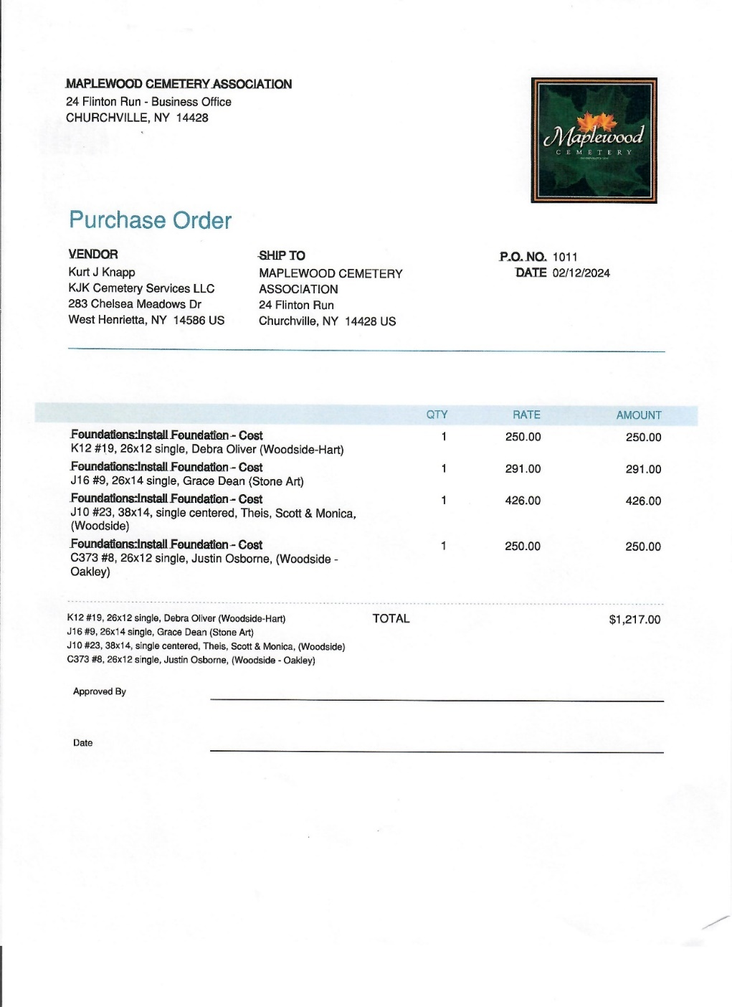
The Purchase Order should include more than 1 foundation whenever possible. This makes things more efficient for us and our contractor.
The RATE is the MWC Cost calculated earlier. This is what we will be billed for the foundation installation.
There should be a corresponding individual monument vendor (customer) invoice for each one of these. It is recommended that the individual invoices be created before generating the contractor PO.
This PO can be edited and have additional foundation orders added to it before sending it to the contractor.
The contractor prefers having the monument vendor listed, as shown. Some of the monuments are received and installed by our contractor.
Other monument vendors use their own contractor to install the monuments.
Remember, ALL foundations are reviewed, approved, and installed by us and our contractor.
Scheduling: Once a PO is submitted to our contractor, it may take 2-4 weeks for the foundations to be installed.
The timing depends on a few things but is rarely an issue that delays a monument’s installation. Recently the monument vendors have been quoting 3 – 12 months for the monument to be ready for installation.
Billing: Once the foundations have been installed, we can bill the monument vendor. The foundations must be paid for before any monument can be installed.

Creating the foundation installation PO
To create a new foundation PO:
Open QBO, click on the Vendor tab, search for our contractor, select KJK Cemetery Services.
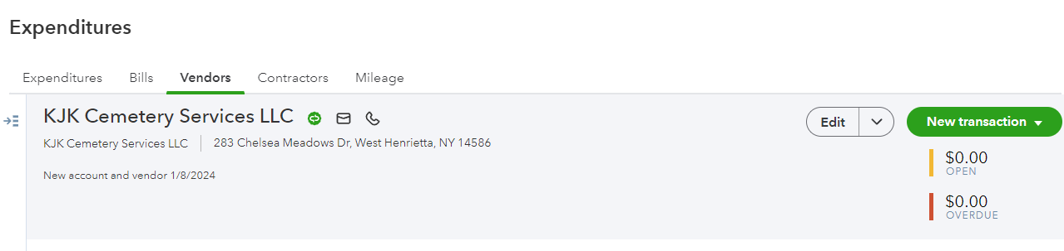
Once this screen appears, select the New transaction button, and select Purchase Order item.
Then a new PO form will appear with the contractor’s information filled in.
Jump down to the Item details section to start entering the order information:
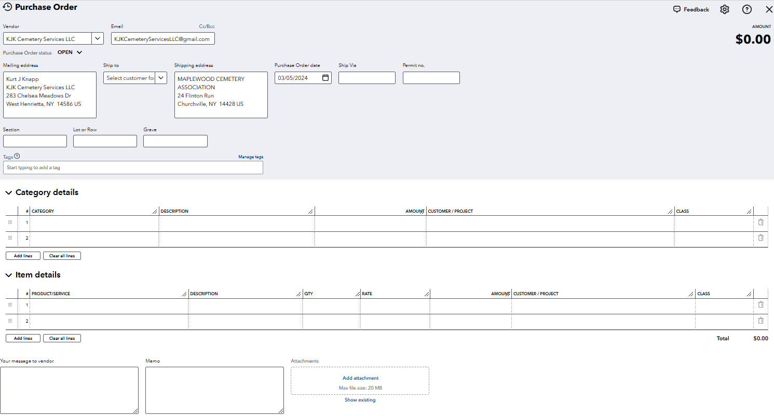
Edit a new or existing foundation PO:
This part will be the same for editing a new or existing foundation PO.
There are similarities to the ‘Customer’ Invoice with the following exceptions:
The product/service item will now be: Install Foundation – Cost. The Rate amount entered will be the contractor cost, an expense for us.
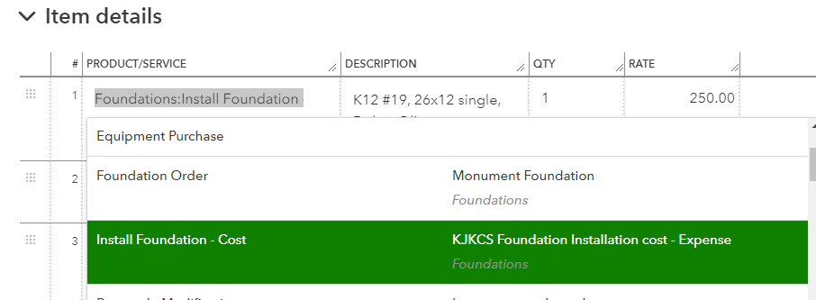
The other exception is the ‘Customer/Project’ pull-down. You can start entering the sub-customer’s name. Just make sure you pick the entry linked to the monument vendor. There may be more than 1 entry for that name.
The description field should be the same description that you entered on the Customer Invoice.
The Class field should also be the same as you entered on the Customer Invoice.
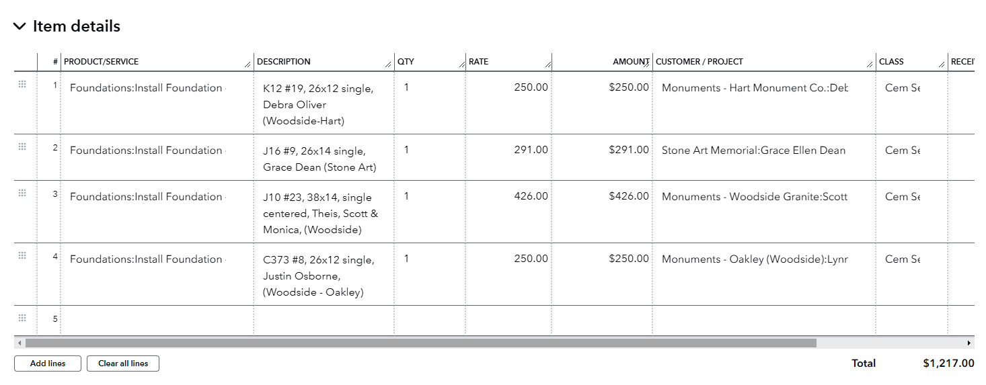
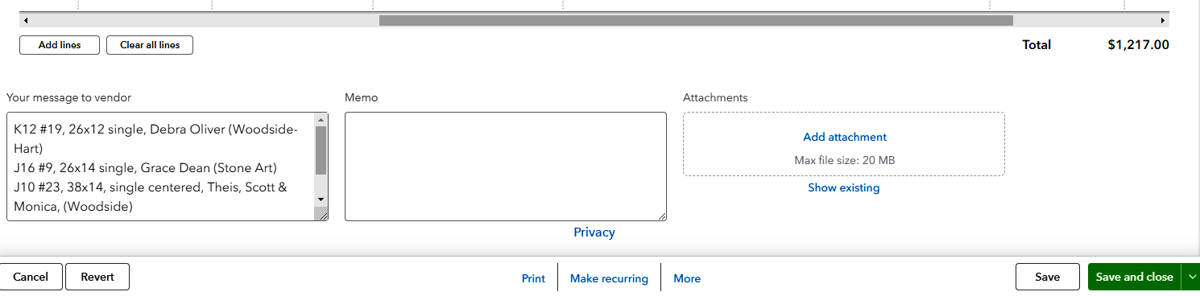
Finishing the foundation PO:
Like the Customer Invoice process and options, you should SAVE the PO, then you can PRINT it. The Save and Close can be selected if it is not time to send the PO to the contractor. The email address is in the contractor’s profile, so if it is ready to send, select Save and SEND.
Tips:
- I would recommend keeping all the customer invoices and this foundation PO together. If more invoices are added, then the PO needs to be revised and reprinted. This gives you an accurate and up to date collection of foundations orders.
- The foundation locations, SLG, need to be staked before the PO is sent.
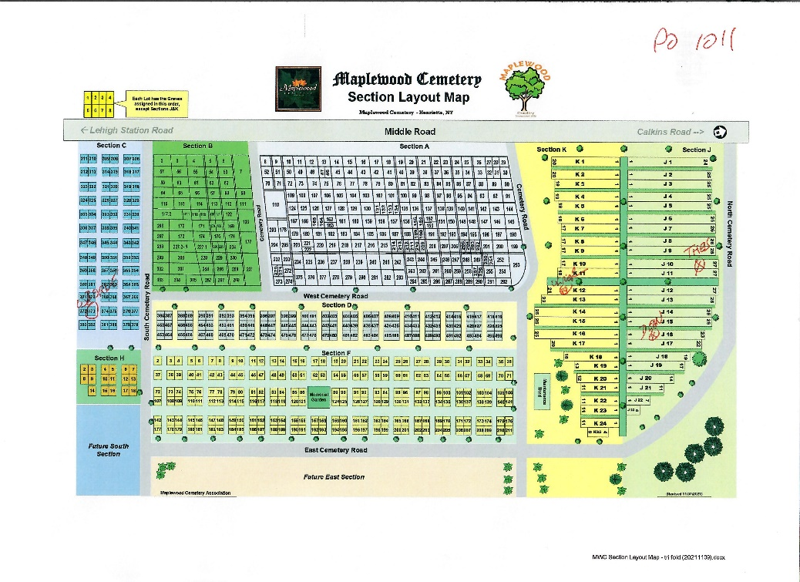
- Circle the SLGs that are included in this PO on a copy of the

This Section Layout Map is available on the MwcAdmin website.
This process will help you manage the foundations easier from start to finish. Attach this map to your packet of invoices and the PO.
The Monument vendors have requested that a copy of this map with their orders shown be included with the invoice.

Other Reference materials: All are on the MWC Admin website.

Reports/NYS Cemetery Div
- cemeteries-101-basics
- cemeteries-101-accounting-basics
- Not-For-Profit-Corporation-Law-Article-15-Public-Cemetery-Corporations
- NYS public cemetery regulations
- NYS treasurers-manual-final-100611

Reports/Training
- MWC Treasurer QBO Training
- MWC Treasurer Training
- MWC Sales Training
- MWC Business Reports
- MWC PM Reports
- MWC Graves SOLD Reports
- MWC Section Maps Training
- MWC Documents and Forms
- MWC Foundation Sales (this document)

