Introduction
Welcome to Treasurer QBO Training!

The role of the treasurer is involved in every Maplewood Cemetery (MWC) transaction. The treasurer is the fiduciary of the Maplewood Cemetery Association, incorporated.
- What Is a Fiduciary? A fiduciary is a person or organization that acts on behalf of another person or persons, putting their clients' interests ahead of their own, with a duty to preserve good faith and trust. Being a fiduciary thus requires being bound both legally and ethically to act in the other's best interests.
- This document will try to list and explain some of the frequently used QBO functions and customizations.
- The methods and procedures may continue to change over time, but the concepts and responsibilities will not.
- The role of the treasurer is a critical and integrated portion of the proper functioning of the entire MWC Association. The tasks require the treasurer to understand how all aspects of the MWC Association function and the timely and accurate response needed from the treasurer.
- The MWC financial core is based on Intuit QuickBooks (QB) software. A change was made at the beginning of 2023 to transition from QB Desktop version to QB Online (QBO).

QBO allows for up to 3 custom fields to be used.
- The 3 most important fields for MWC are:
  - Section
  - Lot
  - Grave
- Section, Lot, and Grave are frequently abbreviated as SLG.
- Make sure that the SLG is recorded for all transactions that involve a grave.
  - Grave Sales
  - Foundations
  - Interments
  - Repairs

Welcome to the QBO Home page….
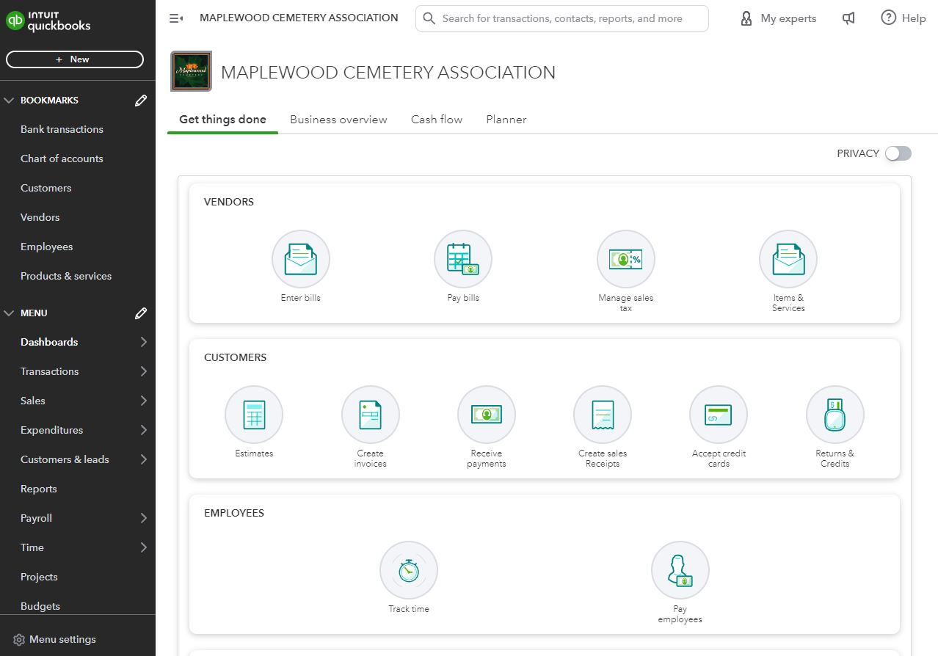
There is little doubt that QBO has a lot to offer. You just must find it!
The online version will look different and show different features as the product is revised. Intuit has made some of this interaction more complicated than it must be, in my opinion.
The emphasis seems to be focused on electronic transactions and not paper check transactions. That is the direction that we want to go, but not everyone is there yet.
The Automated Clearing House (ACH) is the primary system that agencies use for electronic funds transfer (EFT). With ACH, funds are electronically deposited in financial institutions, and payments are made online.
A simple example is when a contractor submits a bill for services and requires a paper check payment. Once the bill is entered for that contractor, the pay by paper check option does not appear. The ACH options do. Currently you must leave the page that you are on to enter a different page to pay the bills that include printed checks as an option.
There are many options that can be set in QBO, yet those options and form customization options do not compare to what was available in the QB Desktop version.
QBO has strengths, but also weaknesses that impact productivity, forms, and reporting that we had in the QB Desktop version. QBO works for MWC and will hopefully continue to improve.
Getting Started:
- The left side menu can be customized to place the frequently used items in the upper Bookmark area.
- I prefer to have multiple tabs open in QBO to make some transactions easier to manage.
  - An example is a foundation order:
    - Open a new tab for ‘Customers’ by clicking the right-mouse-button and selecting ‘Open in New Tab’.
    - Create a new ‘Pledge’ to enter the new foundation order.
    - That order information will then have to be placed in a new or existing foundation order for our foundation contractor (GVCS).
    - Open a new tab for ‘Vendors’ by clicking the right-mouse-button and selecting ‘Open in New Tab’.
    - Select GVCS as the vendor. Create a new invoice or add this new order to an existing invoice that has not been sent to GVCS. A simple copy-paste between tabs will save some effort between the tabs.
  - The left side menu allows you to open multiple tabs. You cannot do that by clicking on the main menu window.
Let’s start with the ‘Customers’ order:
Grave Sale: You can refer to the Grave Sales Form discussed in the Treasurer Training document.
- The Sales form will be sent to the treasure for entry and billing.
- New Customer: Open the left side ‘Customers’ in a new tab.
- Select ‘New customer’ and a new screen will open:
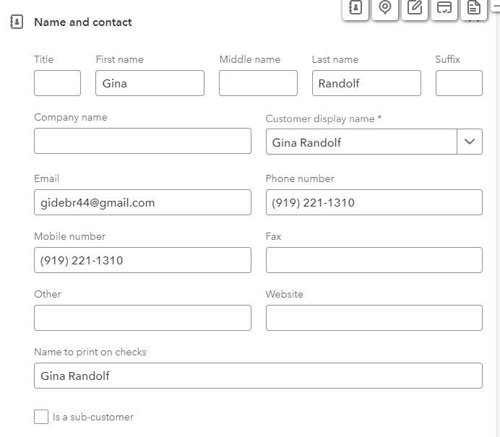
- Enter the customer contact information from the Grave Sales form.
- Scrolling down this screen will allow the billing and mailing addresses to be entered and any notes or payment preferences.
- This customer contact information can be edited later if anything changes.
- Occasionally the Deed owner’s address and the billing address of the person paying for the grave are not the same.

- Once the customer contact information is complete, click ‘SAVE’.
- Then click on the New Transaction button again.
  - This time you should see a different menu offering.
  - Select ‘Pledge’, and a new screen will appear to enter the order details.
  - Below is an Invoice with the Grave Sale and Interments listed.
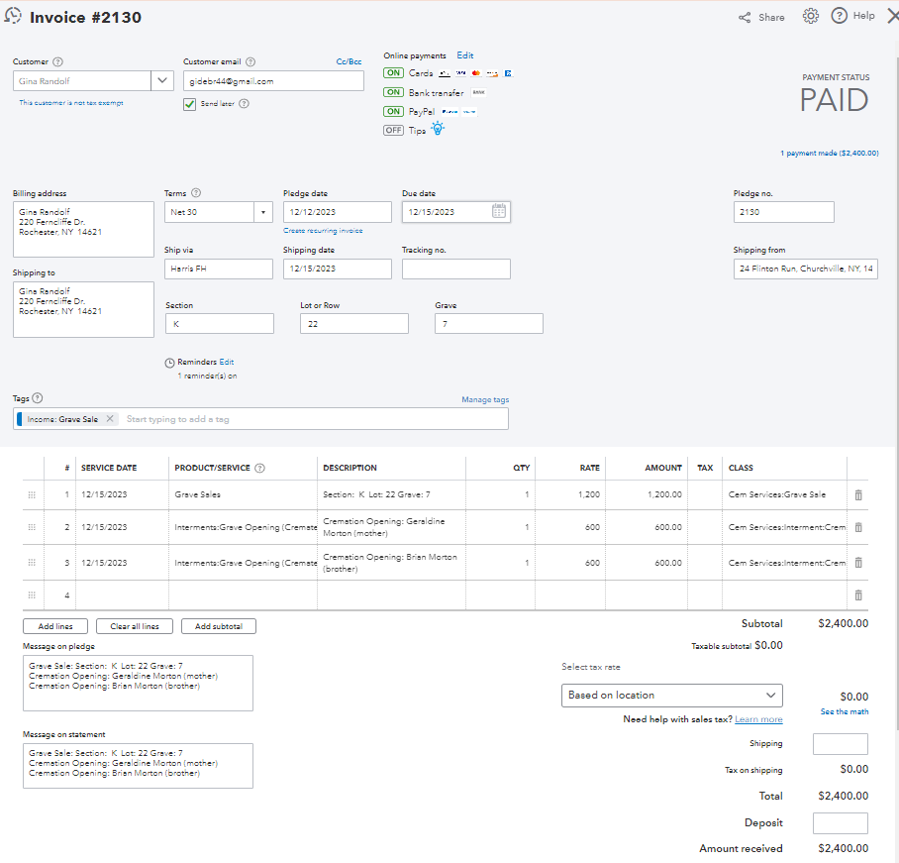
The Customer contact information is automatically entered. The rest is up to you.
We’ll review the Product/Service field, Rates, and Classes next.
The Product/Service List is specific to each company. Below is a portion of the MWC list:
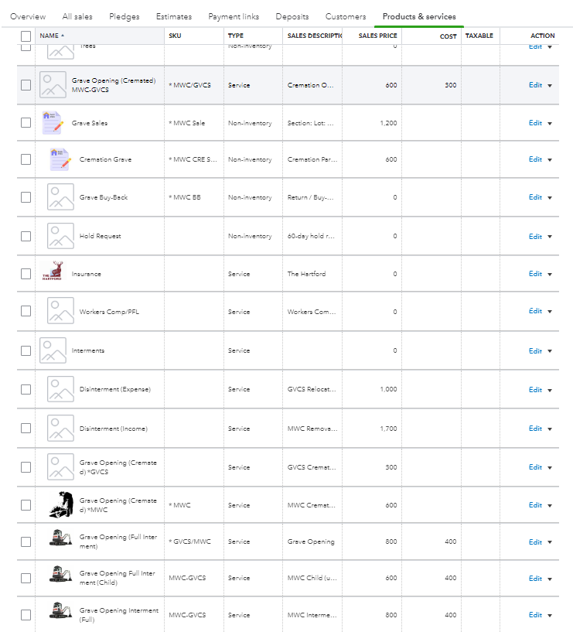
In the Invoice above, the 1st product/service is ‘Grave Sales’. This item is in the ‘pull-down’ list in the invoice and shows the items in the product/service list above. Once ‘Grave Sales’ has been selected, the invoice fields will be filled from the product/service list.
Please note that ‘Grave Sales’ is listed as TYPE Non-inventory in QBO. The MWC inventory of graves is maintained in our MS Access Database and not in QBO.
- The description can be edited to show which SLG has been sold.
- This invoice also shows that 2 people were going to be cremated and interred in that grave. This was an urgent need situation, and the funeral home provided a check for the grave sale and the 2 cremation interments. The invoice adds 2 product/service items for Interments Grave Opening (Cremation) from the pull-down list.
- The ‘MESSAGE’ spaces near the bottom of the invoice should be filled in. This makes auditing and reporting easier to identify.
- This data also needs to be provided to the Secretary to update the MWC database.
- Cremation graves are hand dug by MWC employees. They will include their services in the payroll update at the end of each month in COZI. The same SLG should be entered into the payroll run for those employees.
- The payment is entered into the Pledge Invoice page. In this example, the invoice was captured as paid. When payment is due, the page will have a ‘Receive Payment’ button. On the Receive Payment page you would enter the check received from the funeral home.
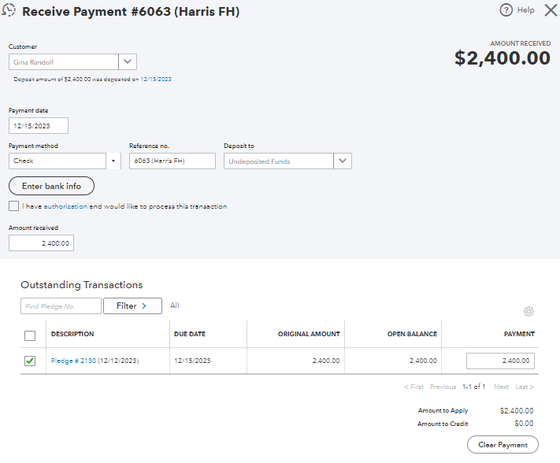

- The above shows the same information in 2 forms. The left being an Invoice format and the right in a Statement format. The Statement form is usually sent as a receipt upon completion of the services rendered.
- Most funeral homes do not request a statement from us. In this case the customer did receive a statement for her records.
- The funeral home check was endorsed, scanned, and printed.
- The check was then deposited in KeyBank using mobile deposit. You will need the KeyBank application on your smartphone.
- You will need to print the KeyBank acknowledgement of the deposit and staple it to the check. This will need to be done for every check being mobile deposited. The check should then be added to the check storage folder.
- The KeyBank mobile deposit notes suggest saving the check for 7 days, then it can be discarded.
- However, NYS Cemetery Division requires the checks to be saved for 7 YEARS. They will want to see the checks during their audits. The audit period varies depending on their staffing and the cemetery’s situation. If the cemetery has any complaints or reports of mismanagement, the audits become a much higher priority. MWC has had a variable interval from 2-4 years to, at the time of this writing, 7 years. It is nice knowing we have a good reputation, but the next audit could be a long one….

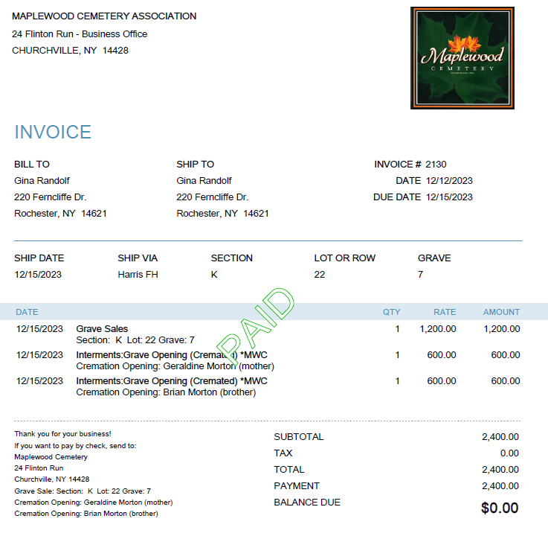
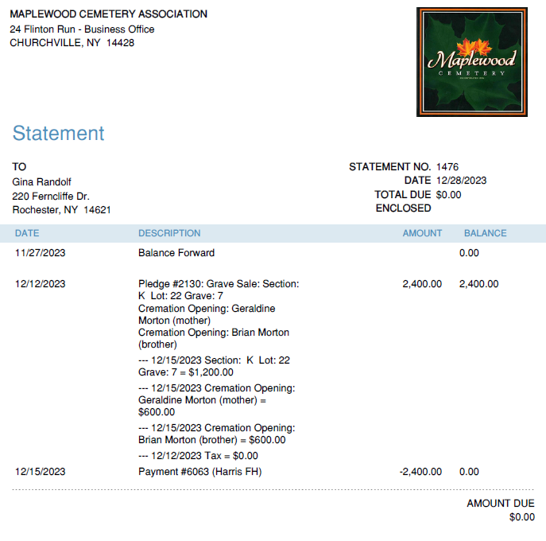
‘Payment Plans’: MWC provides a monthly payment plan option for those with preneed planning.
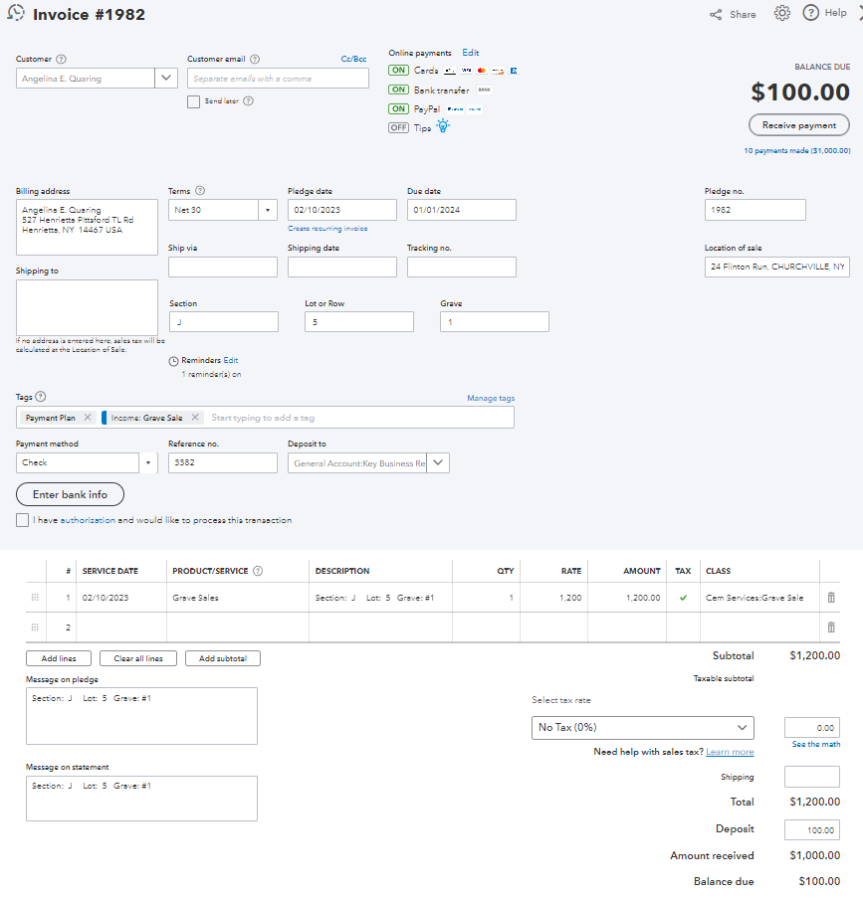
The plan requests a $100 deposit/grave and $100/month.
This payment plan is at the end, already receiving 10 payments with a remaining balance of $100.

The amount due each month can be adjusted depending on the customer’s needs.
A new invoice will be sent out each month showing the progress and reminding the customer about the next payment.

The plan can be set up for check payments, credit card payments, or E-Invoice payments.
QBO will always show the remaining balance due, so be careful when receiving a partial payment that the amount received matches the payment. QBO will adjust the balance due, and the next invoice can be sent to the customer.
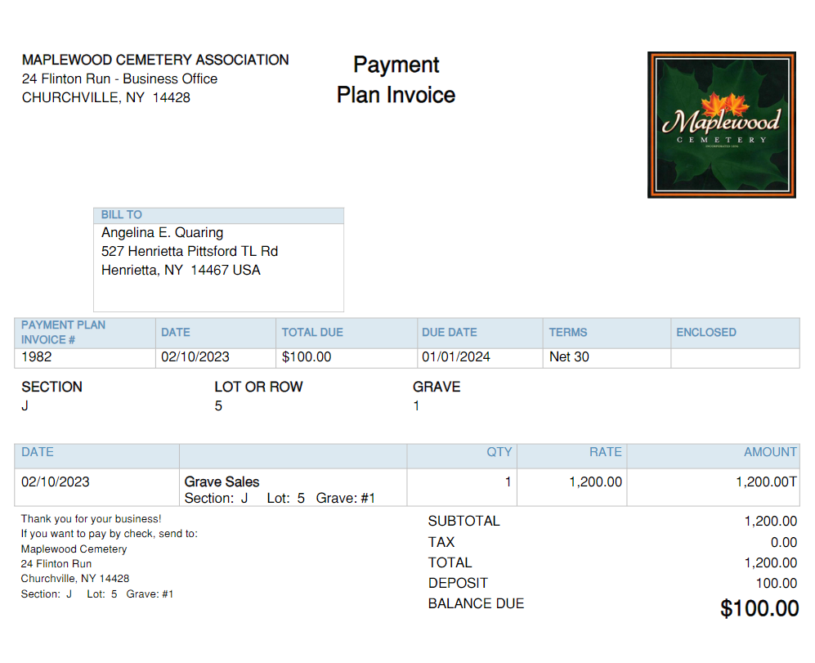
The payment plan invoices provide a clear picture of which grave the customer is purchasing and the payment progress.
Remember that the payment plan is only for Grave Sales and cannot be used for interment prepayments.
The PM quarterly funds transfer requires all payments toward the grave sale to be included, partial or full.
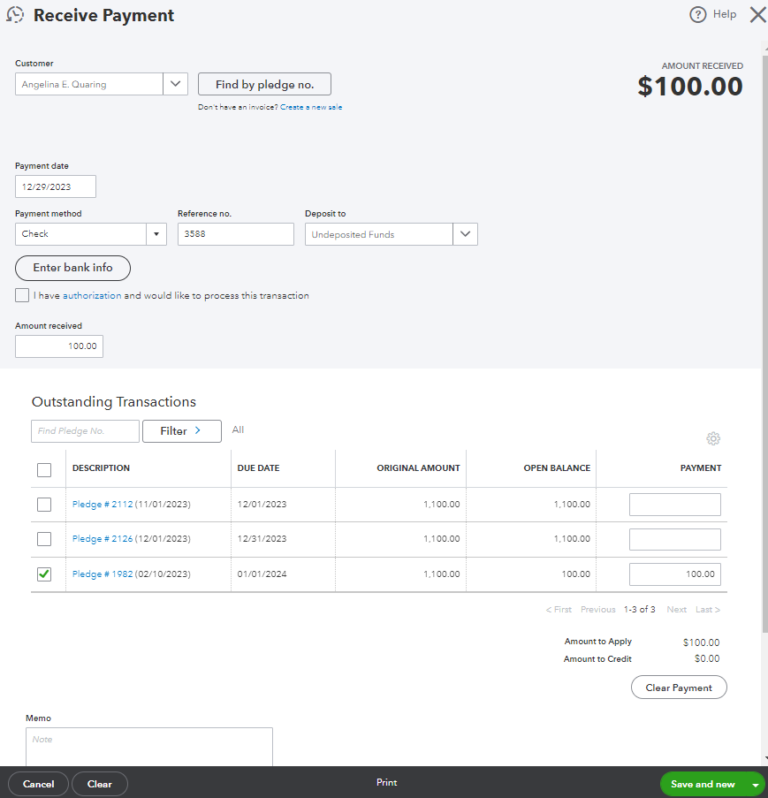
In this case, the final $100 payment has been received. This customer is also linked to other pledges, so make sure the correct pledge is credited.
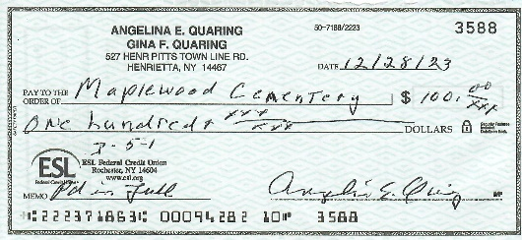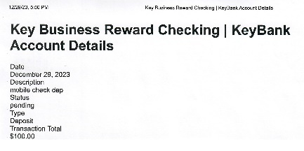
The check will be recorded, endorsed, and ‘mobile deposited’ at KeyBank.
The deposit acknowledgement will be printed and attached to the check.
Notify the Secretary that this grave is now fully paid for. The Secretary will create a DEED and include a packet of information to go with it, including the Rules & Regulations. The final statement should also be included.
Let’s move on to a ‘Foundation’ order:
Foundations: Each foundation order will have a Monument Company foundation order and a MWC Purchase Order (PO) entry for the foundation contractor.
- The customer contact information process will be the same as in the grave sale example earlier, EXCEPT, we will use the ‘sub-customer’ option.
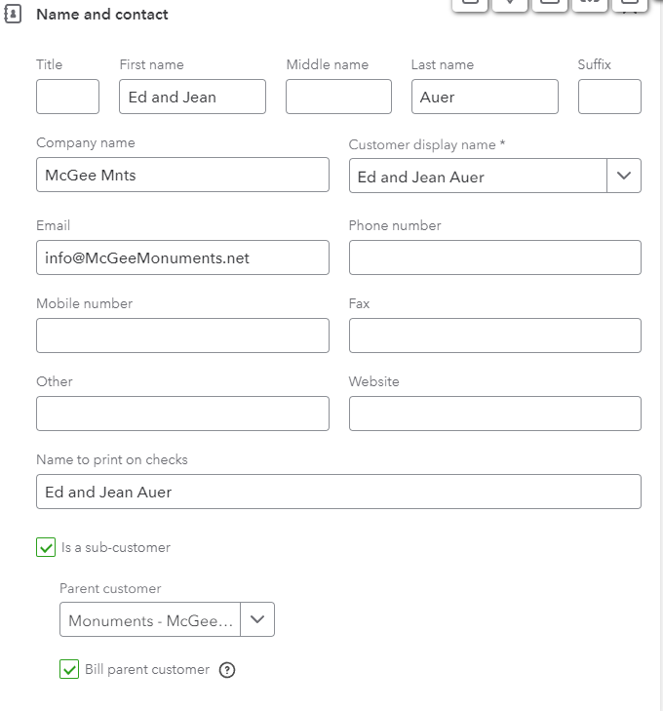

FOUNDATION orders: Our customer is the monument company. Their customer is the ‘sub-customer’.

(no checks will be printed)
Check Box for sub-customer,
Pull-down Parent Customer,
Check box for Bill Parent Customer.
Then save.

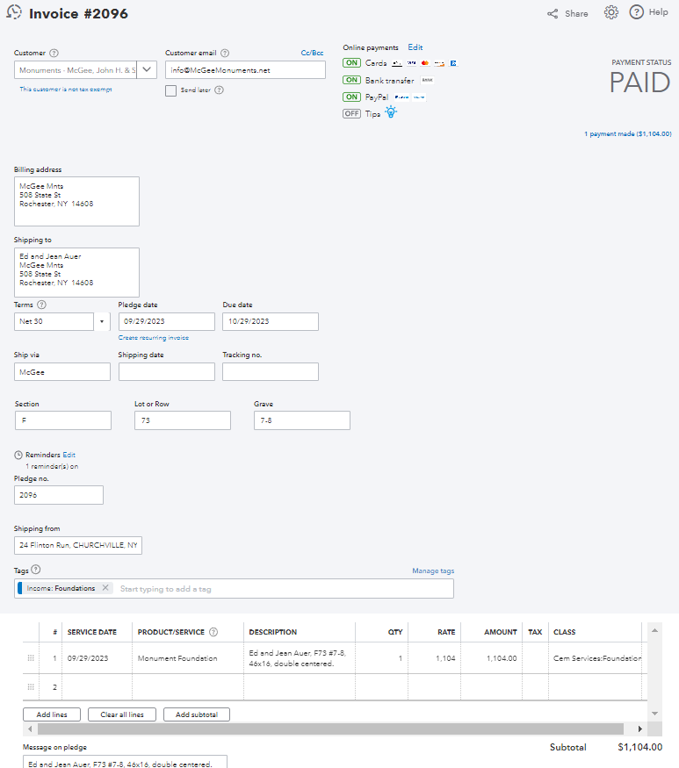
Create the Invoice:
From the customer page, select the ‘New transaction’ button and click on new ‘PLEDGE’.
The ‘Parent’ contact information is filled out.
Verify the SLG of the sub-customer.
Note: The foundation order can only proceed if the grave is paid for. If it is not paid for, notify the monument company.

The MWC Admin website will be used to verify the SLG and calculate the customer and internal cost of the foundation.

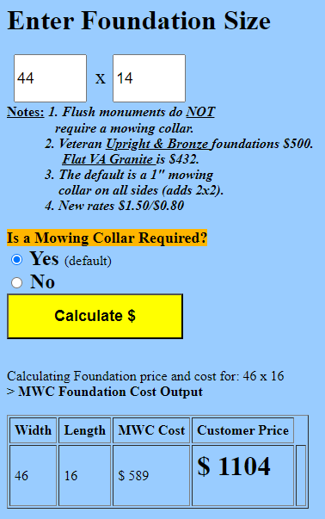
On the MWC Admin website, select the

button.

Enter the requested size from the order, 44x14. A mowing collar is added to the size by default.
Most monument companies have a note on their order stating that a mowing collar has NOT been included.

Press ‘Calculate’

Both the MWC Cost, and the Customer Price are calculated.
The $1104 Customer Price will be used for the customer invoice. (as shown above).
The customer invoice will be sent to the customer (monument company) when the foundation is complete. Foundations are poured between May 1st and October 15th. Any foundation orders that are received outside of that period are entered into QBO and ‘saved’ until ~May 1st.
The next step is to generate the foundation contractor purchase order (PO). The contractor prefers multiple foundations per PO. During the spring and summer months, the orders can be added to the contractor PO for a few weeks until there is more than 1 order. The monument companies usually need 2-4 months to complete the actual monument so our holding a foundation order for a couple of weeks to accumulate orders is more efficient for us and will not impact the monument delivery time.

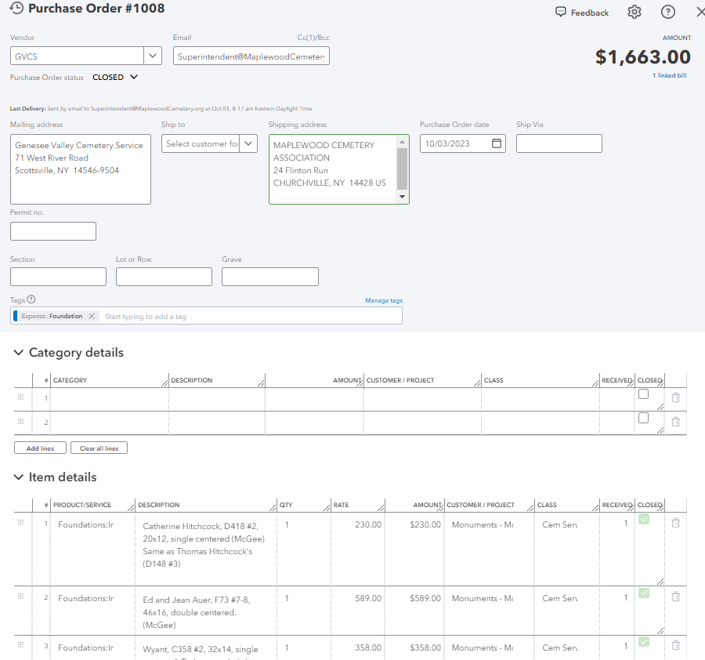
Let’s create the foundation PO.
Open the VENDOR tab.
Select GVCS as our contractor.
Select ‘New transaction’, new PO.
Use the ‘ITEM DETAILS’ area to enter the foundation order(s). Use the MWC Cost on this PO.
Foundations continued,
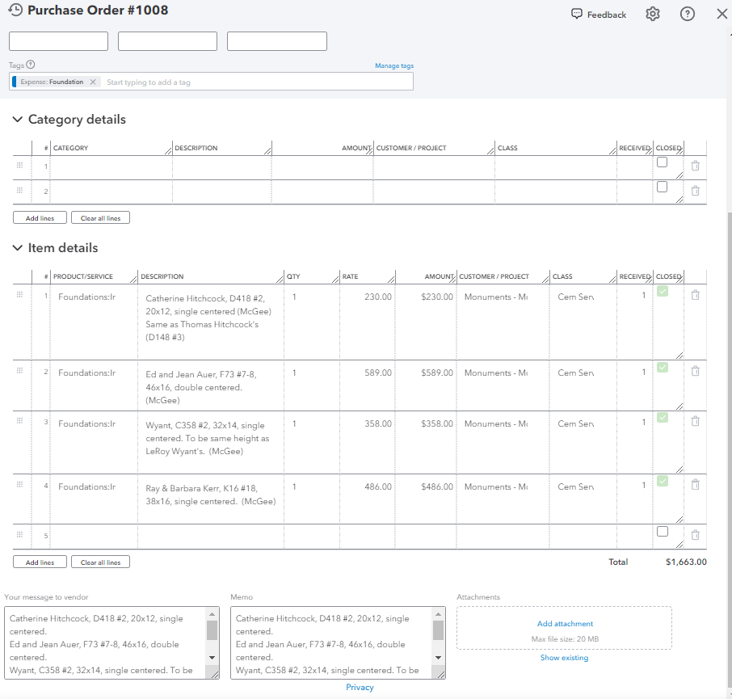
- Next, send a copy of the foundation PO to the MWC Superintendent. The graves must be staked out before the contractor can be notified.
- After the graves have been staked out, send the PO to the contractor.
- Once the contractor has completed the foundations, the invoices can be sent to the monument companies.
- The monument companies prefer receiving a map indicating where the foundations are located.
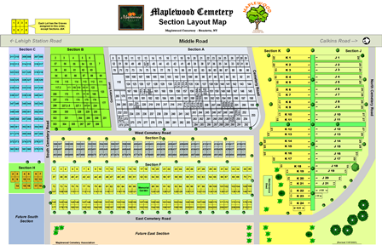
- Circle the SLG of each foundation completed for that invoice and include the last name of the customer. Include a map with these annotations for each monument company being notified of completion.
- Most monument companies will pay the invoice in a few days.
- The Secretary and the webmaster will want updates on the foundations for the records and for monument photos.

Payroll
- Payroll is run every month. A COZI reminder is sent out to remind everyone (mostly hourly employees) that they need to report on their services performed for that month.
- The services have different rates associated with each service, so an hourly reporting is not sufficient.
- QB Desktop provided a payroll calculator to easily calculate the amounts to be paid.
- QBO, so far, does not provide any way to handle anything but hours reported.
- A payroll calculator has been created in Excel to handle that. The calculations then need to be entered into QBO.
- When the ‘Pay Employees’, tab is opened, the amount to be paid per item will be entered.
- QBO will calculate the withholdings and prepare the payroll. Click on RUN PAYROLL to finish this payroll run. The data is normally entered a few days before the end of the month. The payroll will be sent out and available to the employees at the end of the month.
- QBO will send out the IRS and NYS withholding and reports automatically.
- QBO WORKFORCE will email the employees when their payroll has been run for the month.
- QBO WORKFORCE will notify the employees that their W-2 is available for download after January 1st or the new year.
- QBO will send out the 1099 reports to the 1099 tagged vendors. The 1009 reports will also be e-filed with the IRS.
QBO Reports:
- QBO has many reports available as standard.
- QBO also allows for customizations to be made to focus on certain areas of interest,
- Many of the reports do not directly apply to MWC. A custom set of reports has been created and stored in the Custom: MWC report folder.
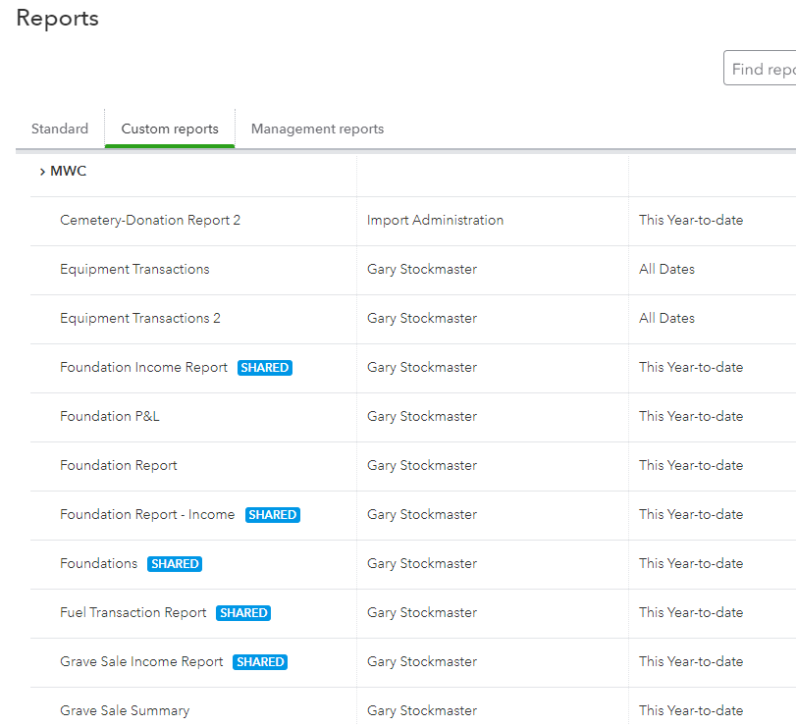
- Here is a subset of the MWC Reports.

- Reports for Income, Expenses and Profit & Loss (P&L) are frequently used.

- The P&L reports for foundations and interments are used for the quarterly MWC board reports. The NET earnings are important for the reporting.

- The Permanent Maintenance (PM) data can be retrieved from these reports. More information will be provided on the PM calculations, funds transfer and reporting.

- Not all reports can get their data from QBO directly.

  - KeyBank and Vanguard statements are required to be accessed and recorded. Vanguard is not linked to QBO currently. Keep in mind that ALL financial transactions must pass through KeyBank.
  - Grave Sale reports can get interesting….
    - The PM amount to be paid is based on ALL income for grave sales, including monthly payment plans.
    - The MWC Quarterly reports listing the Number of Graves Sold is a sum of those graves either fully paid for or a new monthly payment plan started within the year being reported.
    - The grave sale quantity and the income amount will not necessarily agree in the quarterly report due to the monthly payment plans.
    - Caution must be used when calculating the number of graves sold. The MWC database can report the number of graves sold, with a deed issued, or include partially paid graves. Either way, many graves have more than 1 person assigned to a single grave.
    - The grave sale data must be filtered to provide the correct answers. More details on doing this can be found in the ‘Graves Sold’ reports on MWC Admin.
- The Quarterly Business Report is a good example of a report that cannot be generated by QBO alone.
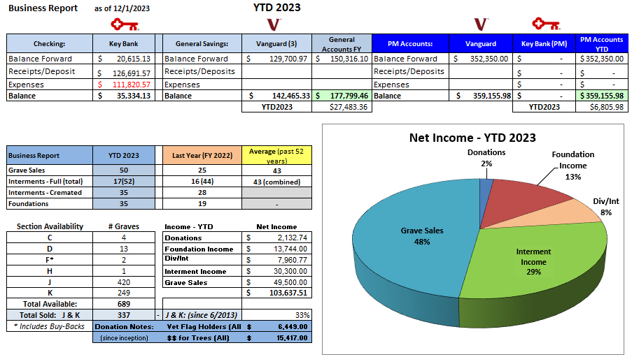
Below is a sample of the quarterly business report:

This is a complex report to generate and requires multiple sources. More details on how to create this report are provided in the ‘Business Reports’ document on MWC Admin.

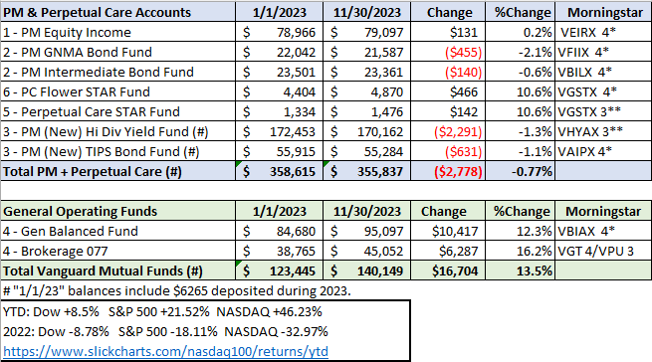
Below is a sample of the Vanguard account financial report:

This is a complex report to generate and requires multiple sources. More details on how to create this report are provided in the ‘Business Reports’ document on MWC Admin.

Other Reference materials: All are on the MWC Admin website.

Reports/NYS Cemetery Div
- cemeteries-101-basics
- cemeteries-101-accounting-basics
- Not-For-Profit-Corporation-Law-Article-15-Public-Cemetery-Corporations
- NYS public cemetery regulations
- NYS treasurers-manual-final-100611

Reports/Training
- MWC Treasurer QBO Training (this document)
- MWC Treasurer Training
- MWC Sales Training
- MWC Business Reports
- MWC PM Reports
- MWC Grave Sale Reports
- MWC Section Maps Training

UPDATE: As of 12/31/2023, GVCS has stopped all operations.
Kurt Knapp, formerly of GVCS, has started a new company, KJK Cemetery Services.
KJKCS will be our new primary contractor for full grave openings and foundation installations.
- Substitute this vendor in QBO where GVCS was used.

