Introduction
Welcome to PM Report Training!
“A cemetery’s permanent maintenance account is its financial commitment to its future care. Over time, these funds must grow to meet the maintenance needs of the sold-out cemetery. It is essential to collect enough money as sales are made and to invest the funds wisely, so the purchasing power will grow and keep pace with increases in maintenance expenses”.
John F. Llewwllyn, A Cemetery Should be Forever

Please read the NYS cemeteries-101-accounting-basics.pdf document on MWC Admin.
Information needed for this PM report requires data from:
- QuickBooks Online (QBO)
- MWC Admin
- MS Access database
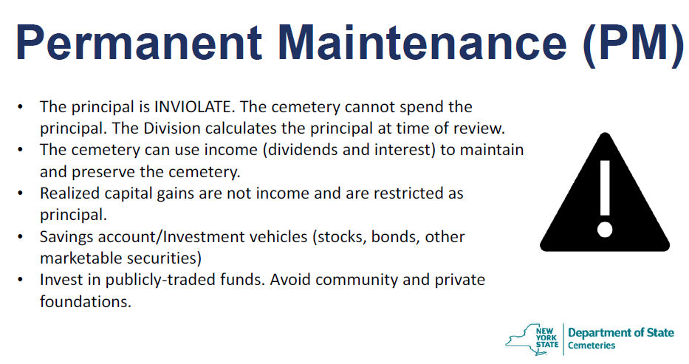
- MS Excel
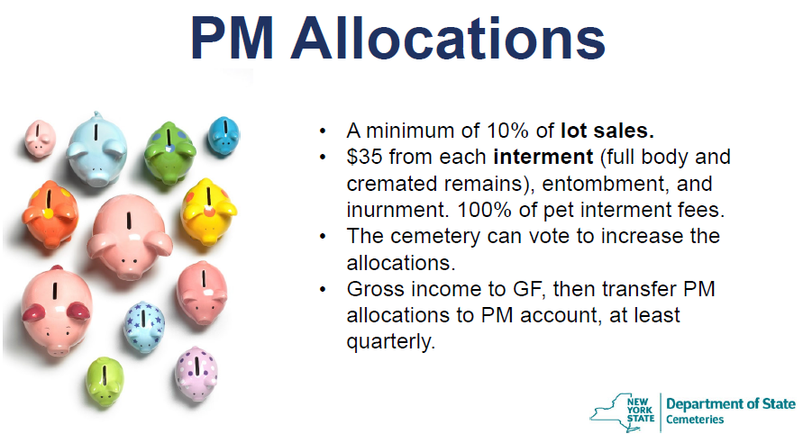

- The PM calculations, deposits, and maintenance are the primary focus of any NYS audit.
- Any errors found will have to be corrected before the audit will be closed.
- There are associated reports that will involve the NYS Vandalism and Assessment fees and the NYS Annual Report.
- NYS differentiates the funds for the PM calculations by:
  - Grave Sales:
    - Full payments
    - Partial payments
    - Perpetual Care
    - Special Trusts
  - Interments:
    - Full Burials
    - Cremations
      - In state
      - Out of state
I prefer to think of these PM accounts as a cemetery retirement account!
The PM deposits are calculated and deposited each quarter. Any errors in the quarterly amounts can be corrected by adjusting the deposits and making note of the reasons.
The PM calculations are not difficult to do. The difficulty is making sure that the data is correct. This is an area that an internal MWC audit could focus on to help.
I have created a MS Excel spreadsheet to load the data and calculate the required PM amounts. Let’s start with the Grave Sale PM first.
Step 1: QBO: Run the MWC - Grave Sale Income Report, below is the beginning of that report.
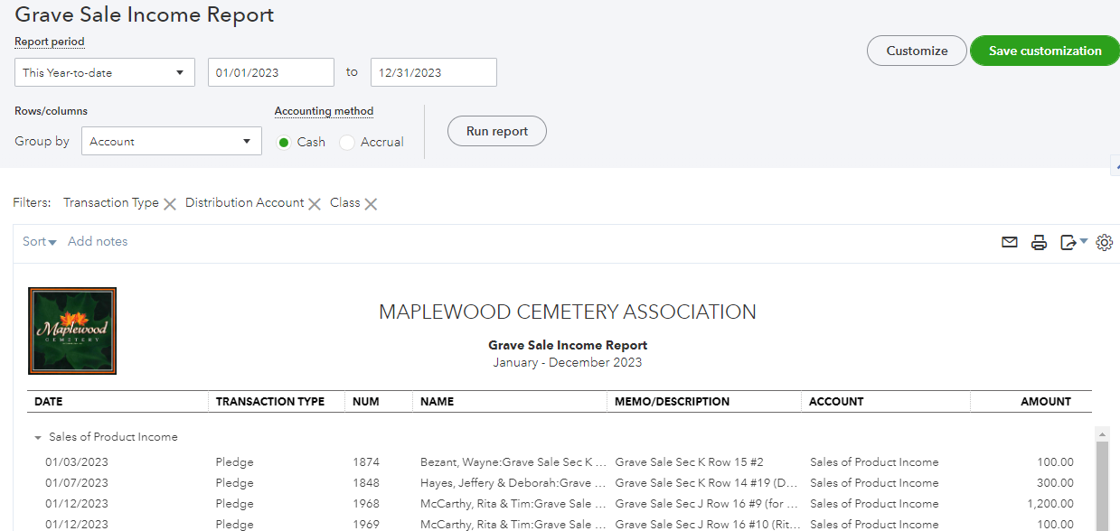
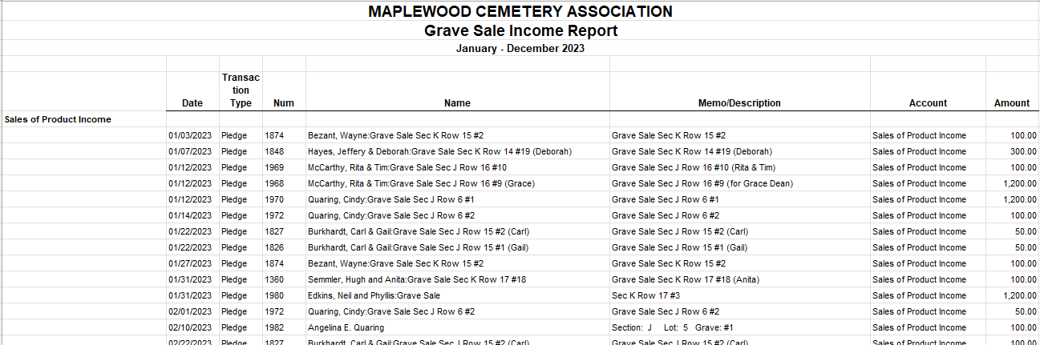
Step 2: QBO: At the top-right of the report just run, click on the EXPORT to Excel option.
Step 3: The Excel file should have been exported and downloaded to your Download directory as:
MAPLEWOOD+CEMETERY+ASSOCIATION_Grave+Sale+Income+Report.xlsx
Step 4: Open this file in Excel.
Step 5: Open the MWC PM Q4.xlsx file (in this example is showing the entire year). Go to the ‘Grave Sales’ tab.
You will see the FY Quarters labeled with subtotals calculated for each quarter.
1Q = January+February+March data, 2Q= April, May, June data, etc.
Step 6: Copy the data, quarter by quarter, from the MAPLEWOOD+CEMETERY+ASSOCIATION_Grave+Sale+Income+Report.xlsx file to the MWC PM Q4.xlsx.
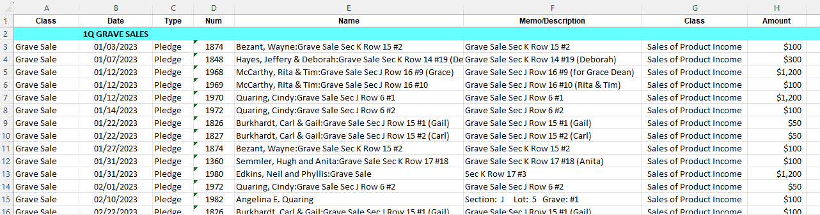
If more rows are needed for a particular quarter, insert the rows needed and make sure the subtotal calculation range is correct.

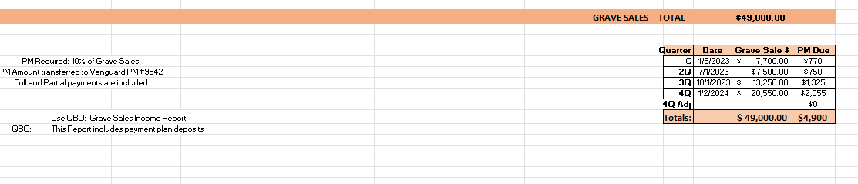
Once the data is placed in the corresponding quarter area, the bottom of the ‘Grave Sales’ sheet should look something like:
- Create a copy of this spreadsheet each year and update it each quarter.
- Save these spreadsheets, print them out and attached the Vanguard deposit acknowledgments.
- You will need these for any NYS audit.

Now we’ll move on to the Interments PM calculations. This is a similar process to the Grave Sales PM.
Step 1: QBO: Run the MWC - Interment Report, below is the beginning of that report.
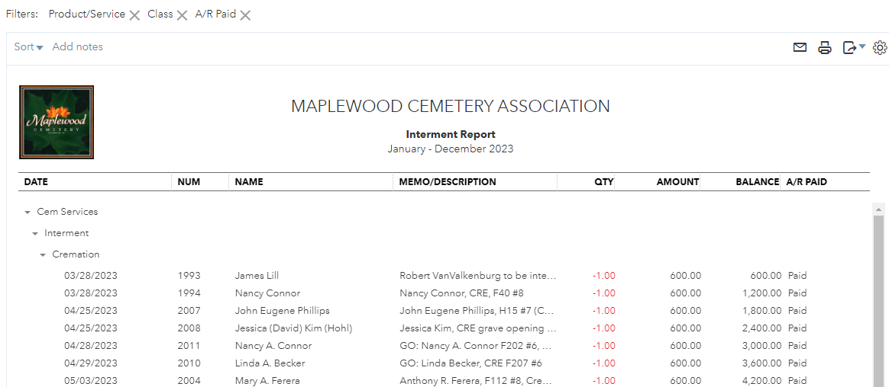
Step 2: QBO: At the top-right of the report just run, click on the EXPORT to Excel option
Step 3: The Excel file should have been exported and downloaded to your Download directory as:
MAPLEWOOD+CEMETERY+ASSOCIATION_Interment+Report.xlsx
Step 4: Open this file in Excel.
Step 5: Open the MWC PM Q4.xlsx file (in this example is showing the entire year). Go to the ‘Interments’ tab.
You will see the FY Quarters labeled with subtotals calculated for each quarter. The data is also grouped by type of interment: Cremation or Full Interment. The other groups or categories will not be copied into this PM report.
1Q = January+February+March data, 2Q= April, May, June data, etc.
Step 6: Copy the data, quarter by quarter, from the MAPLEWOOD+CEMETERY+ASSOCIATION_Interment+Report.xlsx file to the MWC PM Q4.xlsx.
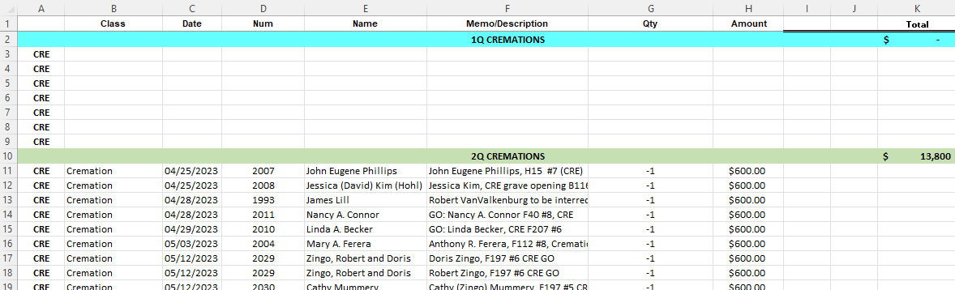
You may notice that there a very few or no cremation interments in the 1st quarter. MWC normally halts cremation interment during the winter months.

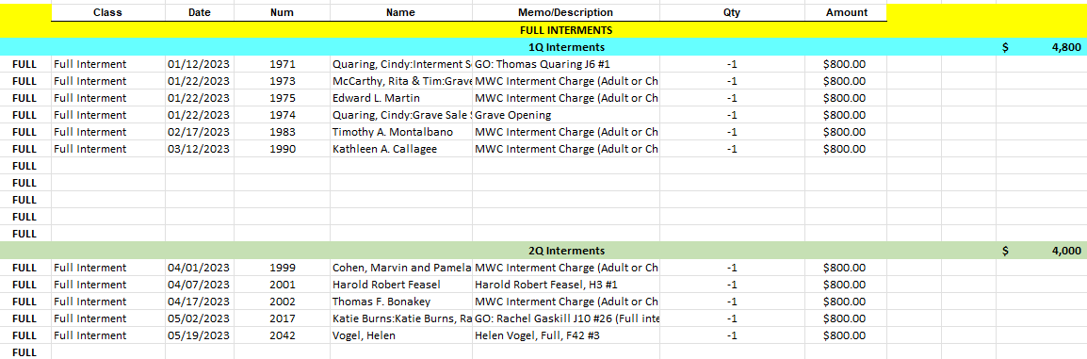

A summary of the total number of Cremation and Full Burials is calculated at the bottom of this worksheet. The amount of income and the amount of PM due per quarter is also calculated.
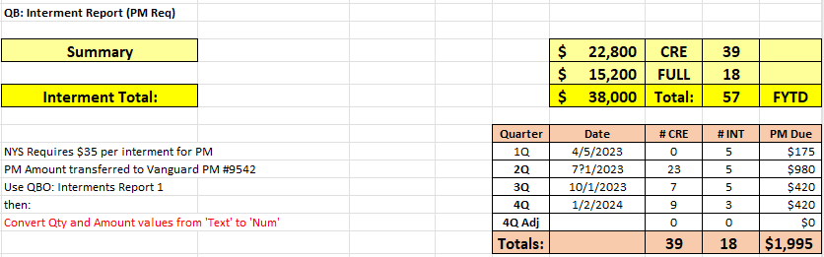
The SUMMARY tab shows both the PM Amounts due for the Interments and the Grave Sales.
You will notice that there are ‘yellow’ highlights indicating ‘Adjustments’ were made to the deposits. The QBO Reports continue to be modified, by us, to make sure that the PM data and calculations are correct. The adjustments were due to the report data filters missing some of the quarterly partial payments.
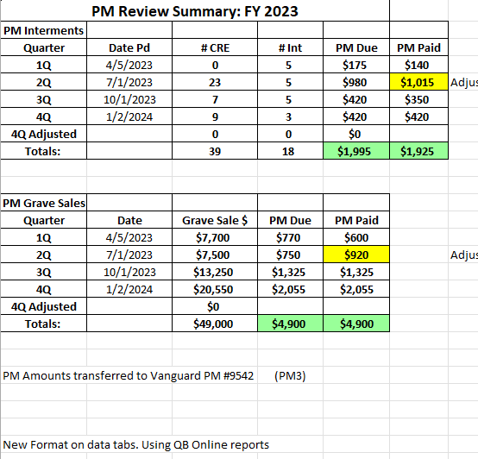
- Also note that if any other adjustment is required that there is a 4Q Adjusted row to record that deposit.

- TIP: There are 2 funds in the PM3 Vanguard PM **9542 account where the PM deposits are made. Deposit the PM Interment amount in 1 fund and the PM Grave Sales amount in the other fund.

- Print the Vanguard confirmation and attach that to the printout of this entire spreadsheet.

Wrapping Up:
The percentage of Grave Sale contribution to deposit into a PM account should be reviewed periodically. MWC board changed the percentage years ago from 25% to 10%. The discussion on whether the higher or lower percentage is best for MWC may vary over time. The lower percentage keeps more money in the GF for operating while the higher percentage adds more funding to the (retirement) PM account. The higher percentage in PM could potentially generate more dividends and interest that would then be transferred to the GF.
Conclusion: The PM accounts and overall money management is the primary focus of any NYS audit. This should be a good way for any MWC audit committee to learn how the cemetery works.
Remember that grave sale payment plans may run over the FY boundaries. Graves that were sold and placed in the payment plan that were purchased in a previous year will not be counted as GRAVES SOLD in this FY but will count as GRAVE SALES income. The PM will be deposited appropriately since any partial payments are included in that income. The NYS Annual report will want the breakout of partial payments vs. full grave payments. The annual report will also want to know how any out of state cremations were interred.

Other Reference materials: All are on the MWC Admin website.

Reports/NYS Cemetery Div
- cemeteries-101-basics
- cemeteries-101-accounting-basics
- Not-For-Profit-Corporation-Law-Article-15-Public-Cemetery-Corporations
- NYS public cemetery regulations
- NYS treasurers-manual-final-100611

Reports/Training
- MWC Treasurer QBO Training
- MWC Treasurer Training
- MWC Sales Training
- MWC Business Reports
- MWC PM Reports (this document)
- MWC Graves SOLD Reports

