Introduction
Welcome to Section Map Training!
Up to date and accurate section maps are critical to the overall sales and operations of the cemetery.
Here are a couple of slides from the Cemeteries-101-Basics presentation by the NYS Division of Cemeteries.
Please read the NYS cemeteries-101- basics.pdf document on MWC Admin.
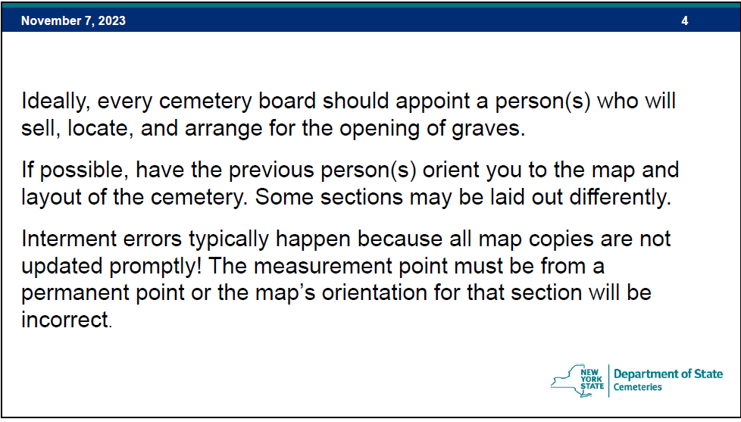

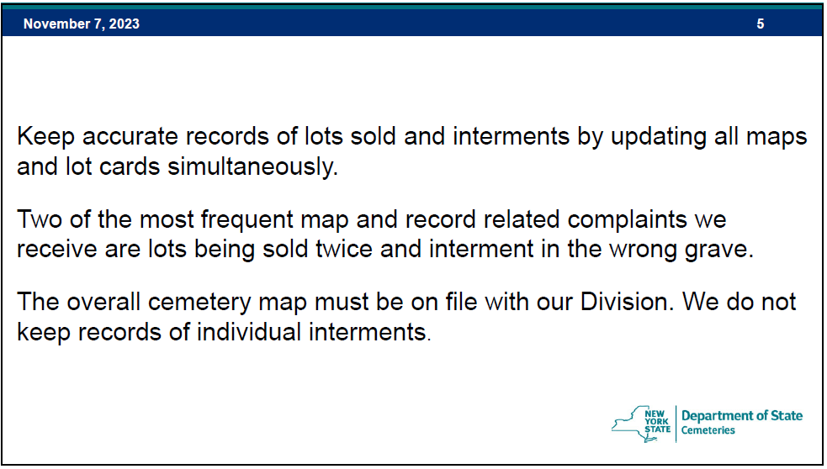

The MWC maps have evolved over time and may continue to do so to meet the needs of our customers and our staff. Currently the MWC maps for our active sales sections are based on MS Excel. The older, mostly inactive, sections may use a more static mapping approach.
We are fortunate that the new J&K Sections have surveyor installed markers for accurate location references. These newer sections are also laid out in a row and column grid pattern making locating a grave much easier than in the older sections. Hopefully a similar grid method will be used when the East and South sections are laid out.
The map updates typically start with the sale of a grave. More information on Grave Sales can be found on MWC Admin in the Sales Training document.
The new grave sale information will be sent to multiple people including the
- Secretary, for records and inventory (graves) management.
- Treasurer, for customer contact, sales, and financial management.
- Webmaster, for customers and MWC Admin website maps and customer updates.
So, who maintains and updates the maps?
- As the NYS Cemetery Division slide mentions above, it would be ‘ideal’ to appoint a person or persons that are involved in the sales, layout, and operations of the cemetery.

Let’s see how the grid maps are Updated.
Updates to a map can be easy.
I have created a Microsoft (MS) Excel spreadsheet to load the data and calculate the availability map and the query map from the Excel data. There should be 1 spreadsheet for each active section.
Step 1: We will use the Section J map for this exercise: Section J + Availability (20240103).xlsx
- Open the map to be updated in Excel.
  - Whenever a map has been updated, do a ‘Save As’ and update the date. This is a good indicator of when the map was updated.
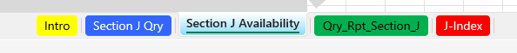
  - Once the map is open in Excel, you will see the bottom worksheet tabs:
  - Intro tab: discusses the important notes and tips about the map.
  - Section J Qry and Section J Availability are the actual maps. More on those shortly.
  - J-Index, the RED tab, should NOT be edited. This will be discussed in a later section.
  - Click on the tab.
Step 2: The open worksheet should look like this:
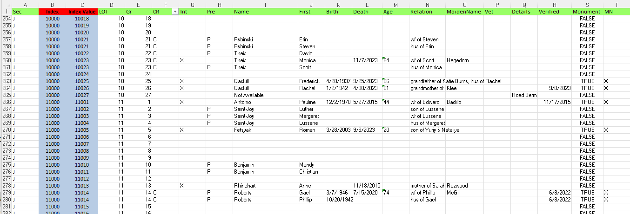
Note that columns B and C should NOT be edited. The data in those columns is key to determining the map layout and positioning.
- The data in columns D through T determine the content in the map cells and can be edited.
- The INITIAL DATA was generated by the MWC Access Database and imported to this worksheet for Section J.
- The UPDATES can be done simply by entering (typing) the new data in the proper row and column.
  - To enter a new grave sale, scroll down to the row for that LOT and GRAVE.
    - Note: If there already is customer data in that row you selected there may be a problem.
      - Verify the data for the new grave sale to make sure it is correct, and previously NOT sold, or NOT marked ‘Not Available’.
      - Contact the Secretary immediately with any questions.
  - Once the new sale data has been entered, the maps will be updated ‘automatically’.
    - Note: All the columns in the row you are editing do not have to be filled in.
      - The critical column in that row is the Name, which is the last name. Any entry in the Name field will make that grave ‘sold’ on the maps.
      - If you know that the person plans to be cremated, the CR column should have a ‘C’. Leave that column blank if you don’t know or if they plan on a full-casket burial.
      - Mark the Pre column with a ‘P’ for Preneed.
      - Once a burial has been completed at that grave, the Int column should be marked with an ‘X’ and the ‘P’ deleted from the Preneed column.
      - You will notice that some of this data shows on both the Availability and the Qry maps. Columns such as Int, Mn, or Vet will only show on the Qry map.
Step 3: Make sure to save the spreadsheet with the date updated in the filename.

Step 4: The updated file will need to have the map worksheets each saved (published) in the web page *.html/*.htm format for posting on the websites. (The webmaster may be responsible for the map publishing and posting.)
- Section_J + Availability (20240107).htm
- J_Qry_Rpt_Section_J (20240107).htm

Let us see how the 2 maps look and the differences.
The map we usually show the customer when selling a grave is the AVAILABILITY map which is on the
tab.
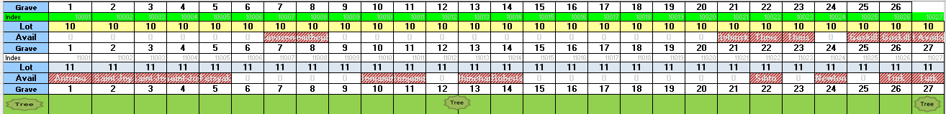
- Here are the rows of Section J shown in data of step 2 above.
- Notice that the SOLD Graves are colored RED with the last name shown.
  - A grave that has been determined to be Not Available will also be colored RED.
- The available graves are all the other graves without the RED color.
The Qry map is named for the Access Database QUERY used to gather the detailed map data.
The Qry map is used when we need more information. Using this map, we can quickly see if the is a monument at or near the grave in question.
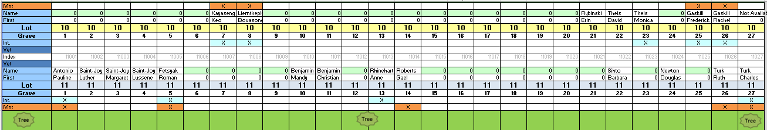
- These are the same rows of Section J shown in data of step 2 above, shown in the Qry map.
- Notice that the SOLD Graves now have more information.
- The Qry maps also show if there is a monument, an interment and veteran status.
These maps can be accessed and printed from the MWC Admin website.
- Printing a map from the Excel worksheet is easy. The print parameters are already set.
- You can also print from the website HTML format display. In the print preview screen, you may need to adjust the scale to be sized properly for the printer.

Let us see how the data is initially imported.
- There are a couple of methods to get the data for the initial import into the
Worksheet.
  - The best method is to request the Qry_Report_Section_J data.xlsx file from the Secretary.
  - The 2nd method is to screen scrape the data from the MWC Admin display. This method is not recommended to load the data but may serve to verify any potential data issues you may encounter.
Step 4: Open this data file in Excel and have the Section J + Availability (20240103).xlsx file open and on the
Worksheet Tab.
The worksheet formats should be the same. The data file rows and columns D -T should be selected for ‘COPY’ in the data file and ‘PASTED’ into the map worksheet. Remember, DO NOT overwrite the data in columns A-C.
Step 5: The values in the worksheet B and C columns should recalculate the cell data locations based on the new data imported.
Note: Many times, the number of rows of new data exceeds the number of rows in the map data worksheet. If that happens, go to the last row where the columns A-C data does exist. Copy that last row of A-C data and paste it in the rows below until all the new data has columns A-C.
- Occasionally you may look at the maps and see that the data is missing, or an ‘N/A’ appears. This may be the issue above where the map cannot find the corresponding location index.
Note: When a grave has more than 1 person listed, only the 1st one listed will appear in the QRY map.
- This could cause some confusion if, for example, the 2nd person listed has passed away, but the 1st person listed has not, then the QRY map will not show any interment.
- This does not affect the Availability Map. The Availability Map could be confusing if the 1st and 2nd people listed for a grave do not have the same last names. The 1st last name will be shown.

How does the Excel spreadsheet figure out where to put data on the maps?
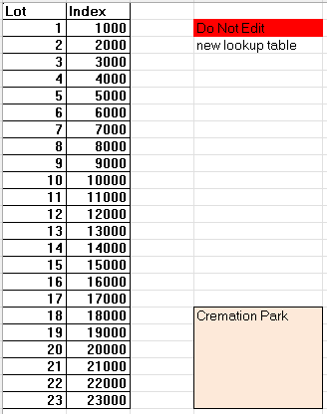
First, we start with the worksheet:

This worksheet table determines the base location-INDEX for the Lot.
For this example, we will select LOT 16.
All graves in Section J, Lot 16 will start with the base location-INDEX of 16000.



Once the data has been imported or updated in this worksheet, columns D – T, the
INDEX value in column B will be ‘looked up’. The equation below shows that we want the INDEX value for the LOT in column D440. The VLOOKUP command will search for the D440 value of ‘16’ in the J-Index table. The INDEX value of 16000 is returned to cell B440.
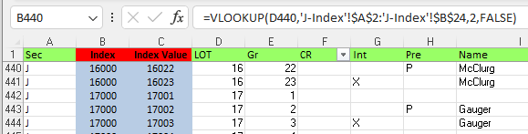

The next step is to calculate the exact grave location, now that the LOT Index has been found.
The equation below calculates the INDEX VALUE by adding the LOT Index B440 and the GRAVE number 22 for a result of INDEX VALUE 16022.
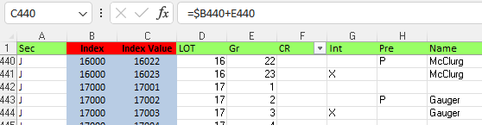
VLOOKUP Offset = 7

So far so good, but how do the maps know what goes where?
If we look carefully at the Qry Map at LOT 16 Grave 22, we will see an MAP Index value assigned to that location on the map. In this case the MAP Index is 16022. If you click on the Qry Map on the cell below the index, you will see the following equation:
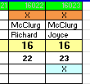
=VLOOKUP (W124, Qry_Rpt_Section_J!$C$2:Qry_Rpt_Section_J!$T$1537,18,FALSE)
This VLOOKUP uses the INDEX in cell W124, which is the MAP Index value 16022. This will now find the INDEX Value of 16022, column C in the above Qry_Rpt_Section_J data.
The VLOOKUP ‘offset’ for this map cell is 18, which indicates whether there is a monument on this grave or not.
- The VLOOKUP ‘offset’ for the LAST NAME for this map cell is 7. (shown above) The VLOOKUP offsets start at 1, being the Index Value, 2 being the LOT #, 3 being the Grave #, and so on.
The process is the same for the AVAILABILITY Map as far as data VLOOKUP equations go. There are fewer lookups required on this map. This map also uses a CONDITIONAL Formatting rule that makes the cell background color RED if there is data there. This color rule makes the map grave availability easier to see just by scanning for non-RED graves. The last name is also shown. It is faint to avoid confusion when searching for an available grave. Use the QRY Map if you need more information, such as ‘is there a monument nearby’? Many times, knowing the monument landmarks will help find the available grave you are looking for.

Wrapping Up:
Using a grid style layout, row, and column, for the new sections has provided several benefits. Mapping is a critical function that requires frequent updates. The easier we can make the update and publishing of these maps the better off we are.
The older sections have been laid out in a sequential wrap around method that is difficult to navigate. I have adapted the Section Map methodology shown here to some of these older sections. Laying out the base INDEX worksheet is the key. Sections C, D, and F maps have been created using a modified base INDEX to align the data to the physical layout of these graves. Care must be taken when doing this modified approach because there are anomalies in the grave numbering. Some of these older sections have evolved over the years. Once labeled as a walkway was later used as a new grave. The grave numbering for these is not consistent and must be indexed carefully.
When the new sections are designed, hopefully they will be laid out in a grid style. New Section maps can be created using the same methods shown in this training.
Communication is a key factor, especially if we have multiple people involved in sales, record keeping, finance, and map updates.

Other Reference materials: All are on the MWC Admin website.

Reports/NYS Cemetery Div
- cemeteries-101-basics
- cemeteries-101-accounting-basics
- Not-For-Profit-Corporation-Law-Article-15-Public-Cemetery-Corporations
- NYS public cemetery regulations
- NYS treasurers-manual-final-100611

Reports/Training
- MWC Treasurer QBO Training
- MWC Treasurer Training
- MWC Sales Training
- MWC Business Reports
- MWC PM Reports
- MWC Graves SOLD Reports
- MWC Section Maps (this document)

