Introduction
Welcome to Section Map Training!
Up to date and accurate section maps are critical to the overall sales and operations of the cemetery.
Here are a couple of slides from the Cemeteries-101-Basics presentation by the NYS Division of Cemeteries.
Please read the NYS cemeteries-101- basics.pdf document on MWC Admin.
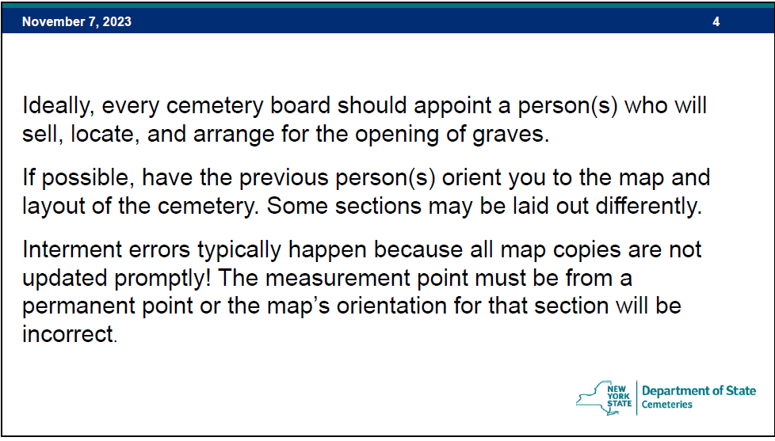

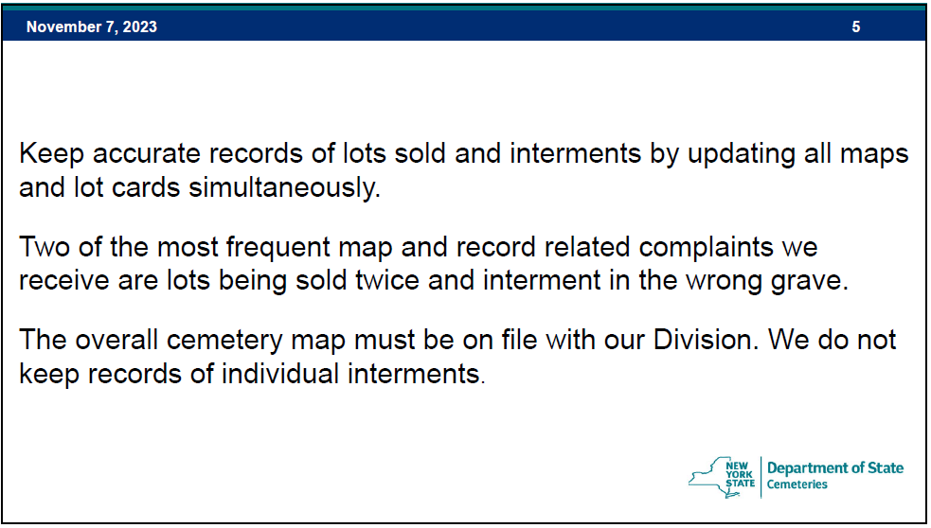

The MWC maps have evolved over time and may continue to do so to meet the needs of our customers and our staff. Currently the MWC maps for our active sales sections are based on MS Excel. The older, mostly inactive, sections may use a more static mapping approach.
We are fortunate that the new J&K Sections have surveyor installed markers for accurate location references. These newer sections are also laid out in a row and column grid pattern making locating a grave much easier than in the older sections. Hopefully a similar grid method will be used when the East and South sections are laid out.
The map updates typically start with the sale of a grave. More information on Grave Sales can be found on MWC Admin in the Sales Training document.
The new grave sale information will be sent to multiple people including the
- Secretary, for records and inventory (graves) management.
- Treasurer, for customer contact, sales, and financial management.
- Webmaster, for customers and MWC Admin website maps and customer updates.
So, who maintains and updates the maps?
- As the NYS Cemetery Division slide mentions above, it would be ‘ideal’ to appoint a person or persons that are involved in the sales, layout, and operations of the cemetery.

Let’s see how the grid maps are Updated.
Updates to a map can be easy.
I have created a Microsoft (MS) Excel spreadsheet to load the data and calculate the availability map and the query map from the Excel data. There should be 1 spreadsheet for each active section.
Step 1: We will use the Section J map for this exercise: Section J + Availability (20240103).xlsx
- Open the map to be updated in Excel.
  - Whenever a map has been updated, do a ‘Save As’ and update the date. This is a good indicator of when the map was updated.
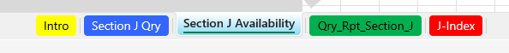
  - Once the map is open in Excel, you will see the bottom worksheet tabs:
  - Intro tab: discusses the important notes and tips about the map.
  - Section J Qry and Section J Availability are the actual maps. More on those shortly.
  - J-Index, the RED tab, should NOT be edited. This will be discussed in a later section.
  - Click on the tab.
Step 2: The open worksheet should look like this:
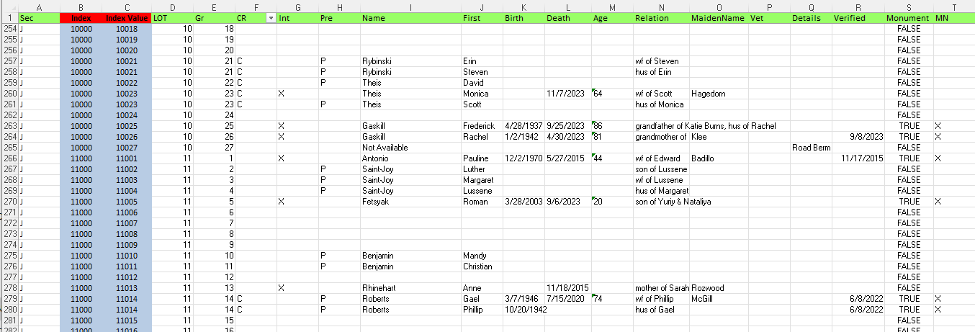
Note that columns B and C should NOT be edited. The data in those columns is key to determining the map layout and positioning.
- The data in columns D through T determine the content in the map cells and can be edited.
- The INITIAL DATA was generated by the MWC Access Database and imported to this worksheet for Section J.
- The UPDATES can be done simply by entering (typing) the new data in the proper row and column.
  - To enter a new grave sale, scroll down to the row for that LOT and GRAVE.
    - Note: If there already is customer data in that row you selected there may be a problem.
      - Verify the data for the new grave sale to make sure it is correct, and previously NOT sold, or NOT marked ‘Not Available’.
      - Contact the Secretary immediately with any questions.
  - Once the new sale data has been entered, the maps will be updated ‘automatically’.
    - Note: All the columns in the row you are editing do not have to be filled in.
      - The critical column in that row is the Name, which is the last name. Any entry in the Name field will make that grave ‘sold’ on the maps.
      - If you know that the person plans to be cremated, the CR column should have a ‘C’. Leave that column blank if you don’t know or if they plan on a full-casket burial.
      - Mark the Pre column with a ‘P’ for Preneed.
      - Once a burial has been completed at that grave, the Int column should be marked with an ‘X’ and the ‘P’ deleted from the Preneed column.
      - You will notice that some of this data shows on both the Availability and the Qry maps. Columns such as Int, Mn, or Vet will only show on the Qry map.
Step 3: Make sure to save the spreadsheet with the date updated in the filename.

Let’s see how the 2 maps look and the differences.
The map we usually show the customer when selling a grave is the AVAILABILITY map which is on the
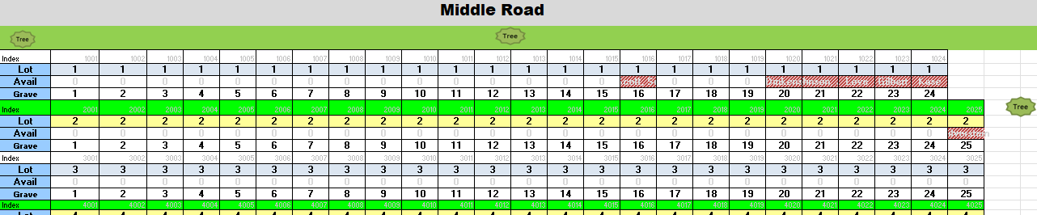
tab.
- Here are the first 3 rows of Section J.
- Notice that the SOLD Graves are colored RED with the last name shown.
  - A grave that has been determined to be Not Available will also be colored RED.
- The available graves are all the other graves without the RED color.

Step 3: The Excel file should have been exported and downloaded to your Download directory as:
MAPLEWOOD+CEMETERY+ASSOCIATION_Grave+Sale+Income+Report.xlsx
Step 4: Open this file in Excel.
Step 5: Open the MWC PM Q4.xlsx file (in this example is showing the entire year). Go to the ‘Grave Sales’ tab.
You will see the FY Quarters labeled with subtotals calculated for each quarter.
1Q = January+February+March data, 2Q= April, May, June data, etc.
Step 6: Copy the data, quarter by quarter, from the MAPLEWOOD+CEMETERY+ASSOCIATION_Grave+Sale+Income+Report.xlsx file to the MWC PM Q4.xlsx.
If more rows are needed for a particular quarter, insert the rows needed and make sure the subtotal calculation range is correct.

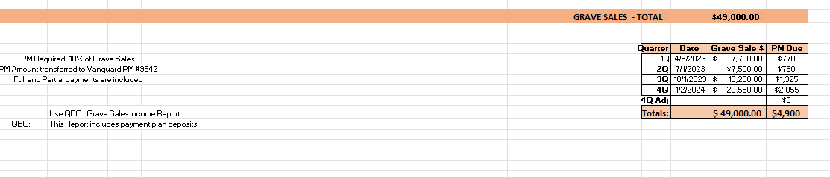
Once the data is placed in the corresponding quarter area, the bottom of the ‘Grave Sales’ sheet should look something like:
- Create a copy of this spreadsheet each year and update it each quarter.
- Save these spreadsheets, print them out and attached the Vanguard deposit acknowledgments.
- You will need these for any NYS audit.

Now we’ll move on to the Interments PM calculations. This is a similar process to the Grave Sales PM.
Step 1: QBO: Run the MWC - Interment Report, below is the beginning of that report.
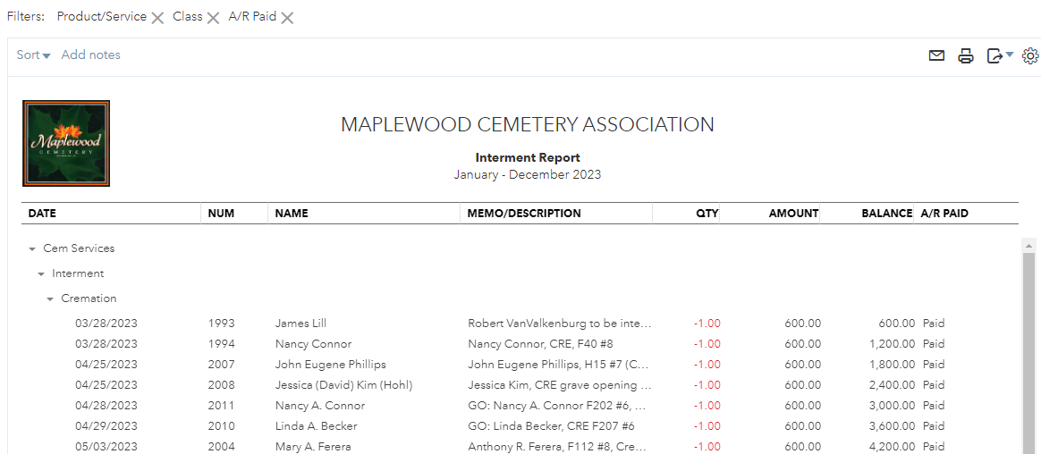
Step 2: QBO: At the top-right of the report just run, click on the EXPORT to Excel option
Step 3: The Excel file should have been exported and downloaded to your Download directory as:
MAPLEWOOD+CEMETERY+ASSOCIATION_Interment+Report.xlsx
Step 4: Open this file in Excel.
Step 5: Open the MWC PM Q4.xlsx file (in this example is showing the entire year). Go to the ‘Interments’ tab.
You will see the FY Quarters labeled with subtotals calculated for each quarter. The data is also grouped by type of interment: Cremation or Full Interment. The other groups or categories will not be copied into this PM report.
1Q = January+February+March data, 2Q= April, May, June data, etc.
Step 6: Copy the data, quarter by quarter, from the MAPLEWOOD+CEMETERY+ASSOCIATION_Interment+Report.xlsx file to the MWC PM Q4.xlsx.
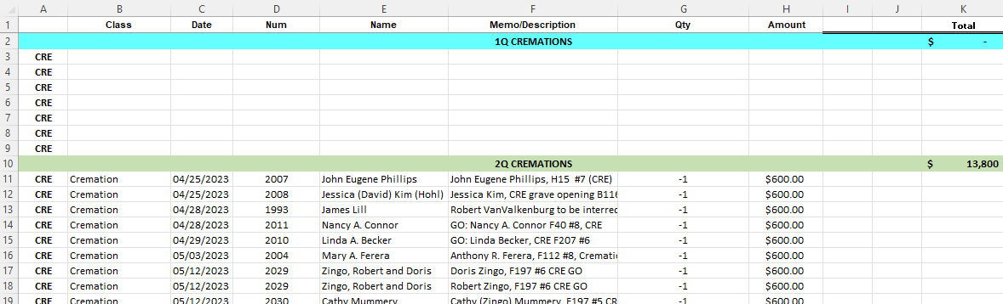
You may notice that there a very few or no cremation interments in the 1st quarter. MWC normally halts cremation interment during the winter months.

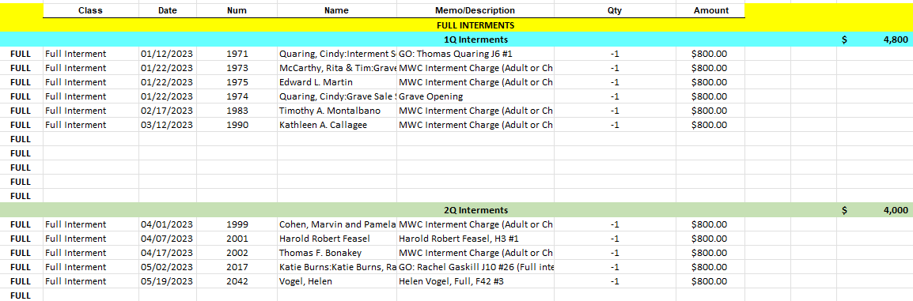

A summary of the total number of Cremation and Full Burials is calculated at the bottom of this worksheet. The amount of income and the amount of PM due per quarter is also calculated.
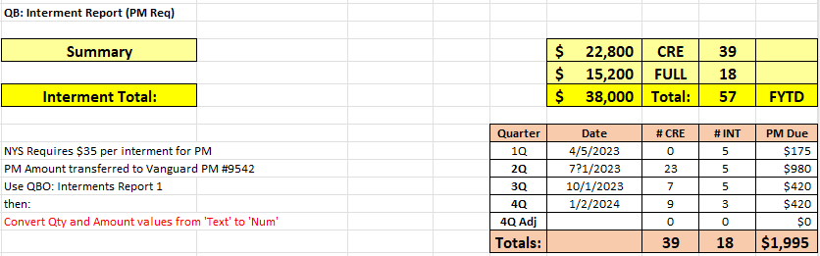
The SUMMARY tab shows both the PM Amounts due for the Interments and the Grave Sales.
You will notice that there are ‘yellow’ highlights indicating ‘Adjustments’ were made to the deposits. The QBO Reports continue to be modified, by us, to make sure that the PM data and calculations are correct. The adjustments were due to the report data filters missing some of the quarterly partial payments.
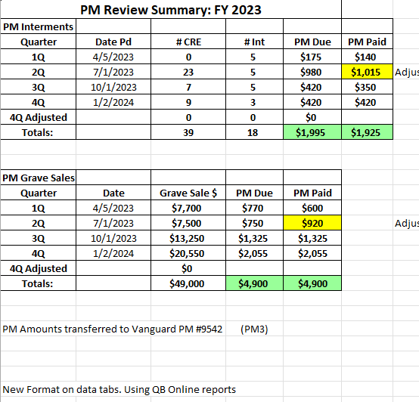
- Also note that if any other adjustment is required that there is a 4Q Adjusted row to record that deposit.

- TIP: There are 2 funds in the PM3 Vanguard PM **9542 account where the PM deposits are made. Deposit the PM Interment amount in 1 fund and the PM Grave Sales amount in the other fund.

- Print the Vanguard confirmation and attach that to the printout of this entire spreadsheet.

Wrapping Up:
The percentage of Grave Sale contribution to deposit into a PM account should be reviewed periodically. MWC board changed the percentage years ago from 25% to 10%. The discussion on whether the higher or lower percentage is best for MWC may vary over time. The lower percentage keeps more money in the GF for operating while the higher percentage adds more funding to the (retirement) PM account. The higher percentage in PM could potentially generate more dividends and interest that would then be transferred to the GF.
Conclusion: The PM accounts and overall money management is the primary focus of any NYS audit. This should be a good way for any MWC audit committee to learn how the cemetery works.
Remember that grave sale payment plans may run over the FY boundaries. Graves that were sold and placed in the payment plan that were purchased in a previous year will not be counted as GRAVES SOLD in this FY but will count as GRAVE SALES income. The PM will be deposited appropriately since any partial payments are included in that income. The NYS Annual report will want the breakout of partial payments vs. full grave payments. The annual report will also want to know how any out of state cremations were interred.

Other Reference materials: All are on the MWC Admin website.

Reports/NYS Cemetery Div
- cemeteries-101-basics
- cemeteries-101-accounting-basics
- Not-For-Profit-Corporation-Law-Article-15-Public-Cemetery-Corporations
- NYS public cemetery regulations
- NYS treasurers-manual-final-100611

Reports/Training
- MWC Treasurer QBO Training
- MWC Treasurer Training
- MWC Sales Training
- MWC Business Reports
- MWC PM Reports (this document)
- MWC Graves SOLD Reports

