Introduction
Welcome Documents and Forms
Our sales process is intended to be easy and helpful for the customer to understand and complete.
- There are many documents that are needed to help our customers and record their requests and transactions.
- Our internal process must be followed and completed to make sure that everything gets recorded properly.
- Most customers have never been through this situation. You are guiding them, and they count on that. Many of our customers will have many questions about the whole situation they are now in. I have included other topics that may help answer some of those questions.
- It is very important to get the process and the information correct the 1st time.
- Communicating the outcome to the right people promptly will be important.
- The MWC public website https://maplewoodcemetery.org/ has a lot of information about Maplewood Cemetery. Do not be worried about referring a customer to the website. The maps, listings, Frequently Asked Questions (FAQs), our Rules & Regulations, and more are there.
- Those documents and forms will be explained here. The responsibilities for these documents may change overtime but should be reviewed and managed properly.
- The frequency of updates needed will also be explained.
- And, of course, there are a few NYS REQUIRED documents and formats. They are here as well!

Let’s get started!
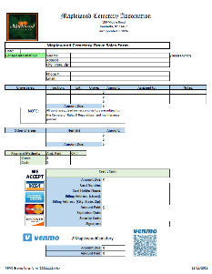
Customer & Sales forms:
- Sales Form: This may be our most used and important form.
  - The use and processing of this form is covered in detail in the MWC Sales Training manual.
  - The sales form itself may not need to be updated very often, but the contents of the completed form are important.
  - Used by anyone selling a grave.
- Sales Training manual: This manual describes the sales process. The manual should be updated when there are details that change in this process.

  - The manual describes the importance of getting the information recorded correctly. The notification process is very important to make sure the proper personnel are notified, and the next steps are put in motion.
- The MWC glossy pamphlet: This pamphlet was printed at Vistaprint. MWC had 1500 MWC brochures (new design) in 2010. We still have some.
  - A brochure is included in every DEED packet.
  - These brochures are also available in the shed brochure holder.
- Rates and Charges: This form needs to be updated whenever a price has changed.
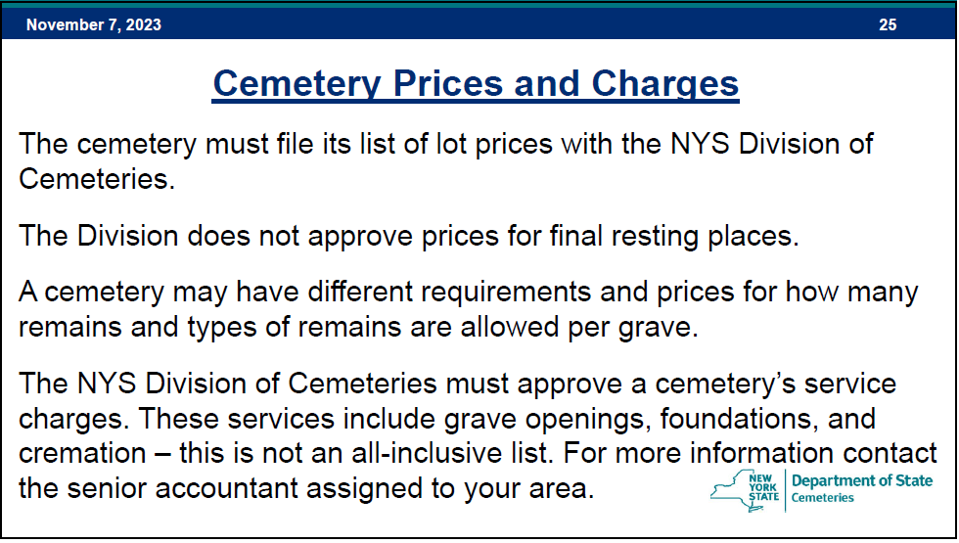
  - Refer to the NYS Cemetery 101 manuals for the requirements for more information. The Rates and Charges brochure is included in every DEED packet.
  - The MWC Board must decide on any price changes. The Secretary or the Treasurer will then send a letter to the Cemetery Division for review and approval. Once approved, the new Rates and Charges brochure must be sent to the Cemetery Division for its records. This record will be used in any audit.
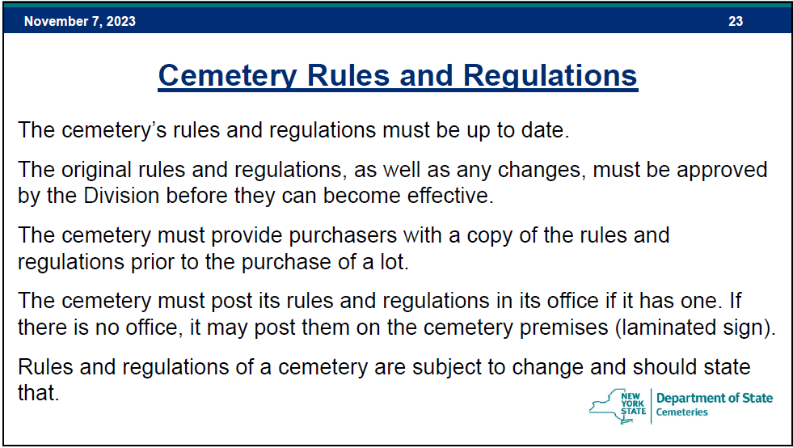
- Rules & Regulations: The MWC Board must decide on the Rules and Regulations. The Secretary will then send the pending Rules and Regulations to the Cemetery Division for review and approval. Once approved, the new Rules and Regulations brochure must be sent to the Cemetery Division for its records. A copy of the Rules and Regulations is included in each DEED Packet, also available in the shed brochure holder, and posted on the shed bulletin board.


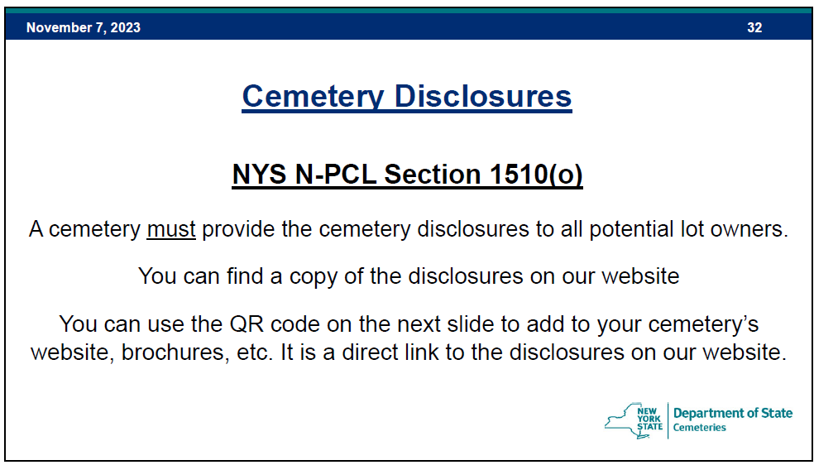

- Cemetery Disclosures – NYS Required
  - This document is created and maintained by NYS. The link is in this QR code.
  - Copies of this document are in the shed brochure holder for our customers.
- Frequently Asked Questions (FAQs): The FAQ brochure can be quite helpful to new customers. This document is available in the shed brochure holder and posted on the MWC website. This document should be revised as needed.
Customer Deed Packet: A deed is created by the Secretary after each grave sale. The indenture-contract stating what they have purchased. Included in this packet are:
- The Maplewood Cemetery Association Indenture: Signed by the MWC President and Secretary. The deed is embossed with the MWC ‘Official’ seal. This is a legal document, and the deed owners should keep this with their other secured legal documents. This should only be created by the MWC Secretary after a confirmed grave sale purchase.
- Grave Sale Receipt: A copy of the grave sale purchase statement is included.
- A Welcome Letter: This letter welcomes the new deed owner to the Maplewood Cemetery Association. There is a map on the back of this with the purchased grave(s) highlighted for reference. This letter would only require revision if the message to the new deed owner had to be changed or the map of the cemetery changed.
- The Rules and Regulations document is included in the packet.
- The current Rates and Charges brochure is included in the packet for reference. Please note that this is only for reference, this is not a price guarantee for the future.
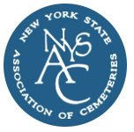
Others forms:
- NYSAC: 2024 NYSAC MEMBERSHIP DUES form. NYS Association of Cemeteries
  - Form and dues required for membership renewal annually. The dues base on the number of interments per the previous year.
- Tax forms and other annual reports will be covered in another manual.

The MWC Bulletin Board:
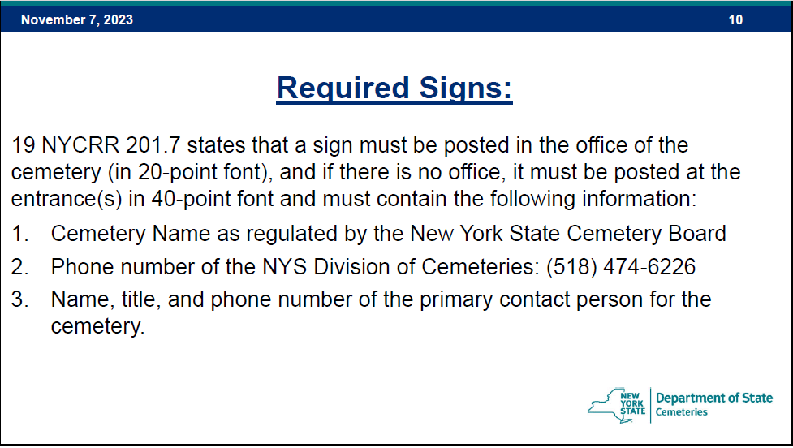

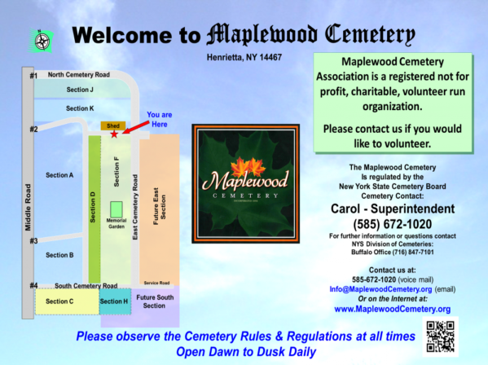
This is the current NYS REQUIRED SIGN.
This is posted on the bulletin board as required.

- The bulletin board on the shed needs to be updated whenever the Rules and Regulations are changed, or the required sign information is changed.
- The Rules and Regulations are laser-jet printed using a legal-sized paper and then laminated.
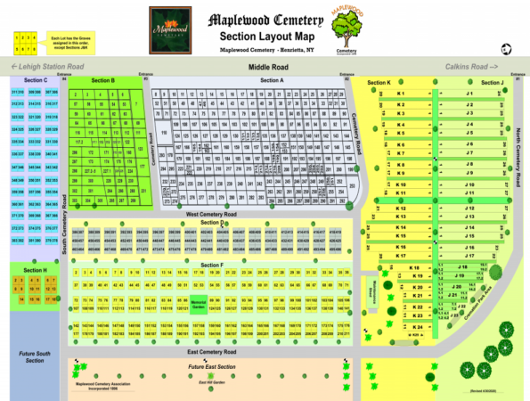
This Section map is also posted on the bulletin board and is very popular.
This should be updated as needed.
Both the NYS Required sign and the Section map are on foam board and printed at BuildASign.com using UV resistant ink. They usually last a year or so and should be replaced when information changes or they look faded.
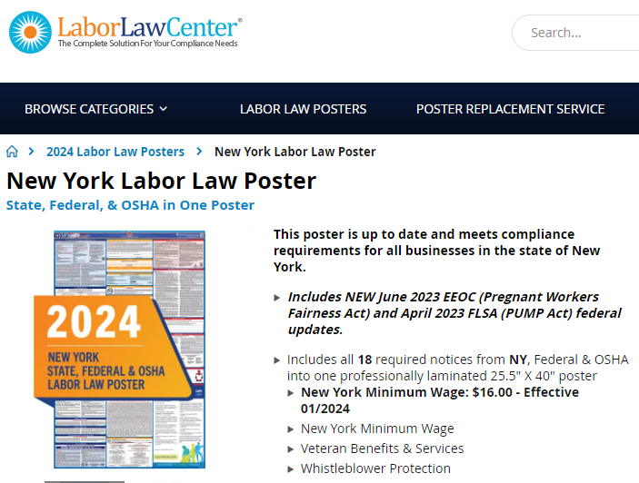
The MWC Shed – Federal & NYS Labor Law Poster
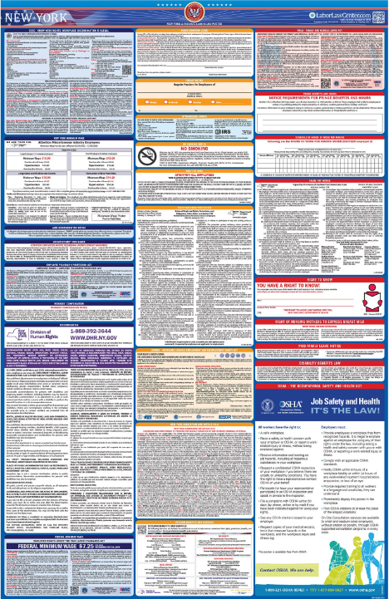
These Labor Law posters are updated every year and are required to be posted for our employees. This is posted in the shed.
Order them from Labor law Center.com New York-labor-law-posters
Note: Occasionally we will receive NYS Poster solicitations from other companies that charge more and seem to use scare tactics to get you to purchase their products.
The Labor Law Center is based in California and has been a good value for a good poster. I order a new poster when the discount code is emailed to me, usually in December.
The wrap up…..
There are key, important, required, and handy documents that have evolved over the years. I have tried to include the most important and required items. There will always be others that pop up.
I have adopted the TRI-FOLD style for most of the documents. This style looks good and fits easily in a letter envelope as well as the shed brochure holder. Most of the documents are printed ‘at home’ on a color Laser-Jet printer. The required quick turn around of revised Section Maps make the ‘at home’ approach more practical.
Other methods of printing can be used. The keys here are ‘professional looking’ documents with a quick turnaround printing ability. The ‘source’ documents are mostly formatted in Microsoft (MS) Word.
The larger signs are created in MS PowerPoint and the section maps are created in MS Excel.
Most, if not all, of the source files are available on the MWC Admin website.
WEBSITE Note: The documents listed here are also available on the MaplewoodCemetery.org customer website. The source documents can be saved in an *.html format for posting by the webmaster.
A few of these documents can also be downloaded from the website. That format link should be the Portable Document Format, *PDF.
Conclusion: Many of these documents may require 3 different formats depending on their intended usage. Keeping all the formats in-sync and updated frequently is important. Fortunately, once a source document is done, it can be saved in the multiple formats easily.
Other Reference materials: All are on the MWC Admin website.

Reports/NYS Cemetery Div
- cemeteries-101-basics
- cemeteries-101-accounting-basics
- Not-For-Profit-Corporation-Law-Article-15-Public-Cemetery-Corporations
- NYS public cemetery regulations
- NYS treasurers-manual-final-100611

Reports/Training
- MWC Treasurer QBO Training
- MWC Treasurer Training
- MWC Sales Training
- MWC Business Reports
- MWC PM Reports
- MWC Graves SOLD Reports
- MWC Section Maps Training
- MWC Documents and Forms (this document)

