Introduction
Welcome to Graves Sold Report Training!

The MWC Quarterly and Annual reports are important and required to present the status of the MWC Association. This training document will take you through the process of completing this report.
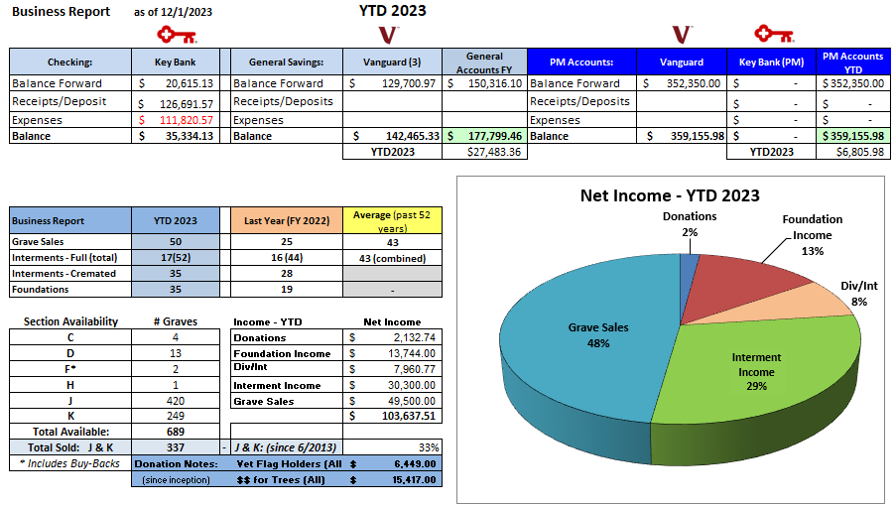
Below is a sample of the quarterly business report:

This is a complex report to generate and requires multiple sources. More details on how to create this report are provided in the ‘Business Reports’ training.

Grave Sales, the actual number of graves sold, in the report year are more difficult to compile. This document focuses on how to report the GRAVE SALES. Multiple ‘tools’ are required. Some of that data will also be used to report the Section Availability numbers.

Information needed for this Grave Sales report requires data from:
- QuickBooks Online (QBO)
- MWC Admin
- MS Access database
- MS Excel

Graves SOLD vs. Grave SALES
It turns out that these are 2 different items that make a big difference on how we report our inventory of graves and how we allocate Permanent Maintenance (PM) for Grave Sales. Both values are needed for our quarterly and annual reports for MWC and NYS.
- QuickBooks Online (QBO)
  - Provides the Grave Sales amount.
  - Grave Sale Income Report: reports all the funds applied to both the complete purchase and the monthly payment plans during the report period.
    - This is the amount that should be entered in the Grave Sales Income cell of the Business Report.
- MWC Admin: To provide the Grave Sold count.
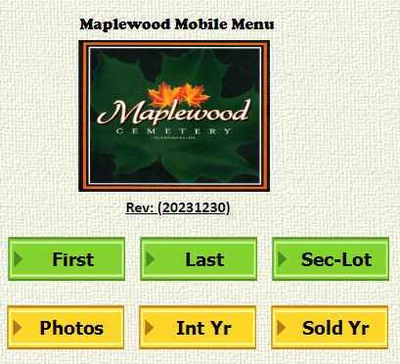
The ‘Sold Yr’ button can be used to generate the listing of Graves Sold for the year entered. This data must be filtered to produce the actual number of graves sold. The MWC database that is used contains the names and graves that each person is recorded as assigned to use.
In many cases, there is more than 1 person assigned to the same grave.
The data filtering needs to be done to eliminate that redundancy and provide an accurate grave sold count.

Once the ‘Sold Yr’ button has been selected and the desired report year entered, the results will be displayed on the screen.
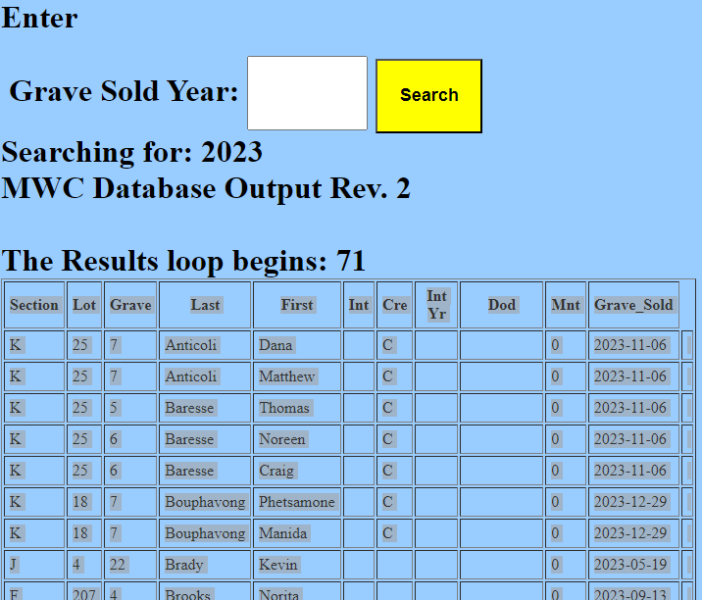
- The results table can then be copied or ‘screen scraped’ and pasted into an empty tab of an Excel Spreadsheet.
- This data should paste properly in multiple columns, with the headers, for further analysis.

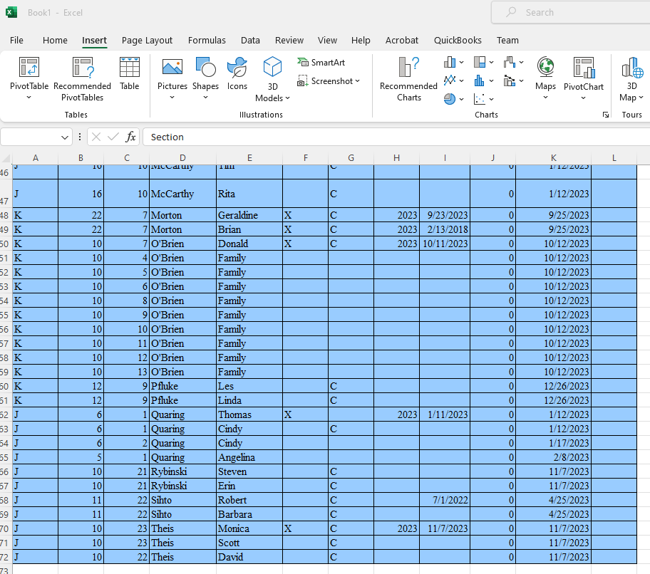
Here is the Graves Sold data pasted into an Excel spreadsheet.
The ‘Filtering’ process involves creating a PIVOT table.
- Select all the data that was pasted into this tab.
- Click on INSERT in the top menu, then Pivot Table.

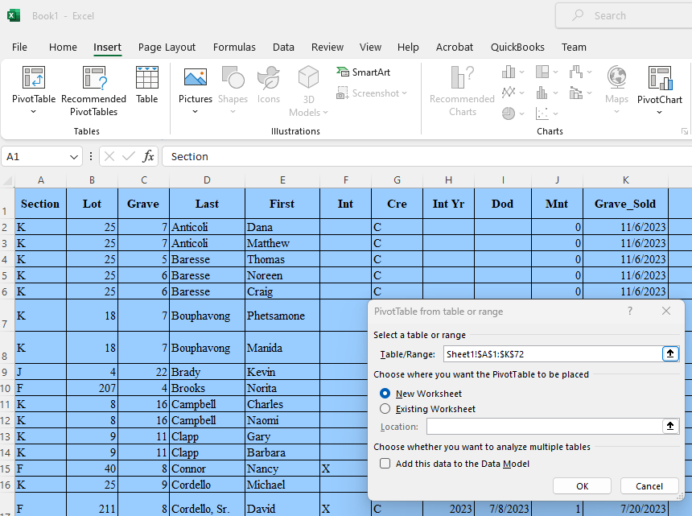

- This pop-up will appear showing the range you selected of this data, including the top row data headers.
- New Worksheet has already been selected. (a new tab)
- Click OK
- Then switch to the New Worksheet – Sheet 2

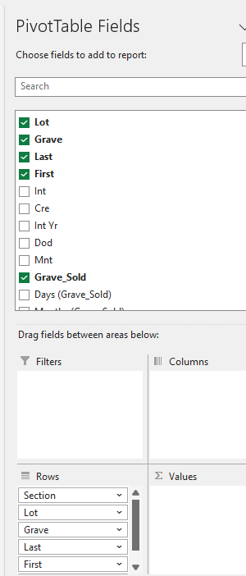

Select these fields to be shown in the Pivot Table in the order shown below.

Make sure that the fields are selected in this order.

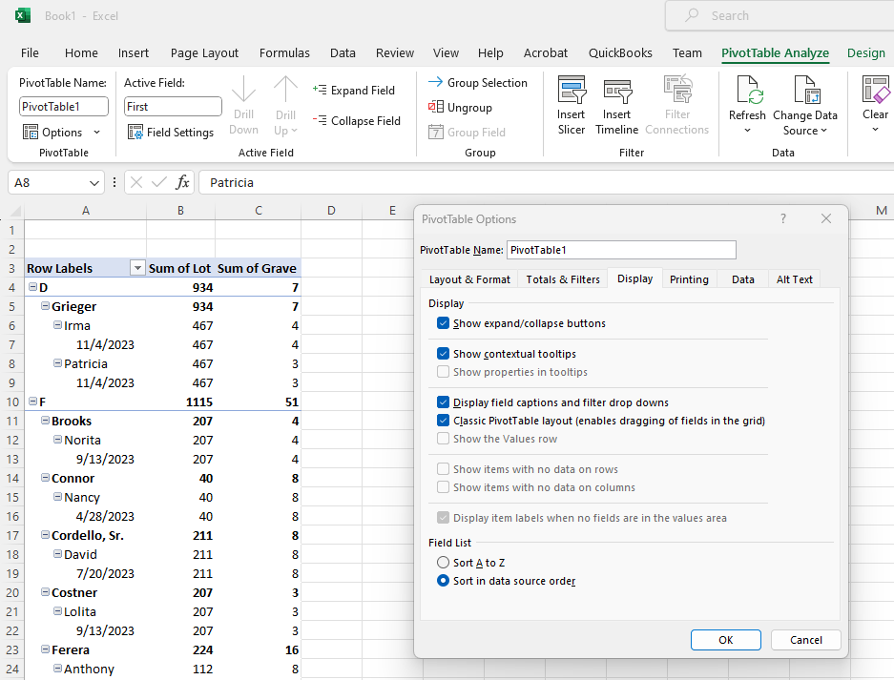

I prefer to use the ‘Classic PivotTable’ view.

The next step is to add a filter to the pivot table to get the actual count of the graves sold.

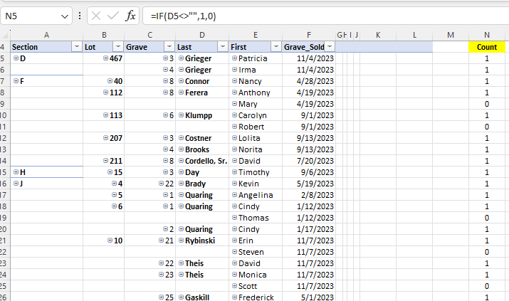
The filter is this equation that will eliminate the redundancies.
Add this equation in column N, repeat the equation to the end of the table data.

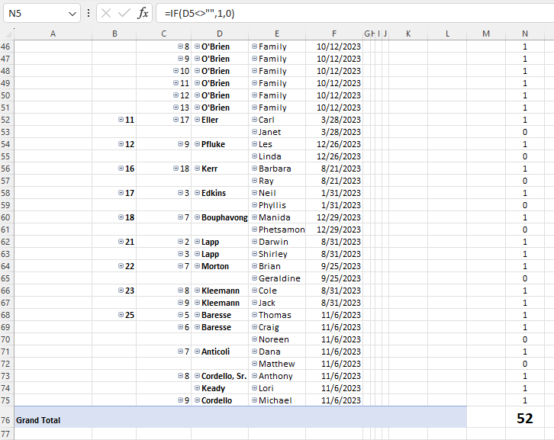
The accurate count of the graves sold in report year 2023 is shown here:

Wrapping Up:
Once all the required data is plugged into the appropriate data cells, the Business Report should be ready to capture.
The area of the report used for distribution will be visible if the Print Area is set up properly. It is recommended that the Print Area of the report also be ‘screen grabbed’ using a tool like MS Snipping Tool to save the image as a PNG format image. This makes the overall quarterly meeting minutes easier to create.
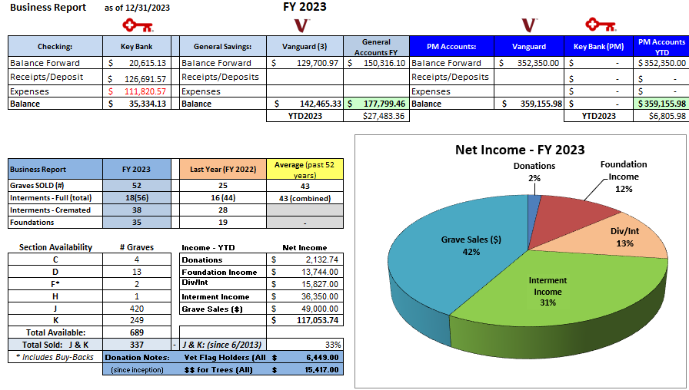
Conclusion: The Graves SOLD X $1,200 (current price of a full grave) = $62,400. That is NOT the actual grave sale income of $49,000 that was received. It is important to be able to calculate and report Graves SOLD vs. Grave Sales accurately.
Remember that grave sale payment plans may run over the FY boundaries. Graves that were sold and placed in the payment plan that were purchased in a previous year will not be counted as GRAVES SOLD in this FY but will count as GRAVE SALES income.

Other Reference materials: All are on the MWC Admin website.

Reports/NYS Cemetery Div
- cemeteries-101-basics
- cemeteries-101-accounting-basics
- Not-For-Profit-Corporation-Law-Article-15-Public-Cemetery-Corporations
- NYS public cemetery regulations
- NYS treasurers-manual-final-100611

Reports/Training
- MWC Treasurer QBO Training
- MWC Treasurer Training
- MWC Sales Training
- MWC Business Reports
- MWC PM Reports
- MWC Grave SOLD Reports (this document)

