Maplewood Cemetery
Rates & Charges
MWC - GVCS

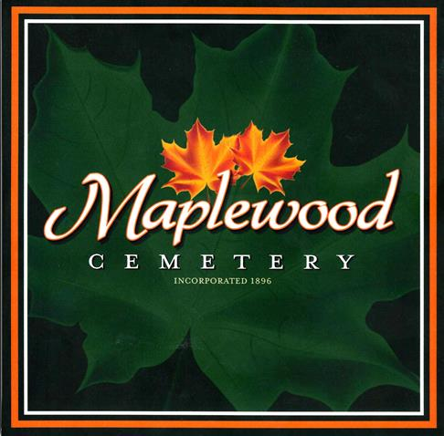

150 Middle Road
Henrietta, NY 14467

Maplewood Cemetery Association
Rates and Charges
2023 Update

Lot Sales: MWC
Full size (per grave) | $1,200
Cremation-only (Section J) | $600
Interments: (1)
Adult and Child (casket/vault) | $800
Infants (up to 4 ft.  length - casket/vault) | $600
Cremated Remains -  Human (urn) | $600
Cremated Remains –  Pet (urn) (2) | $600
Additional Fees:
Special Grave  Maintenance fee (3) | $200
SATURDAY, Sunday & Holiday  Interments Fee | $500 + $300 = $800
Winter Fee (4)  (Dec.1-April 1) | $50
Disinterment Fee (5) | $1,500
Monument Foundations:
Per square inch (6) | $1.50
Minimum Charge | $432
Duplicate Deed: | $10


For Burial and Cemetery information:

Maplewood Cemetery Voicemail 585-672-1020

Lot Sales: GVCS Notes
Full size (per grave) | $1,200
Cremation-only (Section J) | $600
Interments: (1)
Adult and Child (casket/vault) | $400
Infants (up to 4 ft.  length - casket/vault) | $600
Cremated Remains -  Human (urn) | $300
Cremated Remains –  Pet (urn) (2) | $300
Additional Fees:
Special Grave  Maintenance fee (3) | $200
SATURDAY, Sunday & Holiday  Interments Fee | $300
Winter Fee (4)  (Dec.1-April 1) | $50
Disinterment Fee (5) | $1,500
Monument Foundations:
Per square inch (6) | $0.80
Minimum Charge | $230
Upright & Bronze Foundation and setting Fee | $400
Flat VA Granite and setting fee | $300
Duplicate Deed: | $10

Visit us at:
www.MaplewoodCemetery.org

Email us at:
info@MaplewoodCemetery.org

Maplewood Cemetery Association is a not-for-profit, charitable, volunteer run organization

Notes:
- (1) The Rates and Charges include the 2001 NY State mandatory charge of $35.00 to our Permanent Maintenance account for interments and a $5 vandalism fee.
- (2) Cremated pets that require a separate grave opening.
- (3) The Special Grave Maintenance Fee will be charged for exceptions to the concrete vault or concrete liner requirements.
- (4) Winter Access: An additional charge may be made for snow removal or penetration of frost based on the additional costs to the cemetery pursuant to Section 1509 (d) of the not-for-profit corporation law.
- (5) Disinterment: The removal of a buried vault or urn from the ground.
- (6) Foundation price updated 7/1/2022
- (7) Visa, MasterCard, and Discover Card are now accepted for payment in addition to checks and cash. Venmo has now been added!

